# Project Report: AWS Infrastructure Health Monitoring Dashboard

**Project Name:** AWS Infrastructure Health Monitoring Dashboard **Date:** November 2025 **Author:** [Your Name]

## 1. Executive Summary

This project involves the design and implementation of a comprehensive serverless monitoring dashboard on AWS. The primary objective is to solve a common Cloud Support challenge: "How do we verify that our critical infrastructure (EC2, S3, RDS, Networks) is healthy and reachable?"

The solution leverages AWS CloudWatch, Lambda, and SNS to create an automated alerting system that monitors resource health, storage usage, and network connectivity, providing a unified view of the infrastructure's status.

## 2. Project Architecture & Tools

**Core Services Used:**

* **Identity & Access Management (IAM):** For secure user management and permissions.
* **Amazon VPC:** Network isolation and connectivity (NAT/IGW).
* **Amazon EC2:** Virtual servers hosting applications.
* **Amazon S3:** Object storage for logs and backups.
* **Amazon RDS:** Managed relational database service.
* **Amazon CloudWatch:** Metrics collection, dashboard visualization, and alarms.
* **AWS Lambda:** Serverless compute for custom health checks.
* **Amazon SNS:** Simple Notification Service for email alerts.

## 3. Implementation Phases

### Phase 1: Security & Environment Setup (IAM)

Before provisioning infrastructure, we established a secure environment by creating a dedicated Administrator user. This ensures we are not using the Root account for daily tasks, following AWS security best practices.

**Step 1.1: AWS Console Access** We logged into the AWS Management Console to begin the configuration. 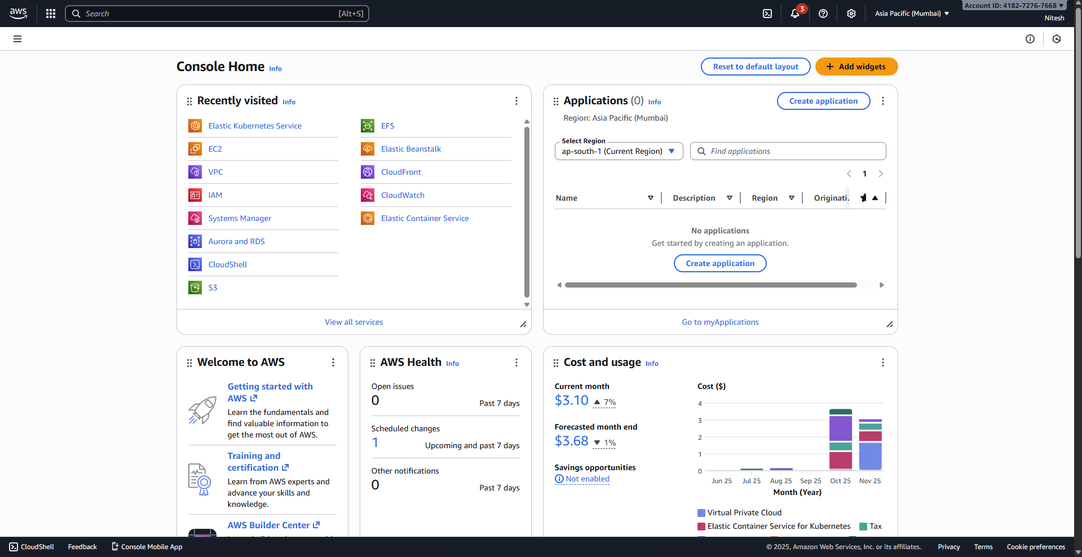

**Step 1.2: Identity and Access Management (IAM) Configuration** We navigated to the IAM service to 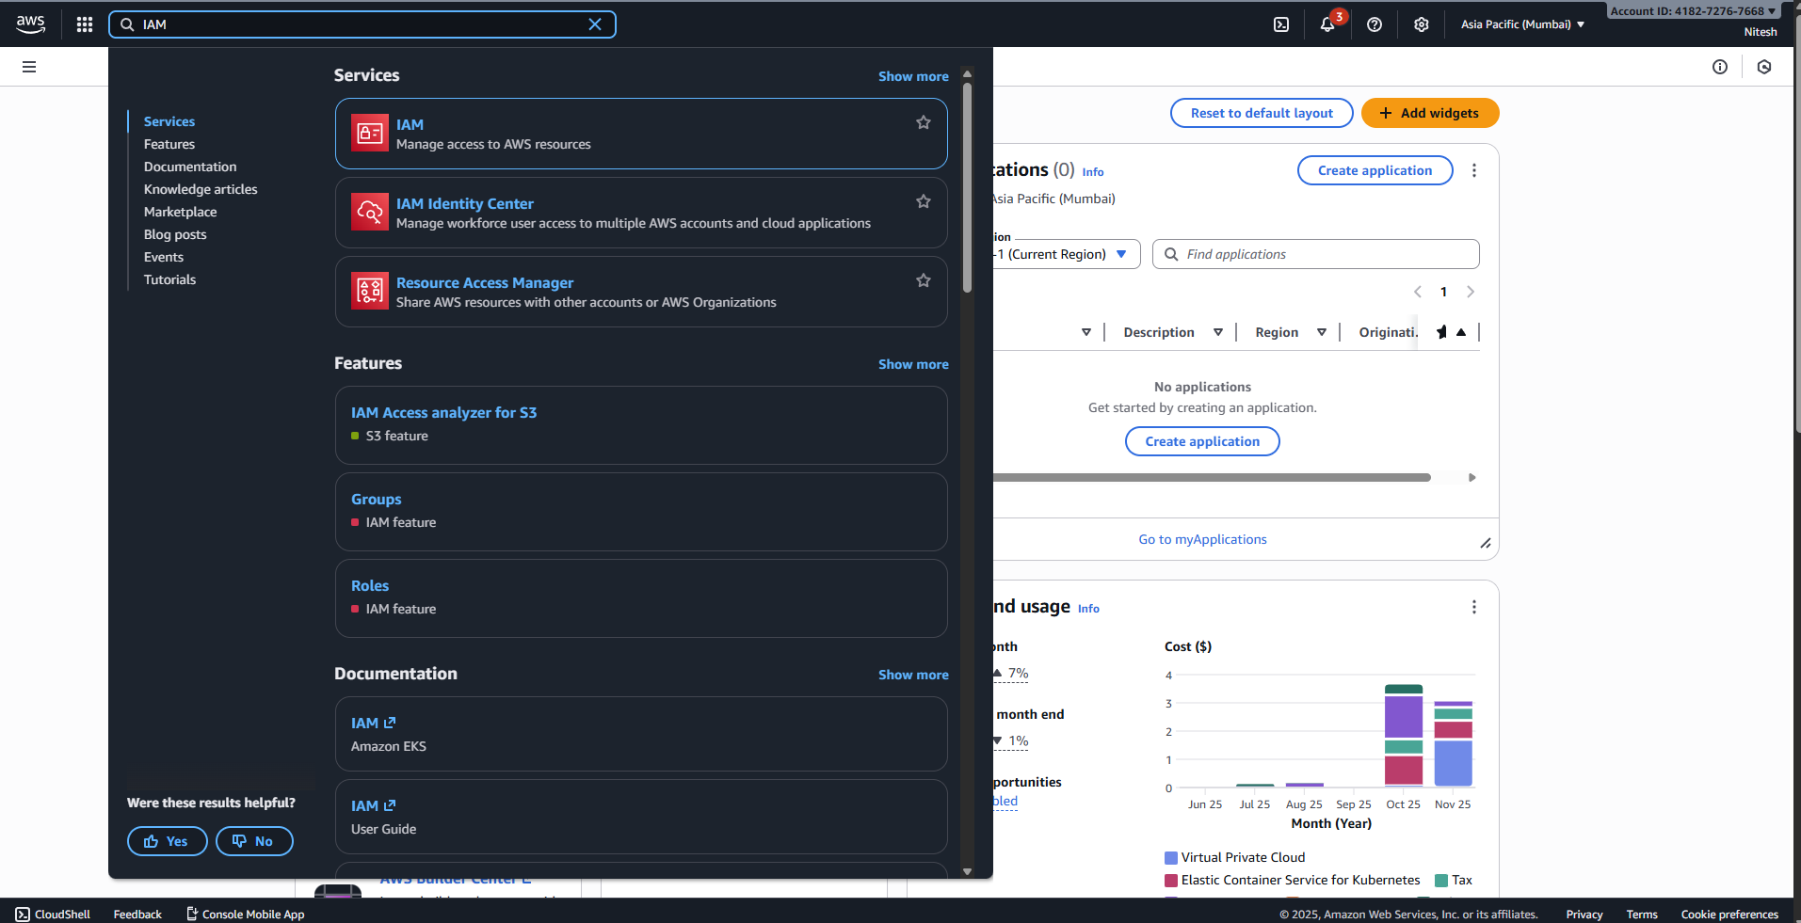

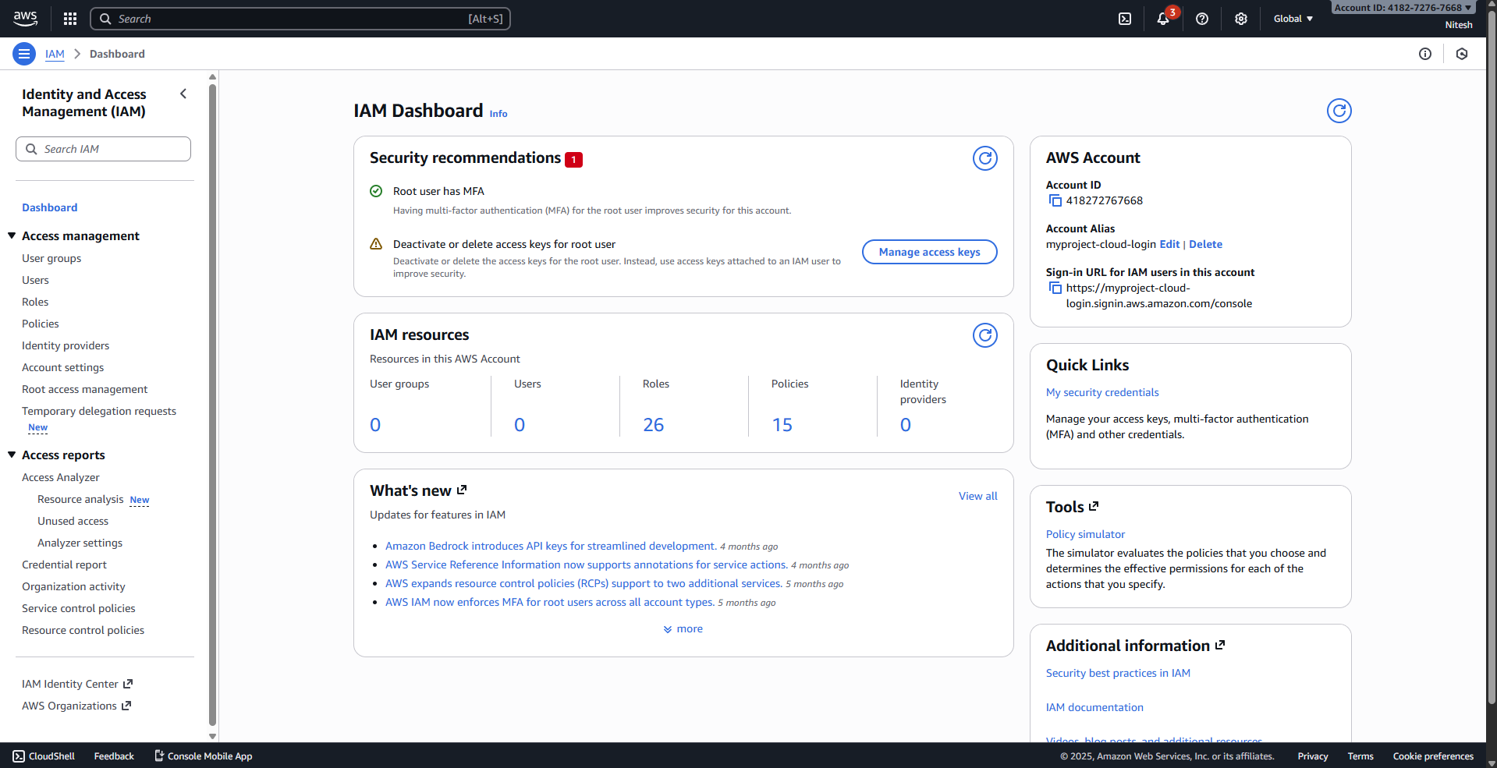

**Step 1.3: Creating the Administrator User** We initiated the user creation process to set up a new admin account named admin-yourname.

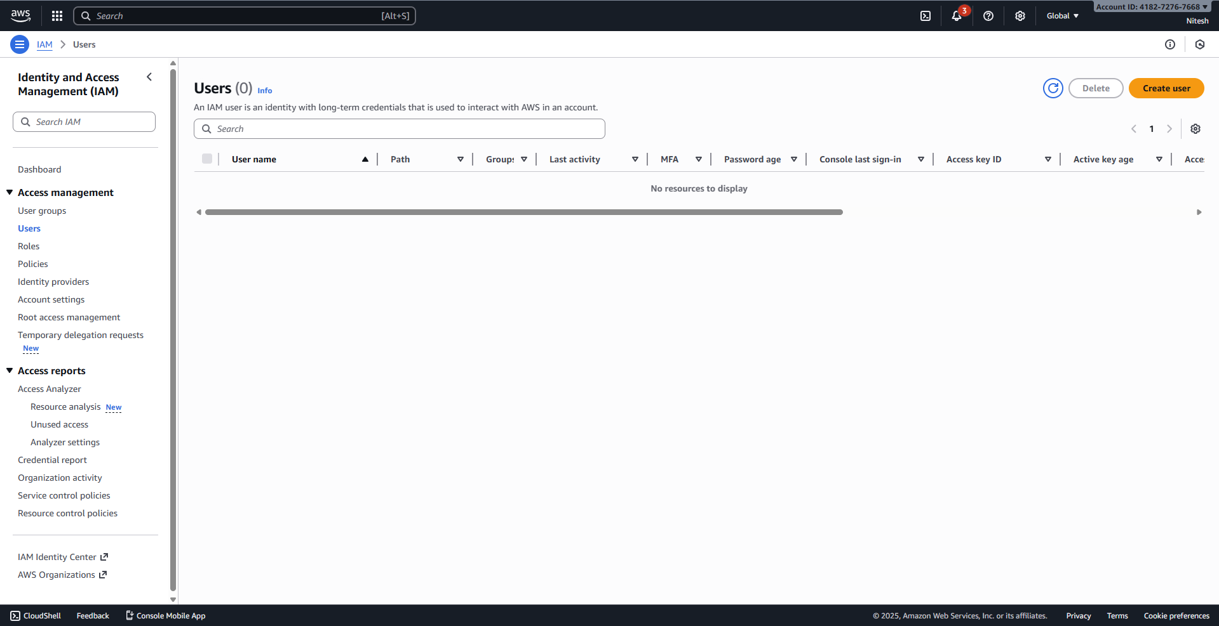

We configured the user details, enabling Management Console access and setting an auto-generated password that requires a reset upon first login.

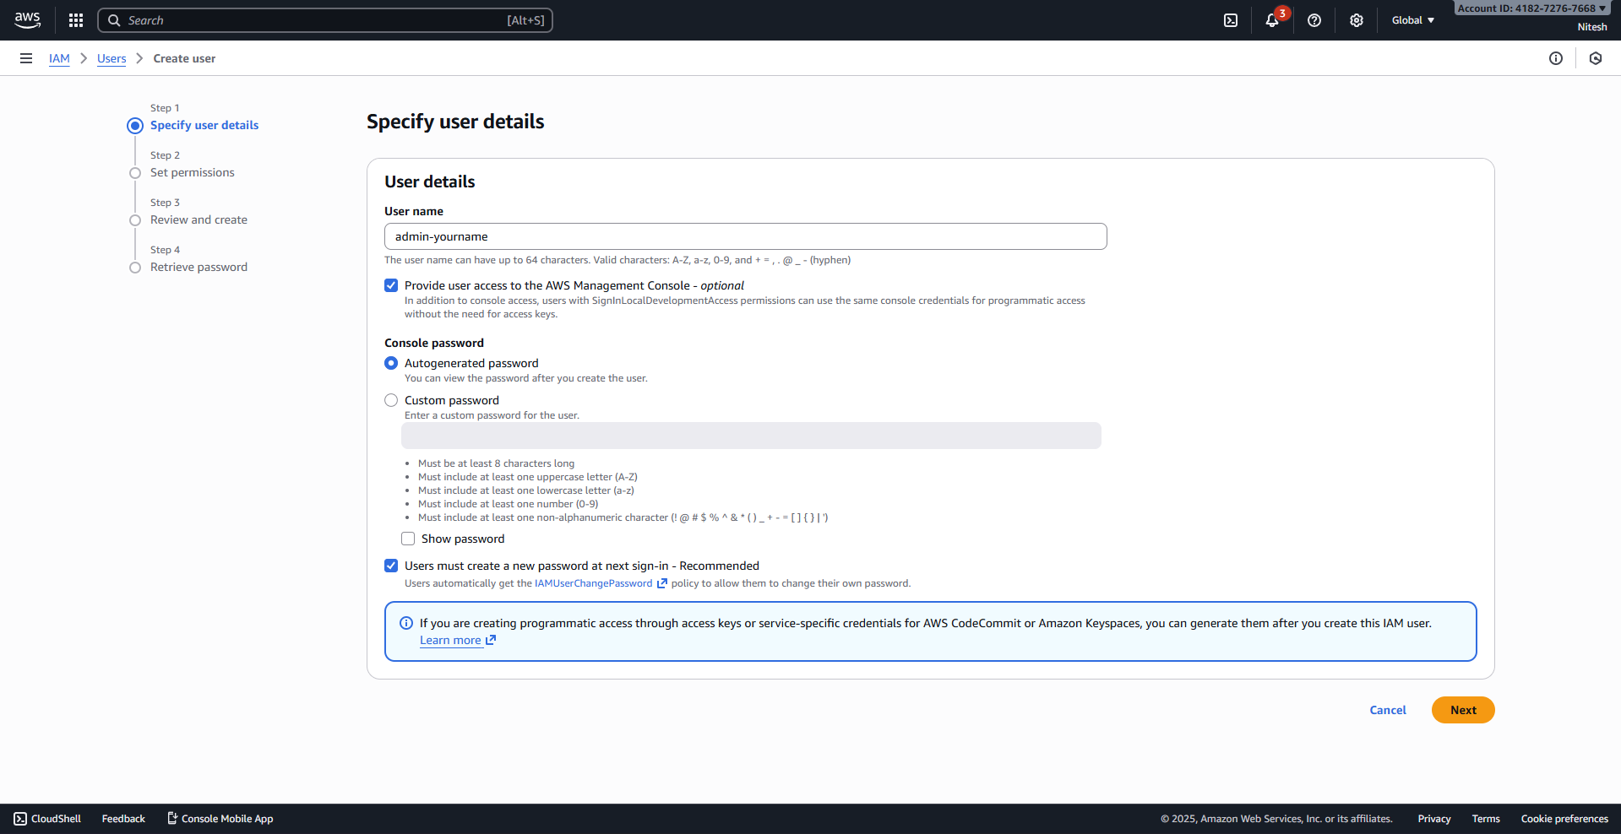

**Step 1.4: Assigning Permissions** To allow this user to build the monitoring dashboard, we attached the AdministratorAccess managed policy.

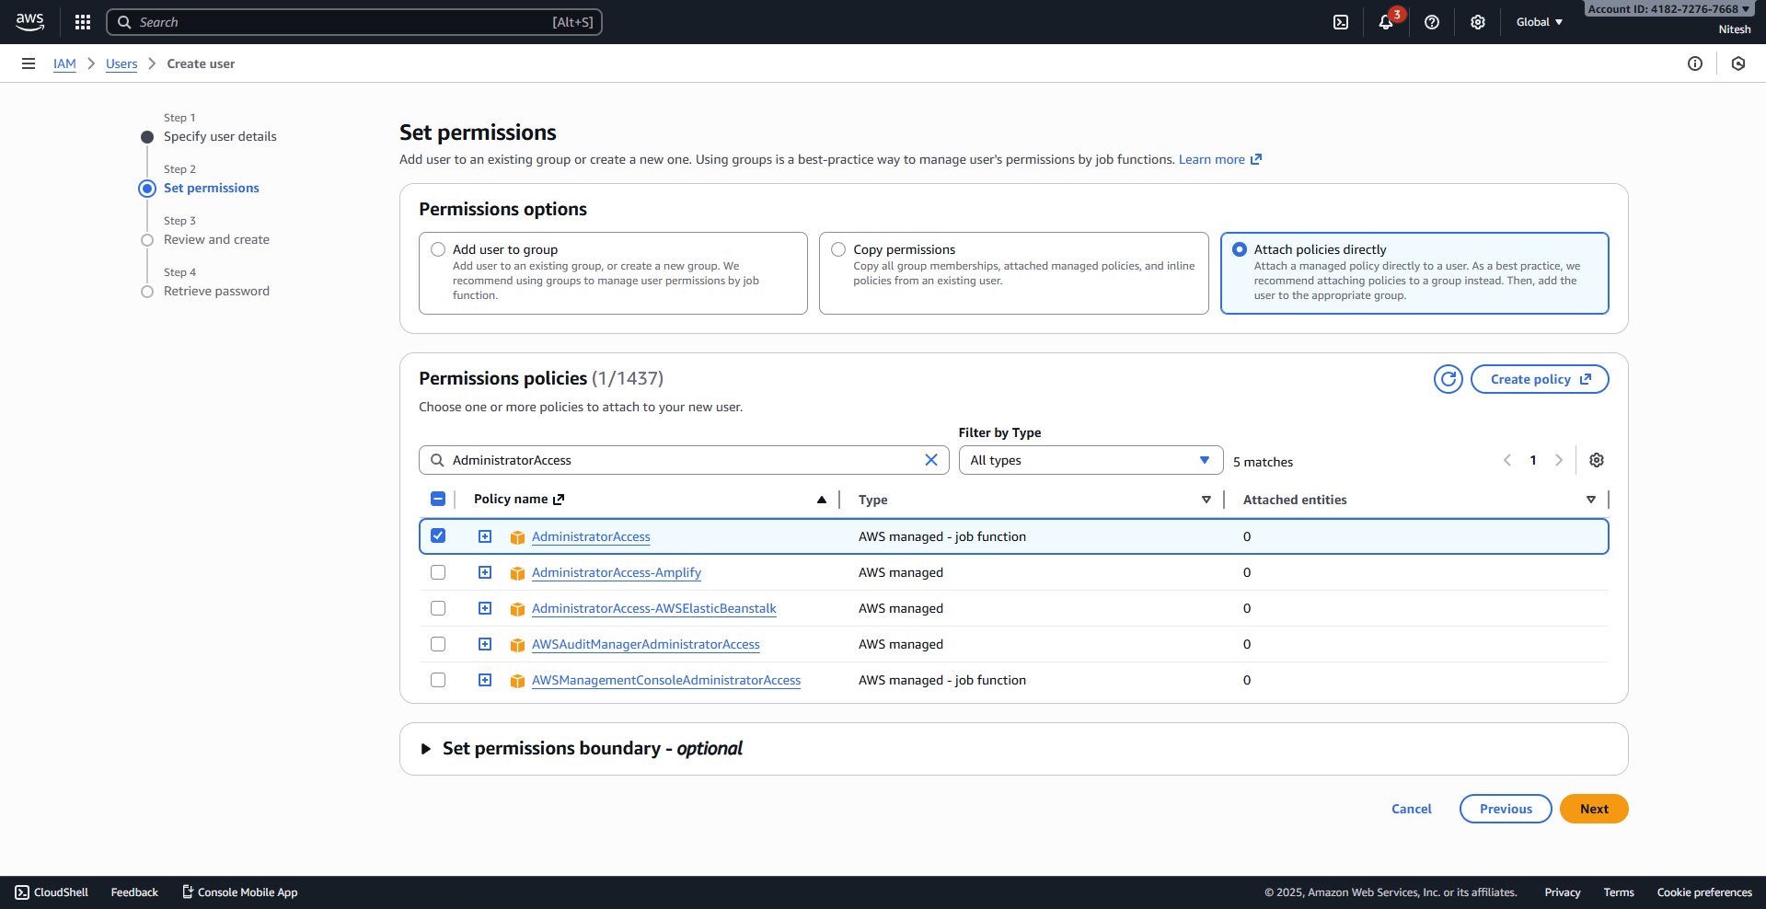

**Step 1.5: Review and Creation** We reviewed the user details and permissions to ensure accuracy before 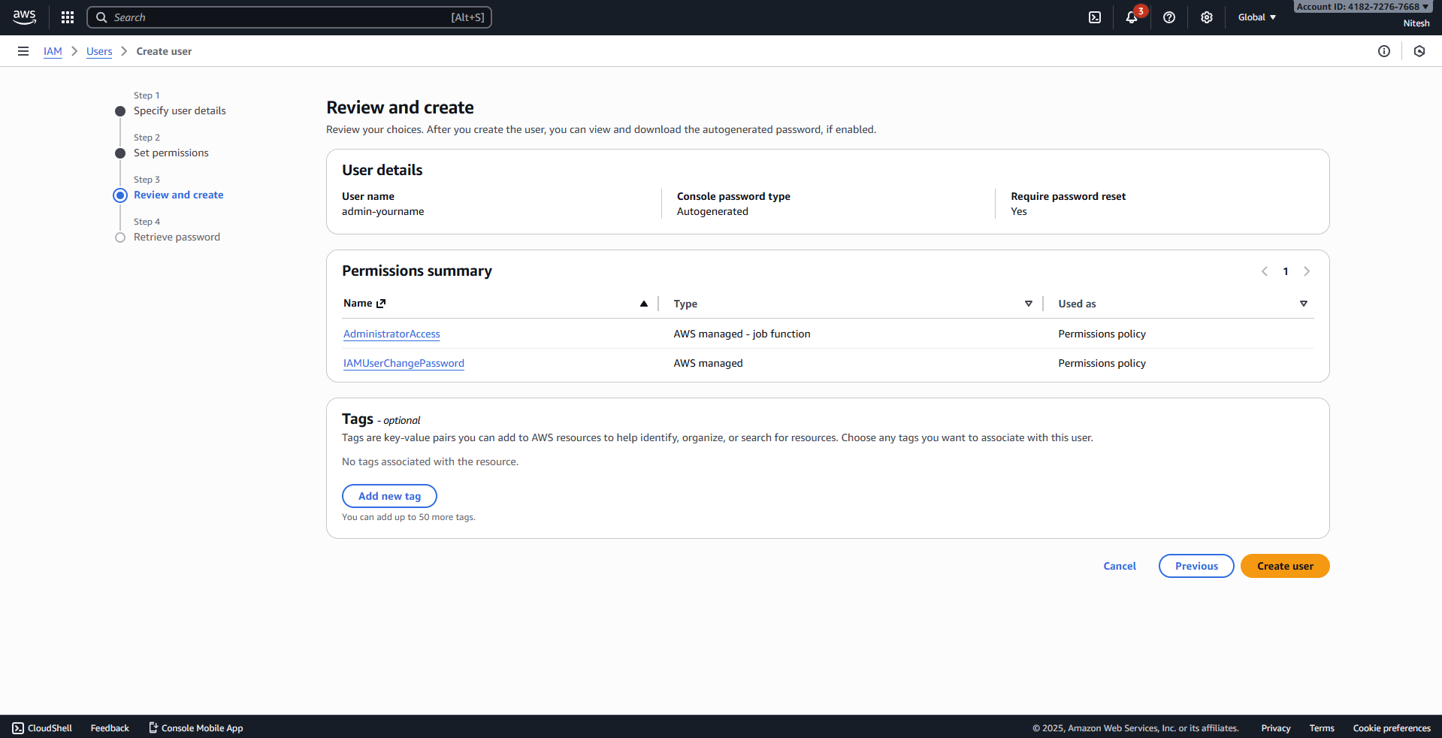

Upon success, AWS provided the console sign-in URL and the one-time password.

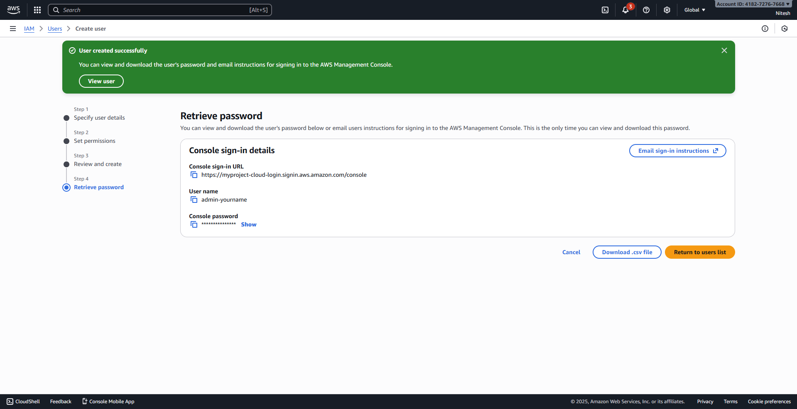

**Step 1.6: Verifying Access & Password Reset** We tested the new credentials by logging in via the specific sign-in URL.

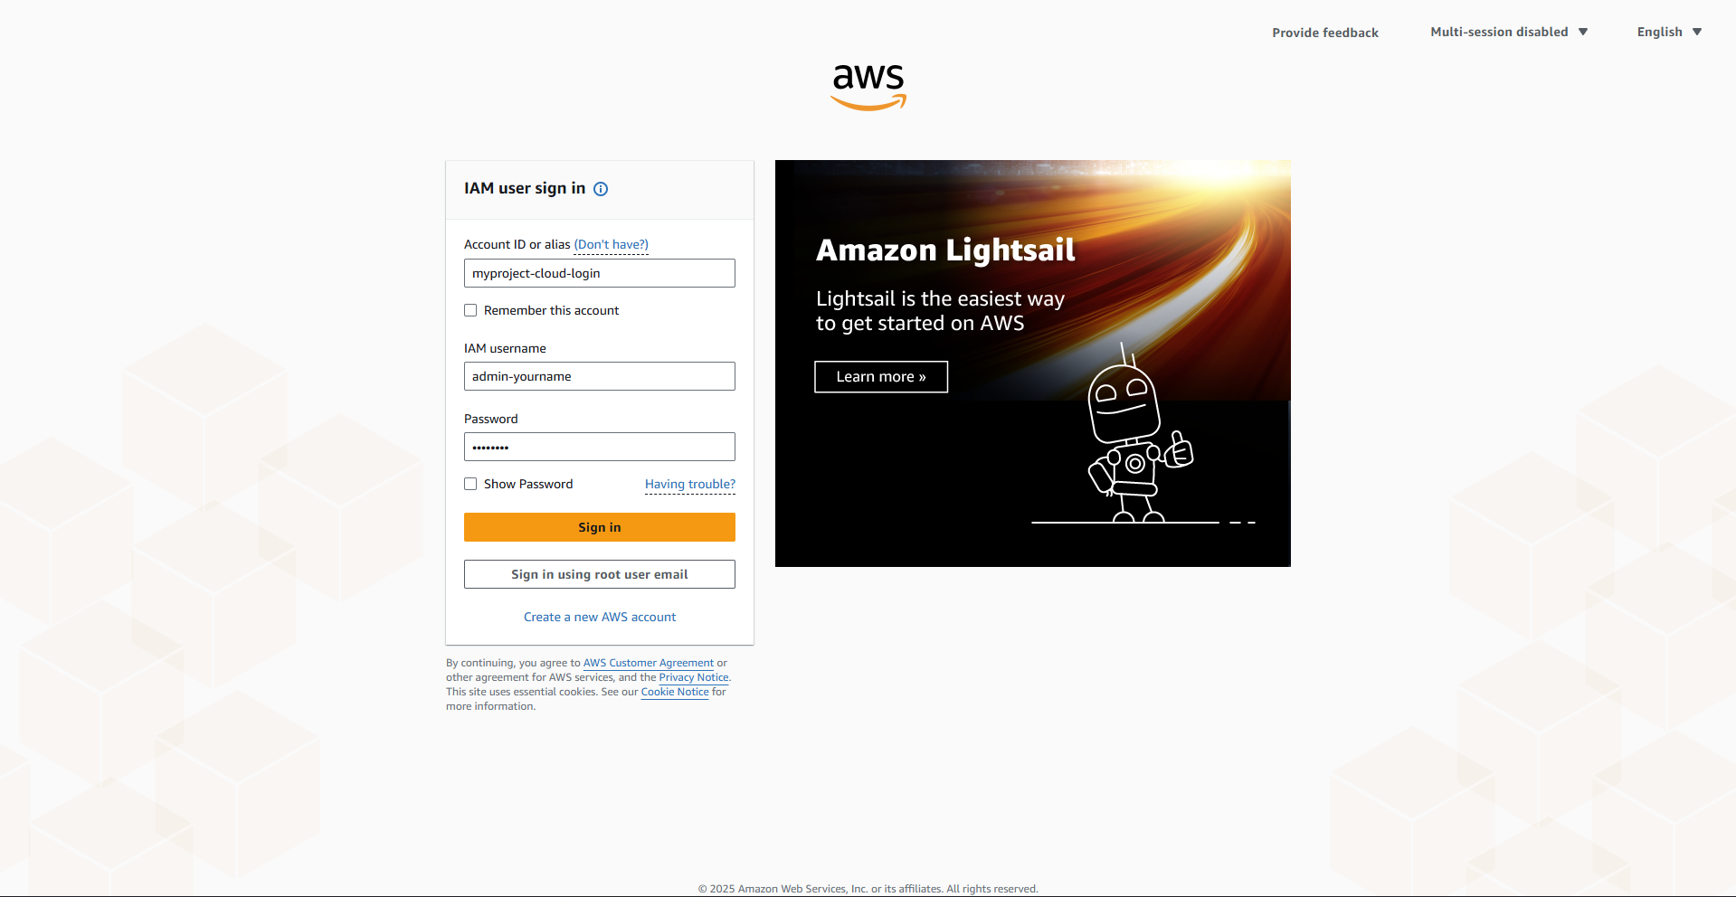

The system prompted for a password change.

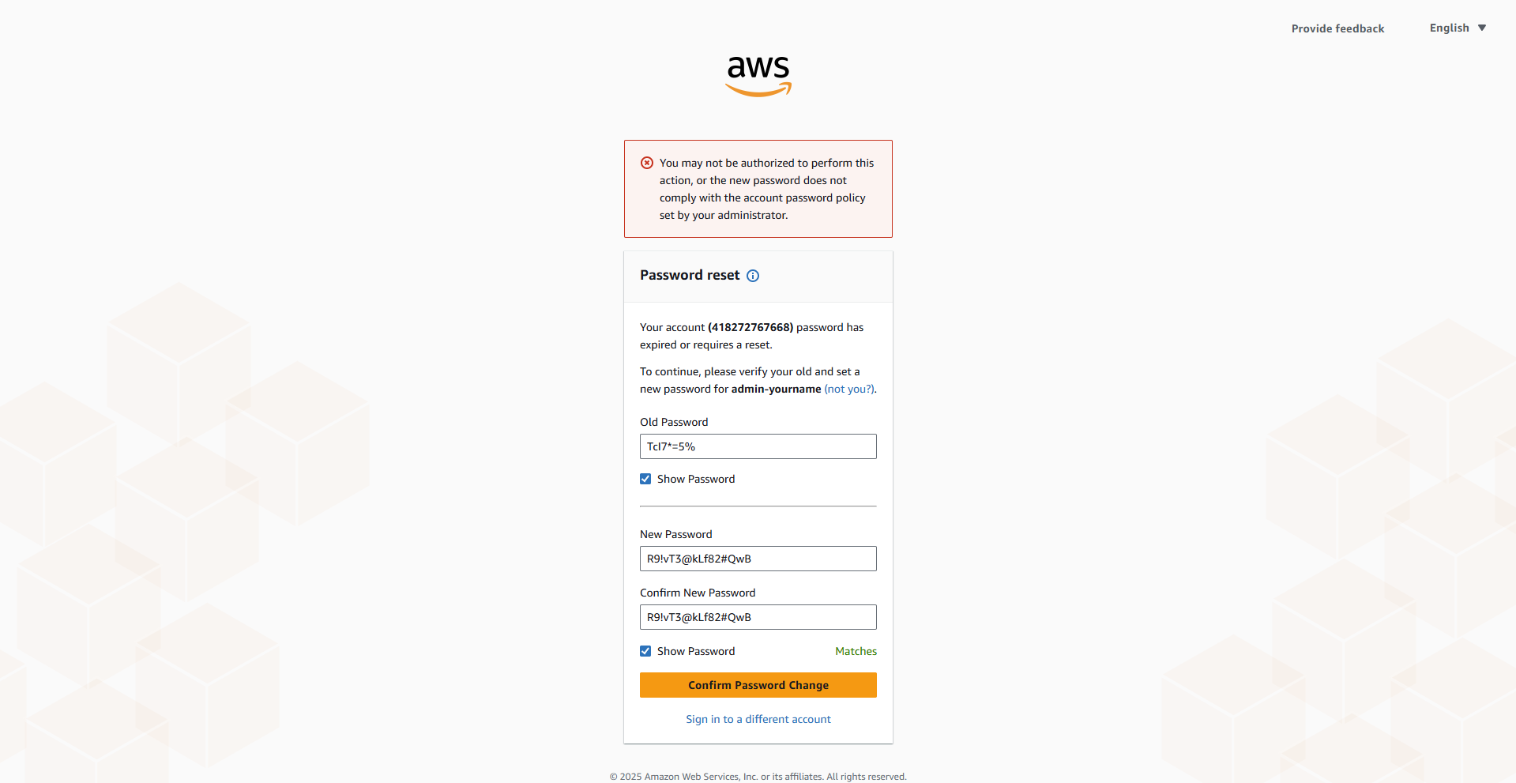

We successfully updated the password, completing the secure setup.

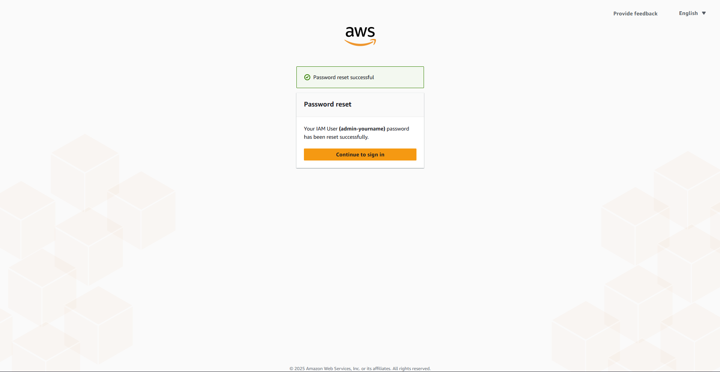

**Step 1.7: Secure Admin Login** We are now logged in as the new Administrator (visible in the top right corner), ready to build infrastructure.

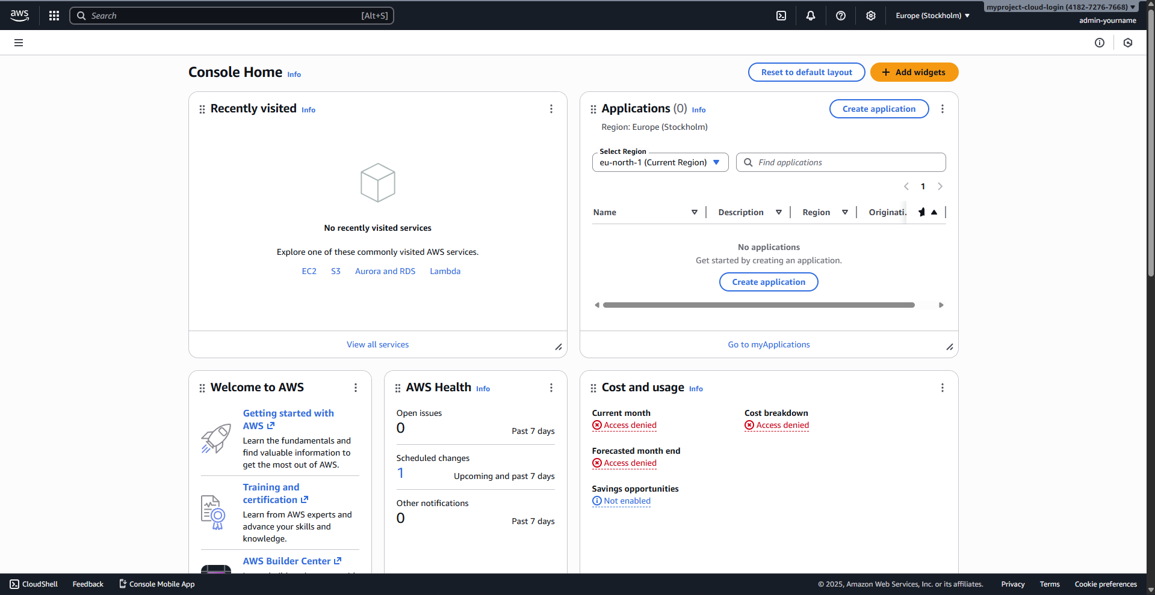

### Phase 2: Network Infrastructure (VPC)

With a secure user, we proceeded to build the network foundation using Amazon VPC. We used the "VPC and more" wizard to simplify the creation of subnets, route tables, and gateways.

**Step 2.1: Accessing VPC Service** We searched for the VPC service in the console.

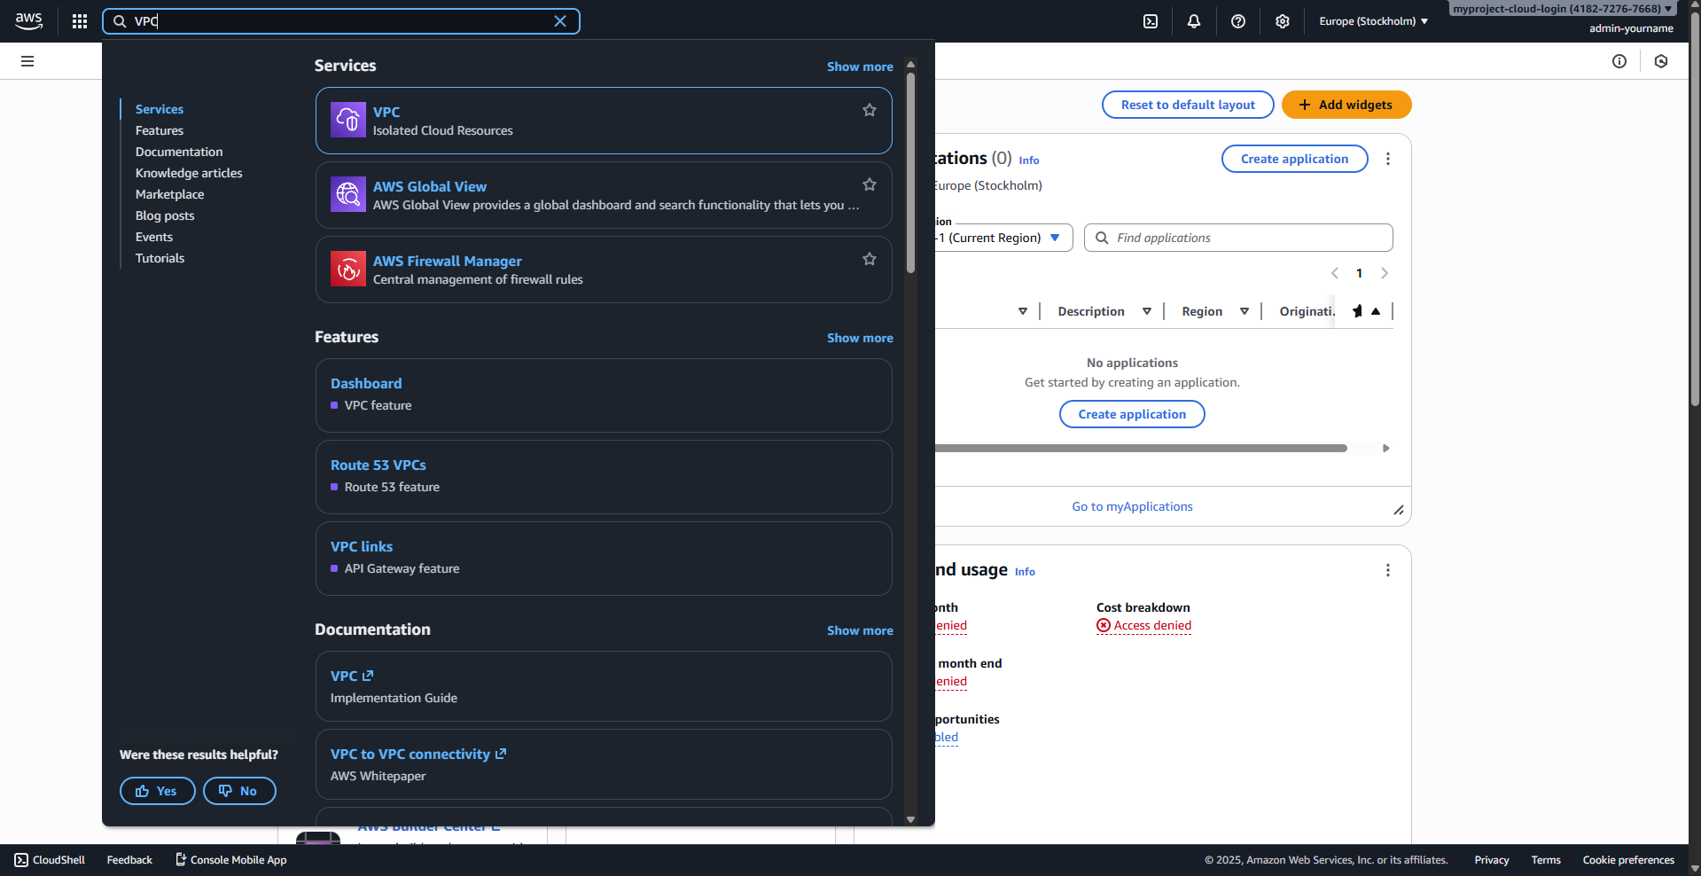

We accessed the VPC Dashboard to begin.

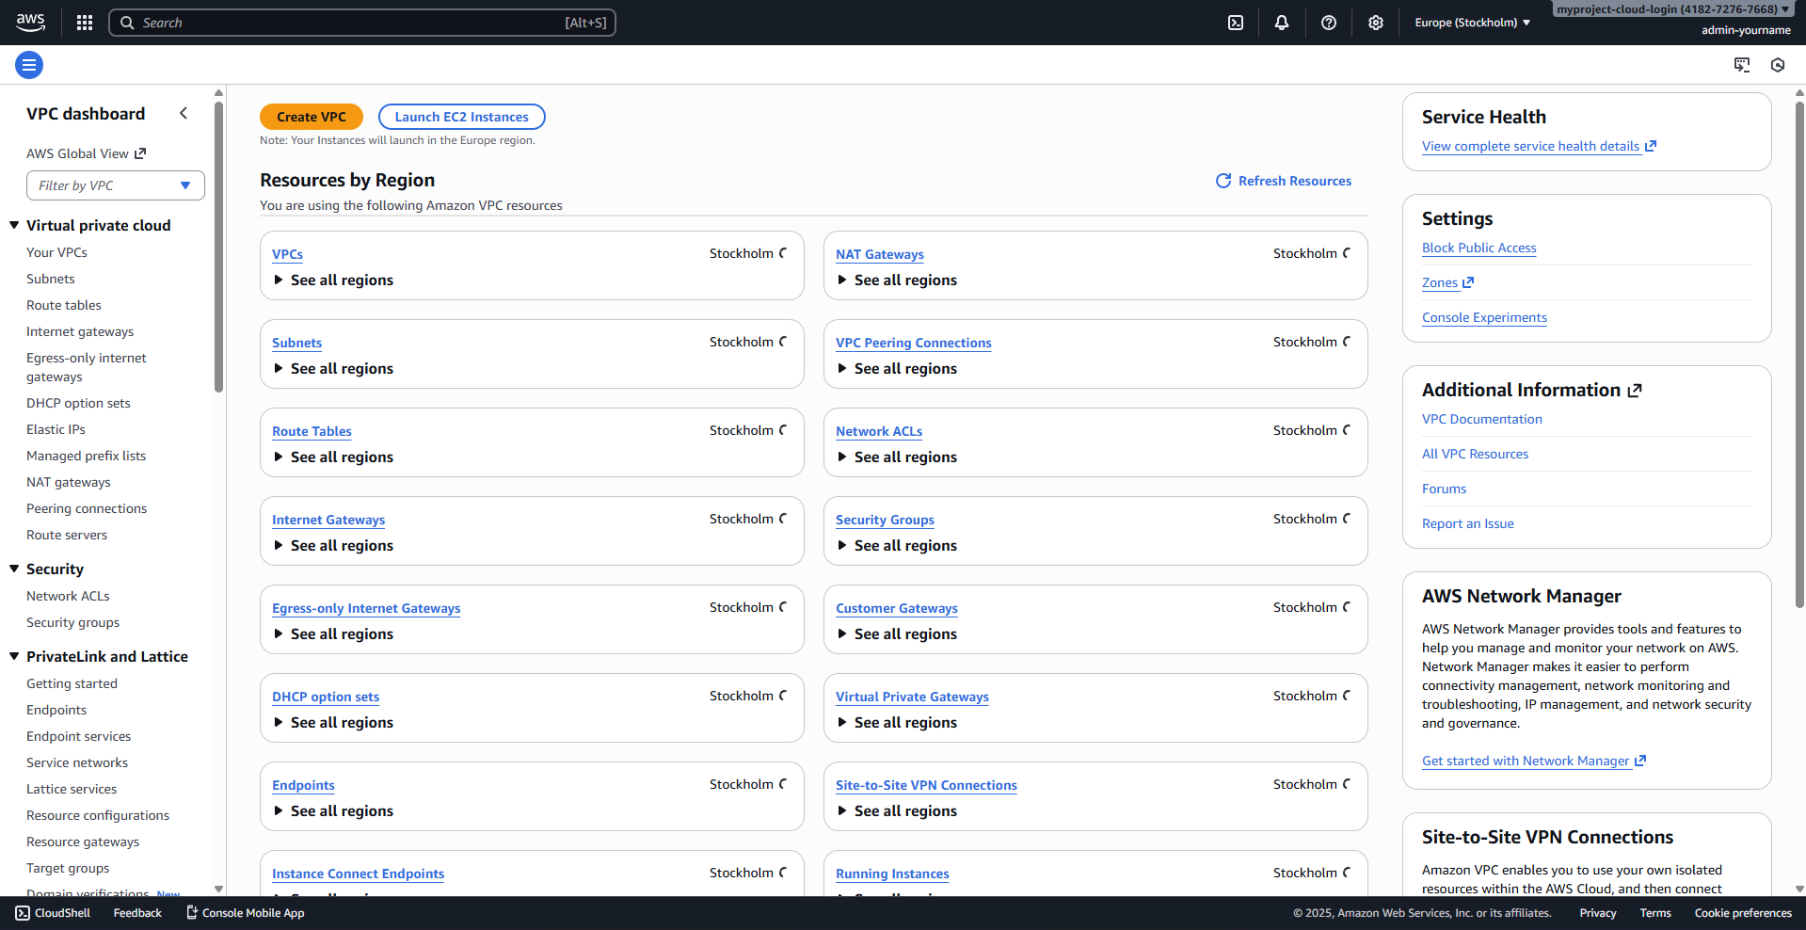

**Step 2.2: VPC Configuration** We selected the "Create VPC" option and chose "VPC and more" to auto-generate the network topology. We named the project MonitorProject and defined the IPv4 CIDR block as 10.0.0.0/16.

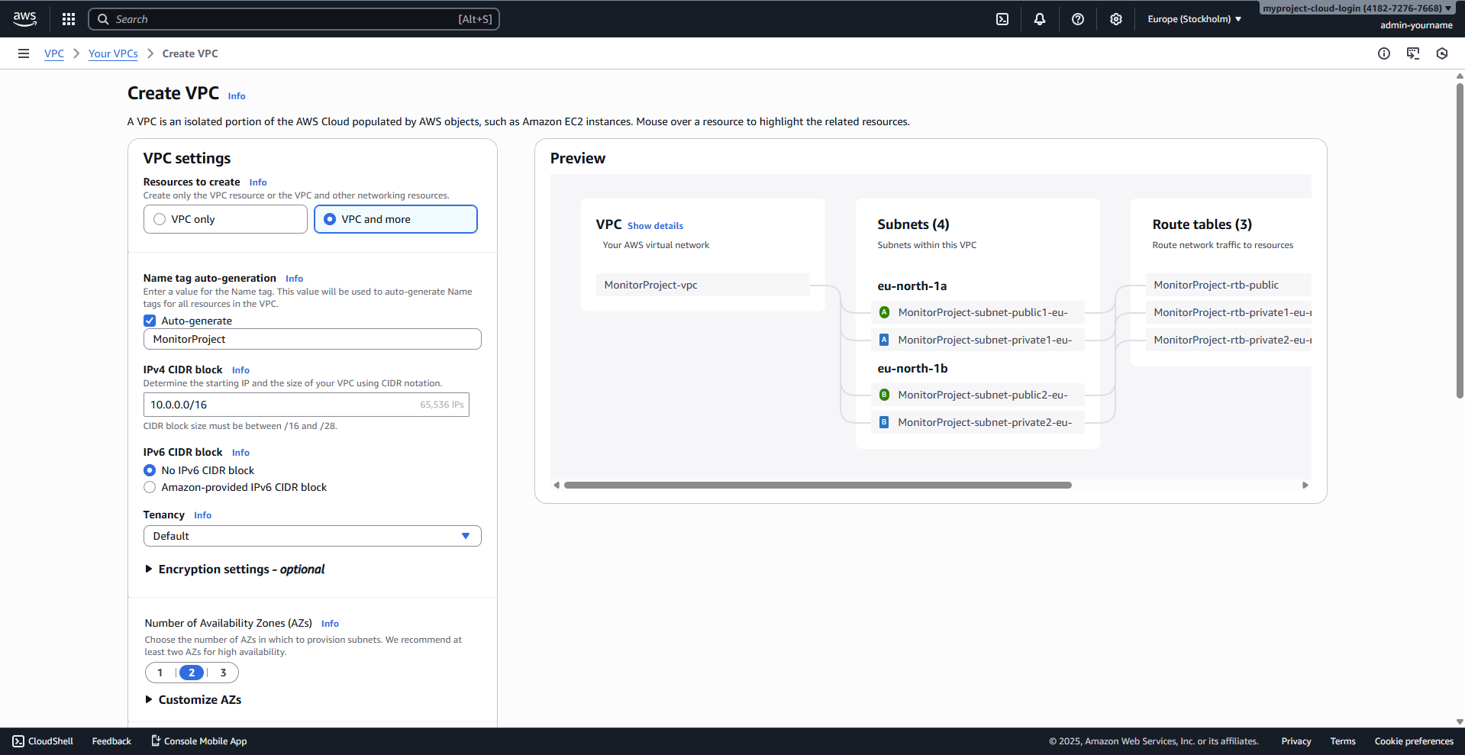

**Step 2.3: Subnet & Availability Zone Preview** We configured the VPC to span 2 Availability Zones (AZs) with 2 Public and 2 Private subnets. The console provided a visual preview of the resource map connecting the subnets to the Route Tables.

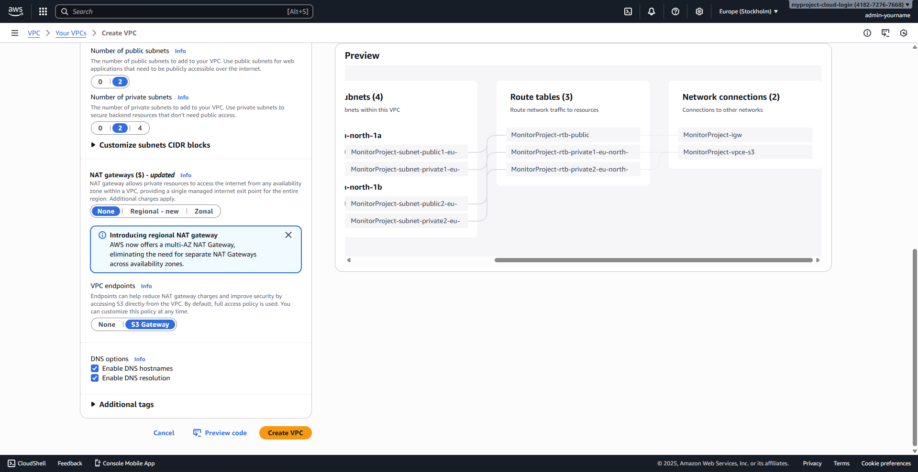

**Step 2.4: Provisioning Network Resources** We initiated the creation process. AWS automatically provisioned the VPC, Subnets, Internet Gateway, and Route Tables in parallel.

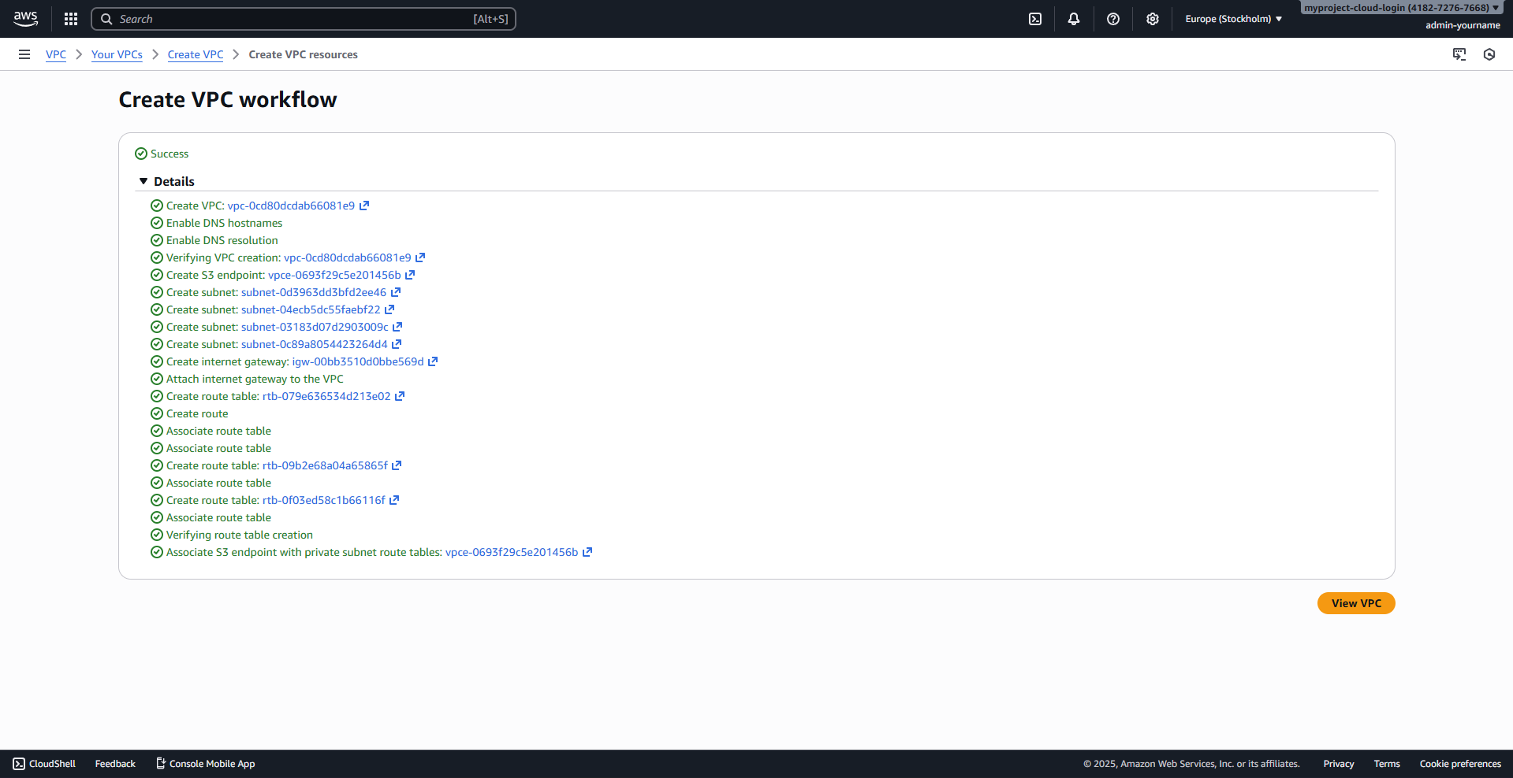

**Step 2.5: Verifying Network Topology** We reviewed the created VPC resource map to ensure the public and private subnets were correctly associated with their respective route tables and the Internet Gateway.

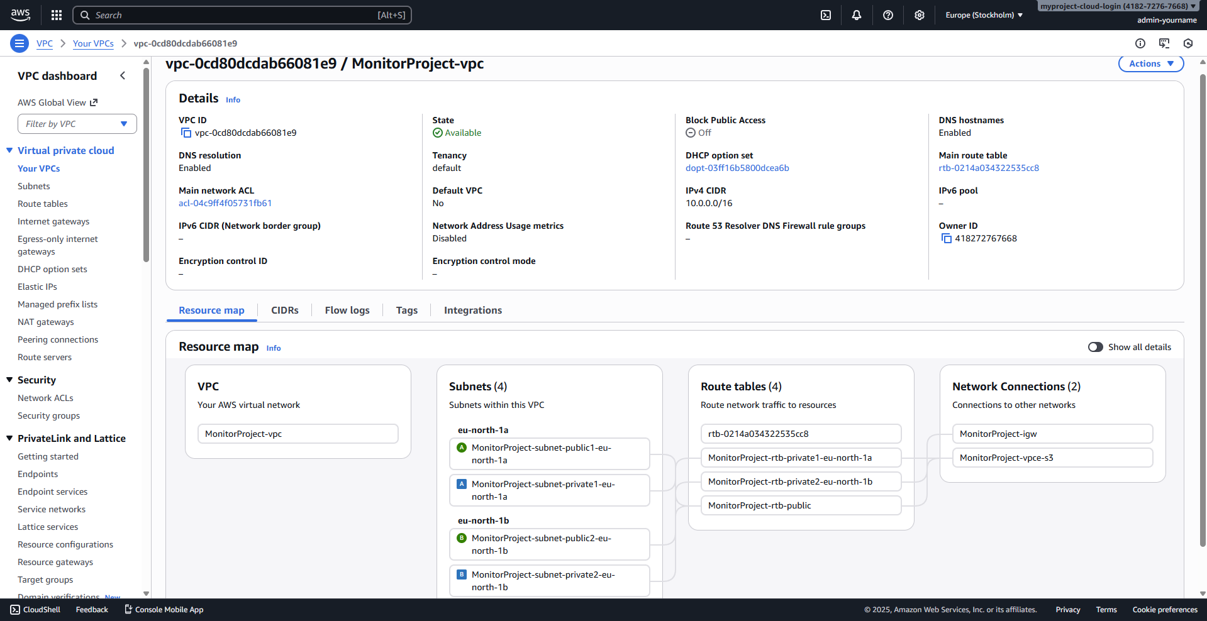

### Phase 3: Compute Infrastructure (EC2)

Next, we prepared to launch the virtual servers that will host our application.

**Step 3.1: Accessing EC2** We navigated to the EC2 service to manage our compute resources.

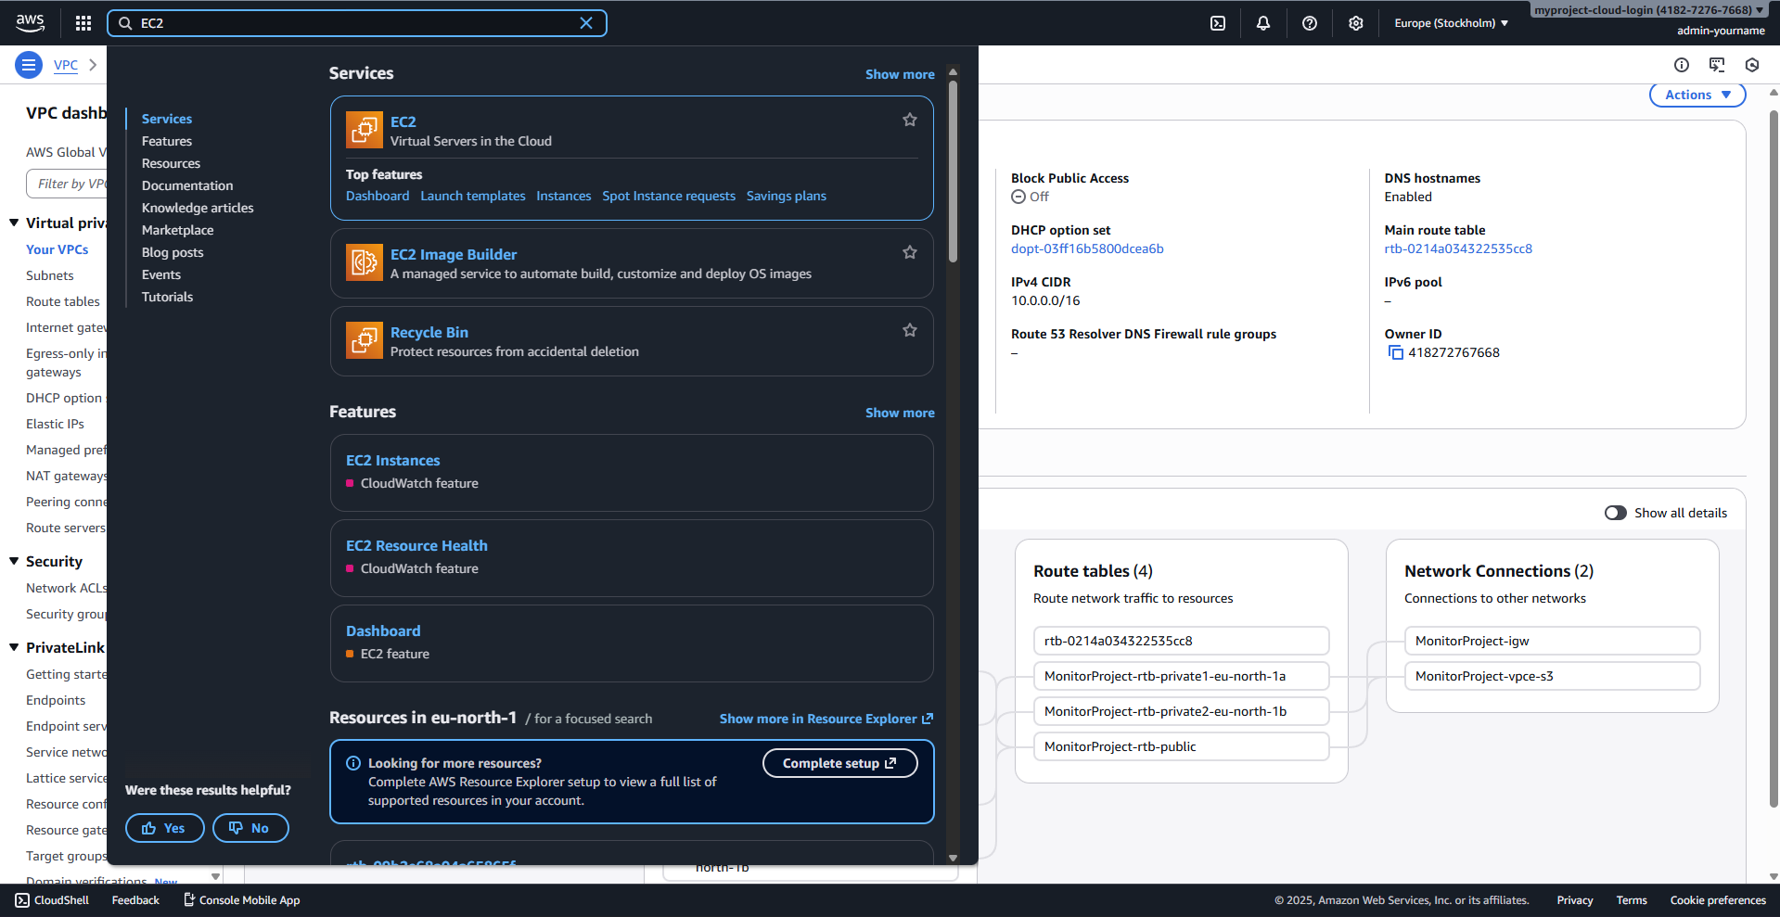

**Step 3.2: EC2 Dashboard & Launch Wizard** We reviewed the EC2 Dashboard and clicked "Launch Instance". We named the server MyWebServer and selected the **Amazon Linux 2023** AMI for a stable, secure operating system.

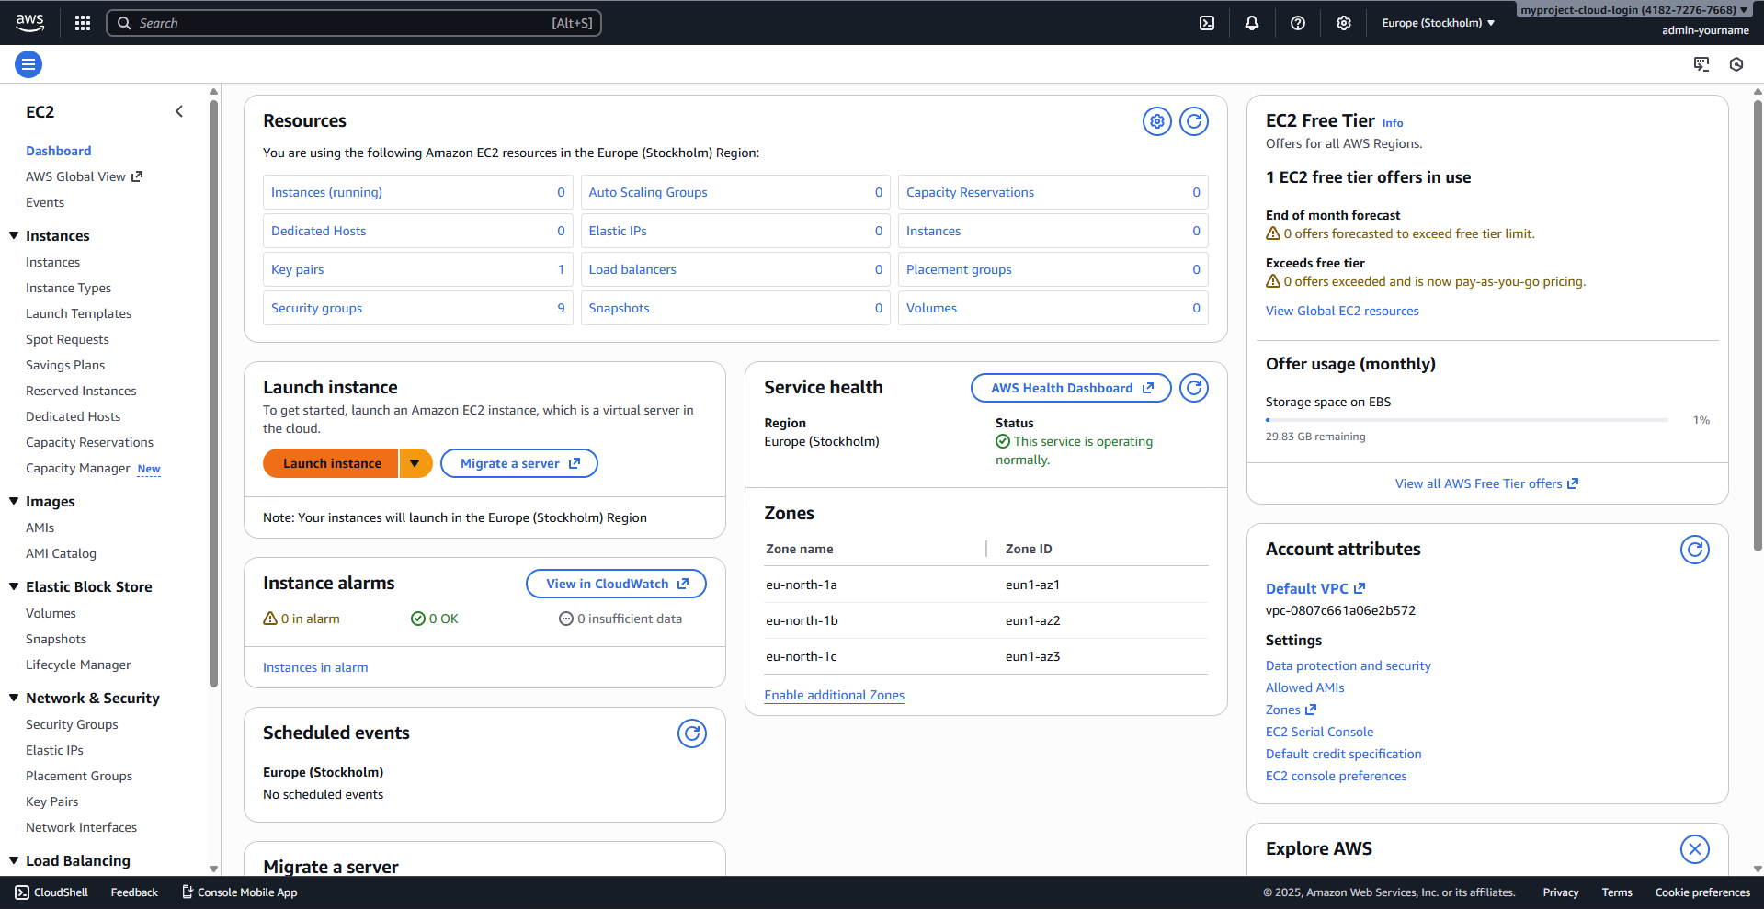

**Step 3.3: Instance Type & Credentials** We selected the t3.micro instance type to stay within the Free Tier. To ensure secure SSH access, we created a new key pair named my-project-key.

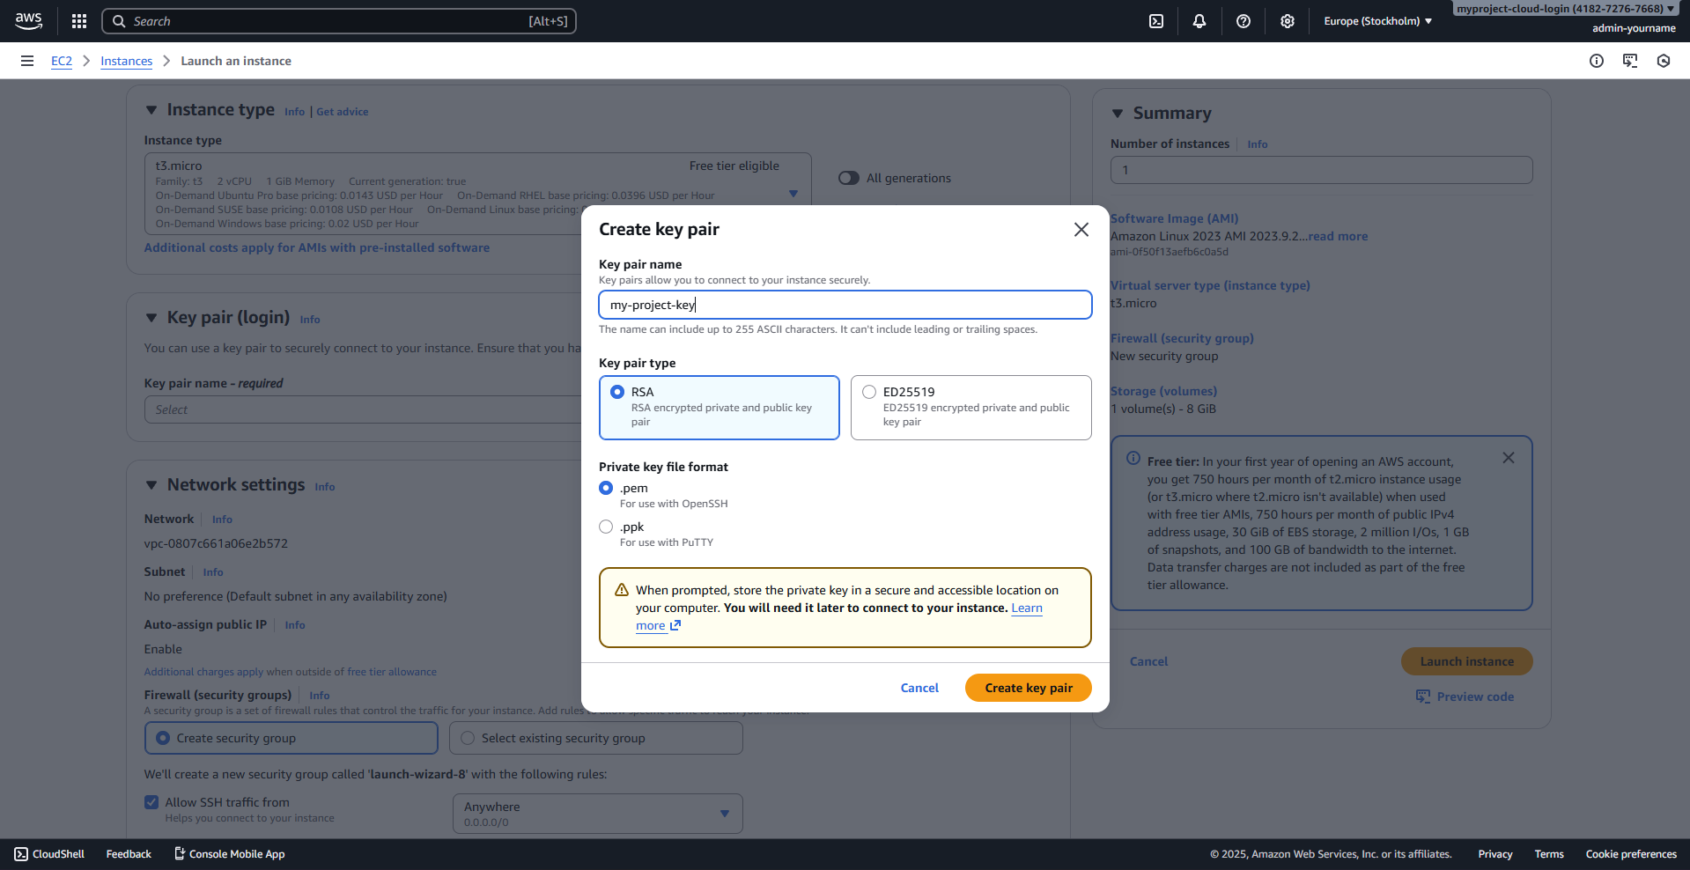

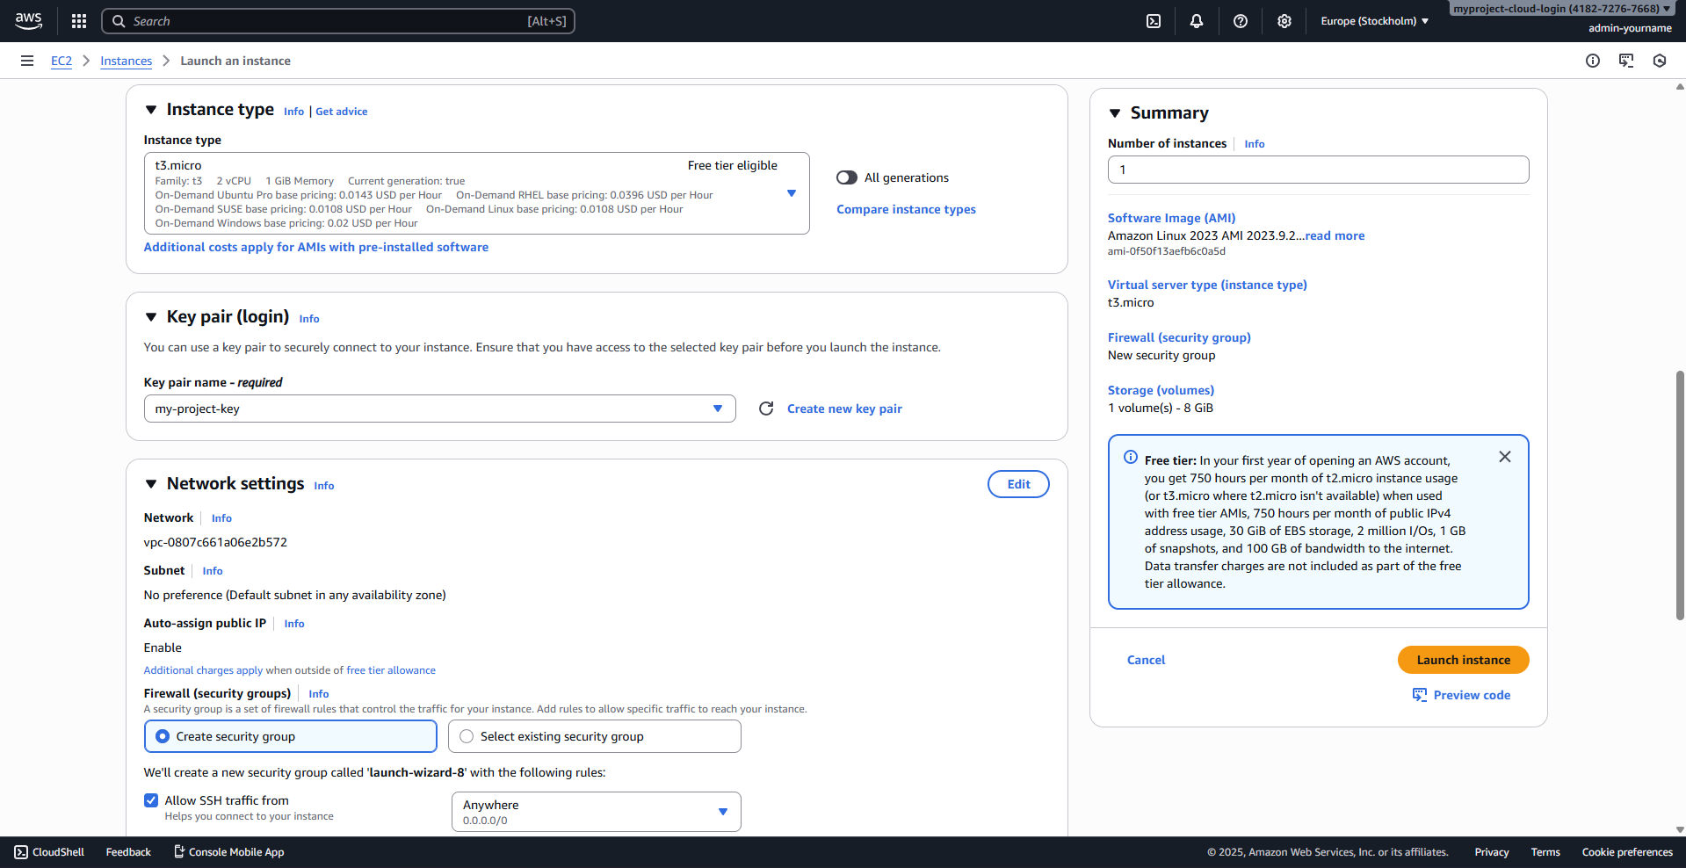

**Step 3.4: Network Configuration** This was a critical step. We placed the instance inside our custom MonitorProject-vpc and specifically into the **Public Subnet** (subnet-public1). We enabled "Auto-assign public IP" to ensure reachability. We also created a new Security Group (launch-wizard-8) allowing inbound SSH (port 22) traffic.

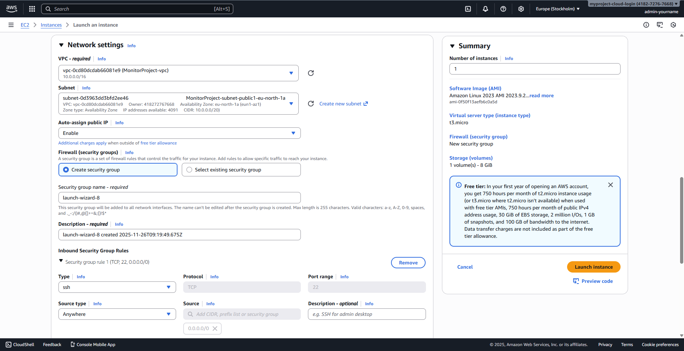

**Step 3.5: Storage Configuration** We provisioned 8 GiB of General Purpose SSD (gp3) storage for the root volume.

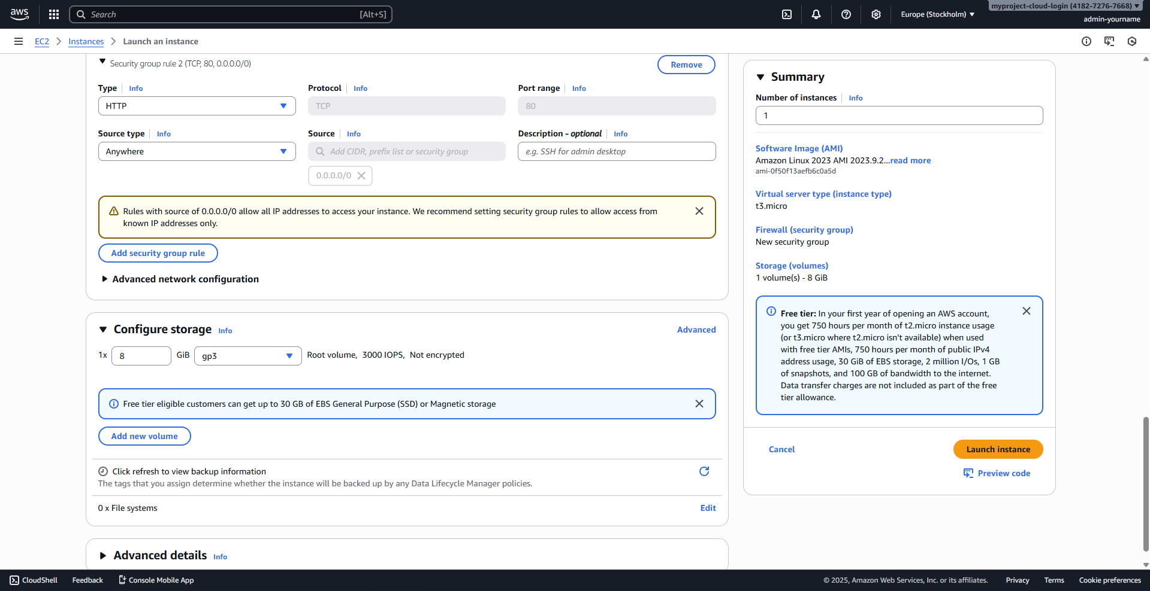

**Step 3.6: Launch & Verification** After reviewing the settings, we launched the instance. AWS confirmed the successful initiation.

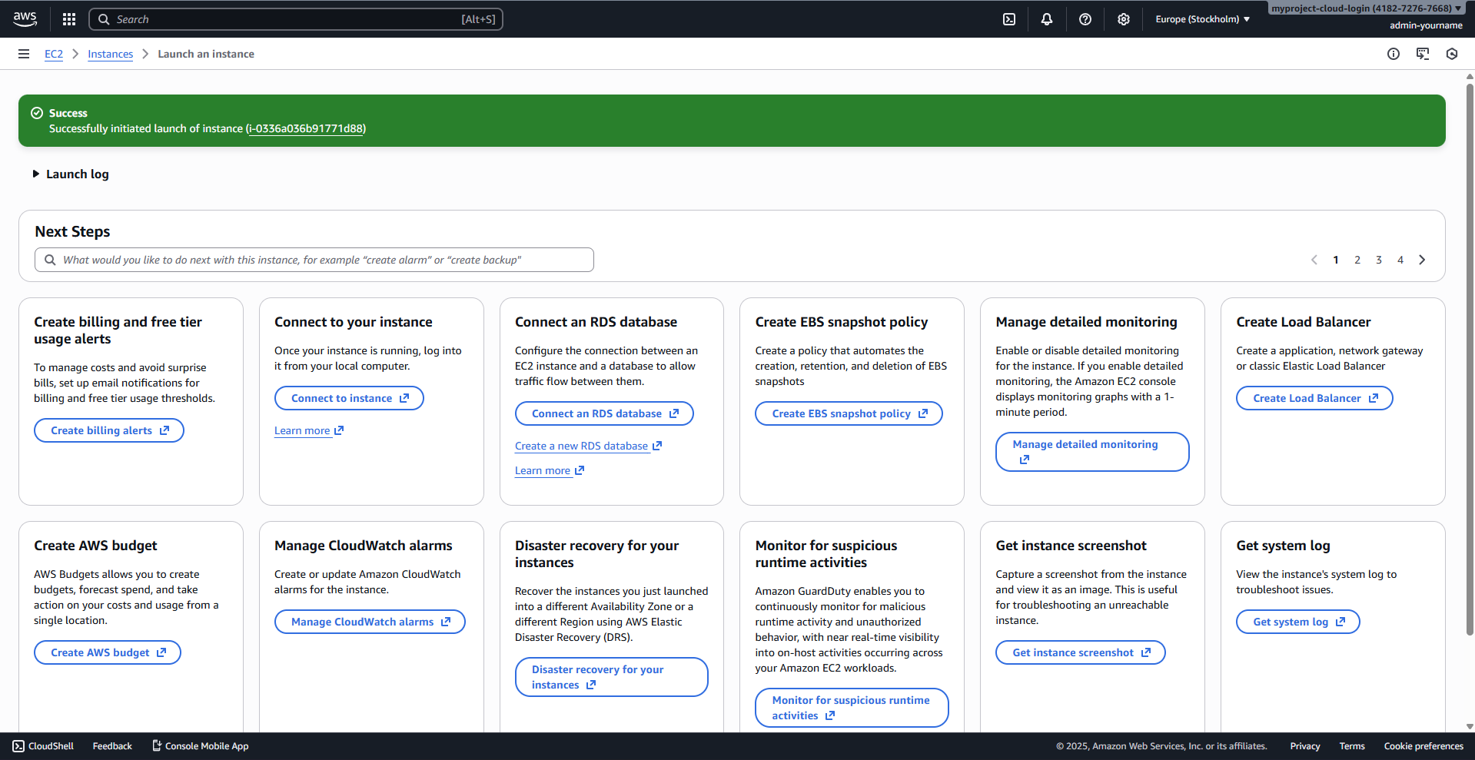

We returned to the Instances dashboard to confirm the server state. The MyWebServer instance was successfully "Running" and had passed its 2/2 status checks, indicating it is healthy and ready for monitoring.

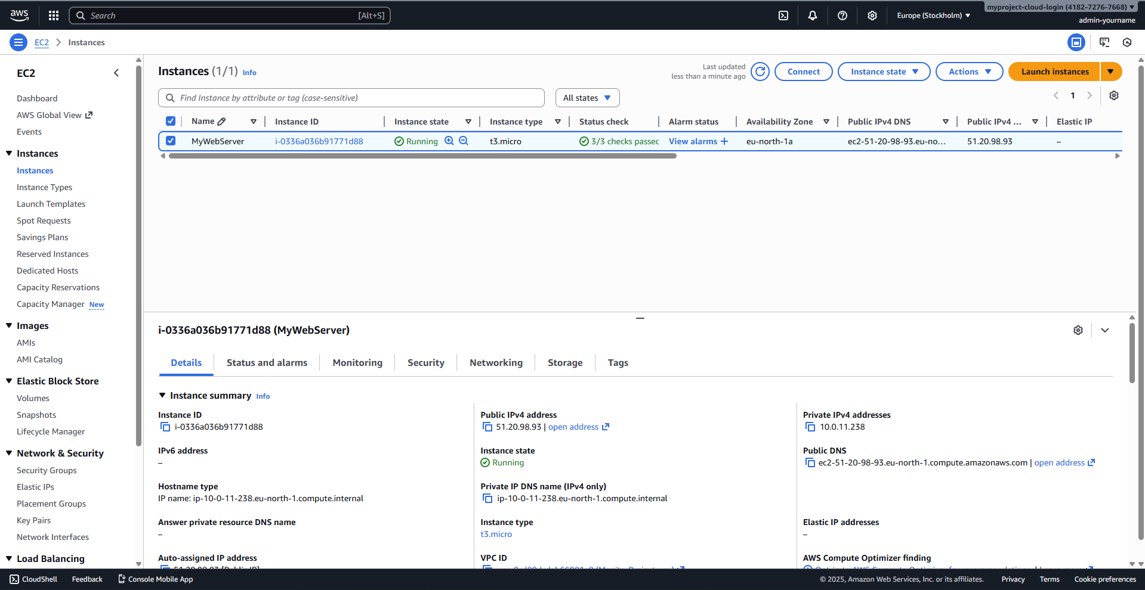

### Phase 4: Storage Infrastructure (S3)

We moved on to setting up object storage for our application logs.

**Step 4.1: Accessing S3 and Bucket Creation** We accessed the S3 Console to create a new bucket named monitoring-project-nitesh-date. We selected the **Europe (Stockholm)** region to match our VPC and EC2 resources.

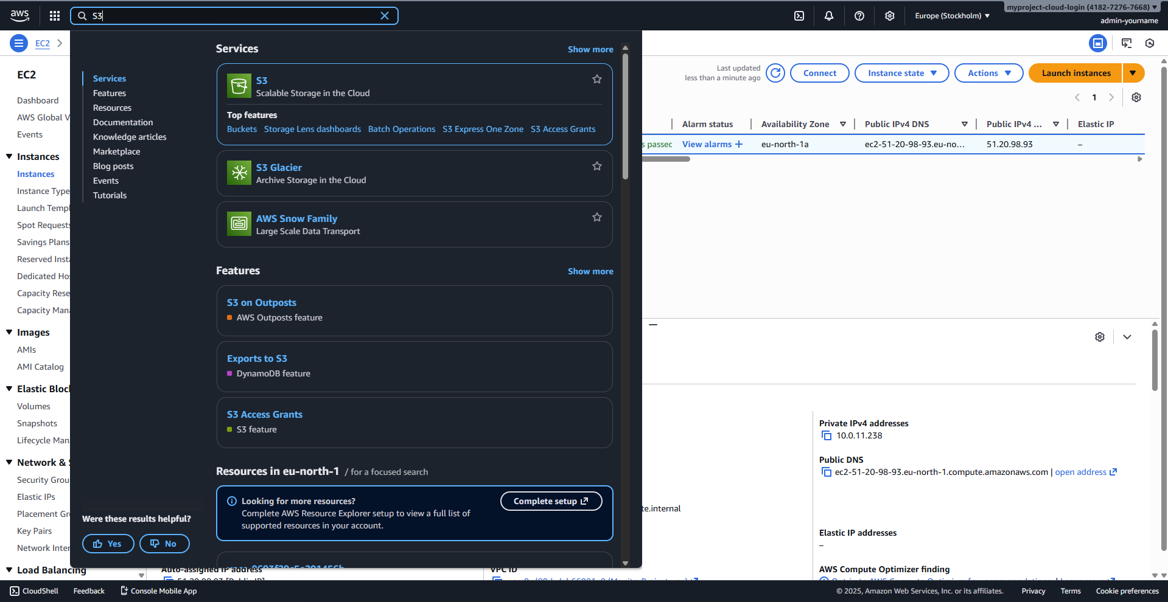

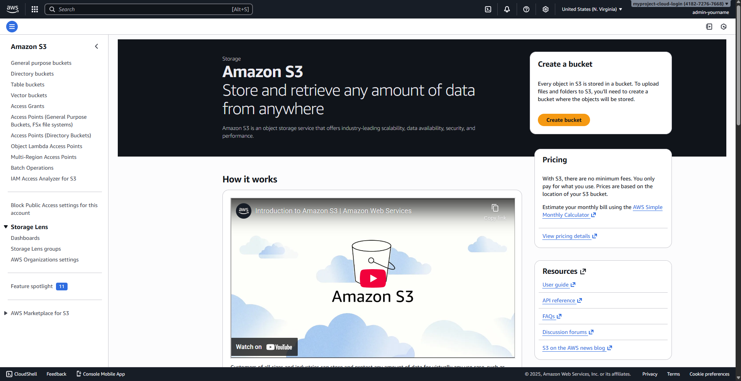

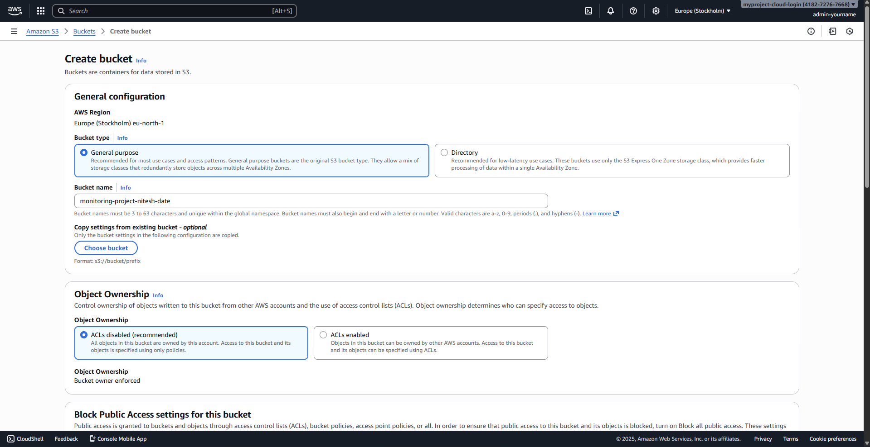

**Step 4.2: Security & Encryption Settings** We ensured that "Block all public access" was enabled to prevent unauthorized data exposure. For security, we enabled Server-side encryption with Amazon S3 managed keys (SSE-S3).

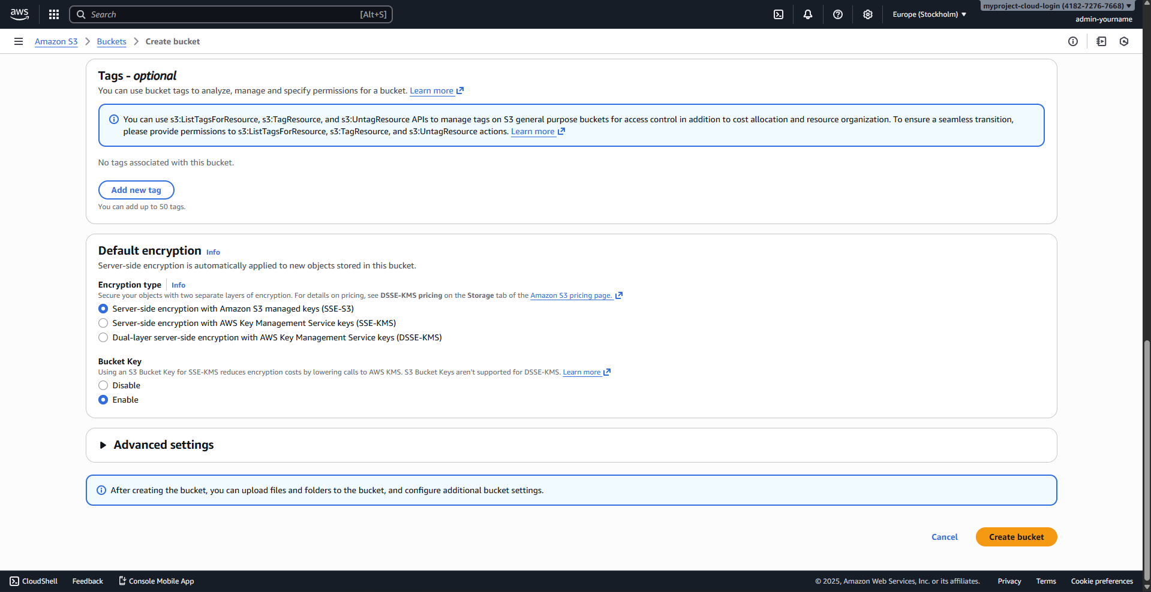

**Step 4.3: Bucket Verification** Once created, the bucket appeared in our dashboard. We opened the bucket to confirm it was ready for object storage.

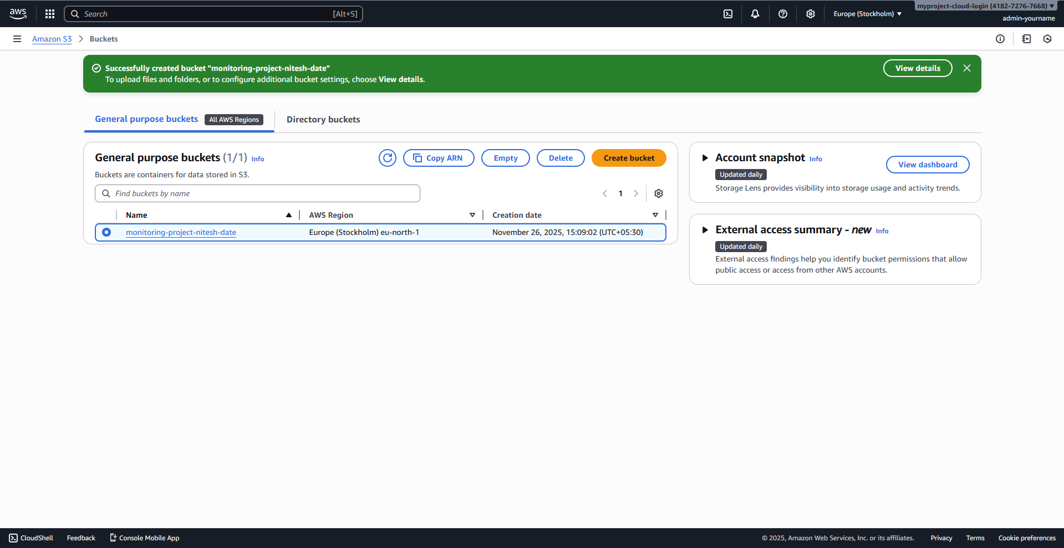

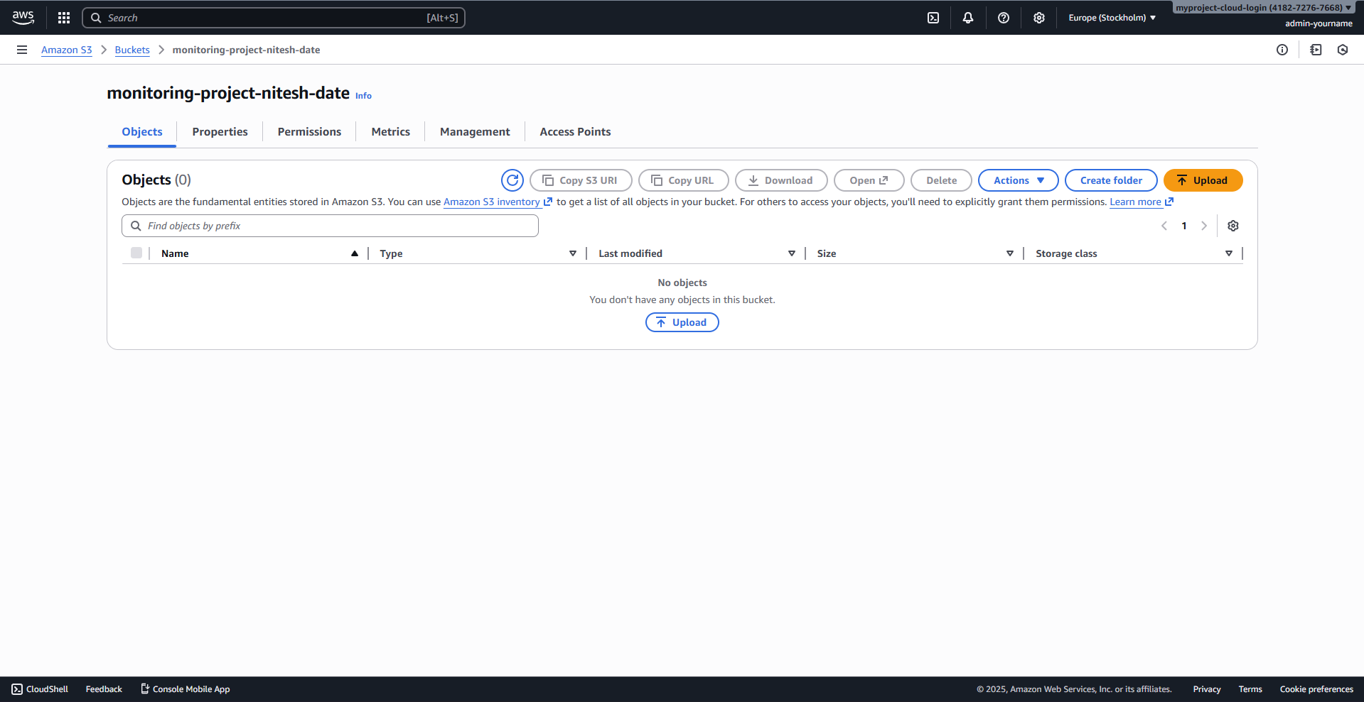

**Step 4.4: Data Upload Test** To verify functionality, we manually uploaded a test file (Mountain.jpg). The upload was successful, confirming that our storage layer is active.

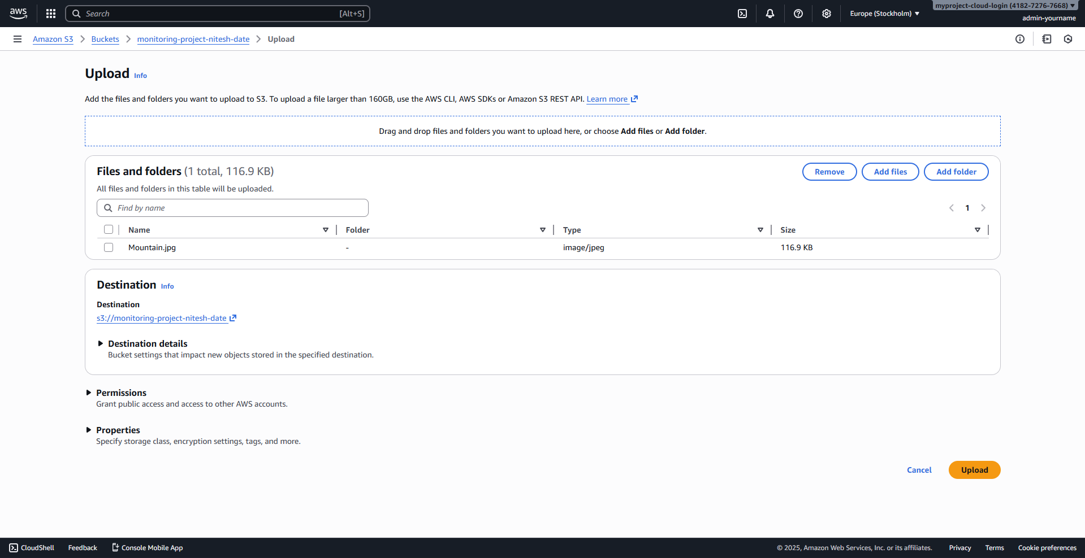

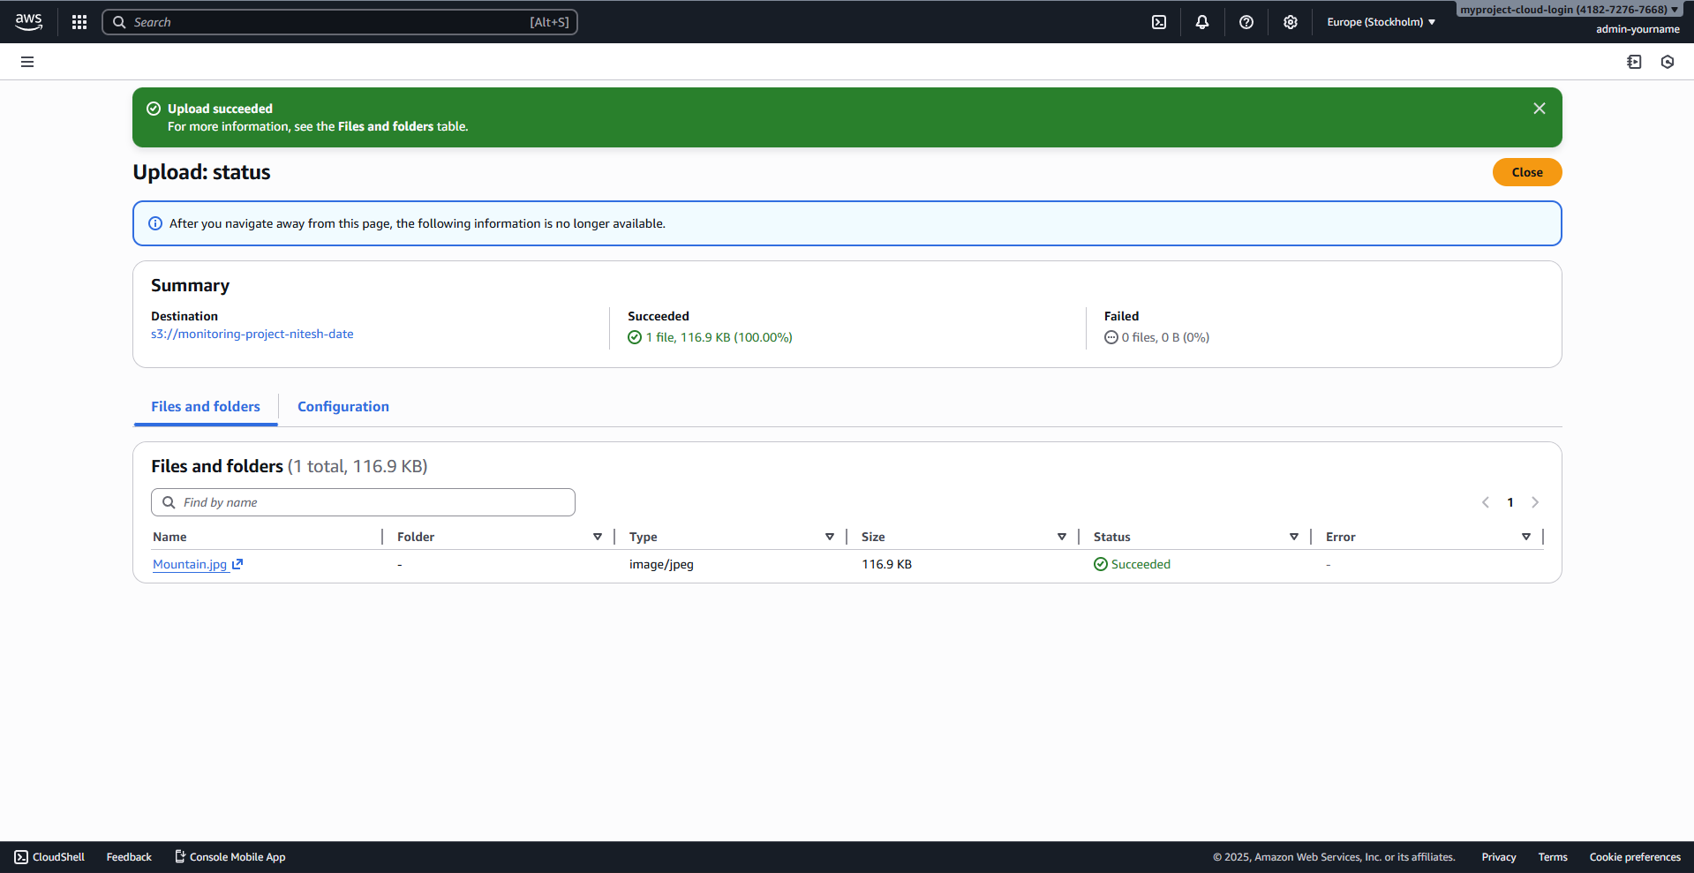

### Phase 5: Database Security & Prep (RDS)

Before launching the database, we needed to configure the network security to ensure only our internal servers could access it.

**Step 5.1: Accessing Security Groups** We navigated to the VPC Security Groups section to create a dedicated firewall rule for the database.

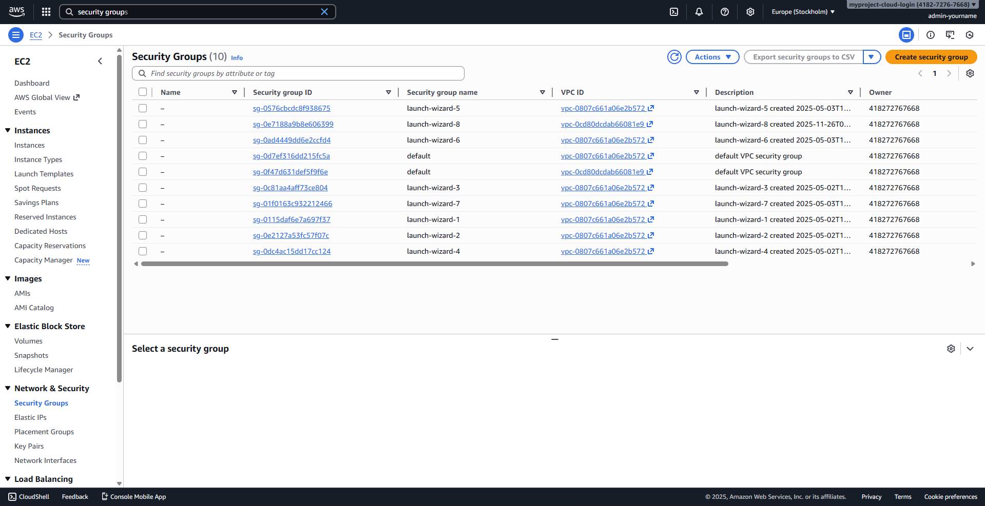

**Step 5.2: Creating the Database Security Group** We created a new Security Group named mydatabase-sg. Crucially, we added an **Inbound Rule** to allow MYSQL/Aurora traffic on port 3306. We restricted the source to our VPC CIDR (10.0.0.0/16) to ensure the database is isolated from the public internet.

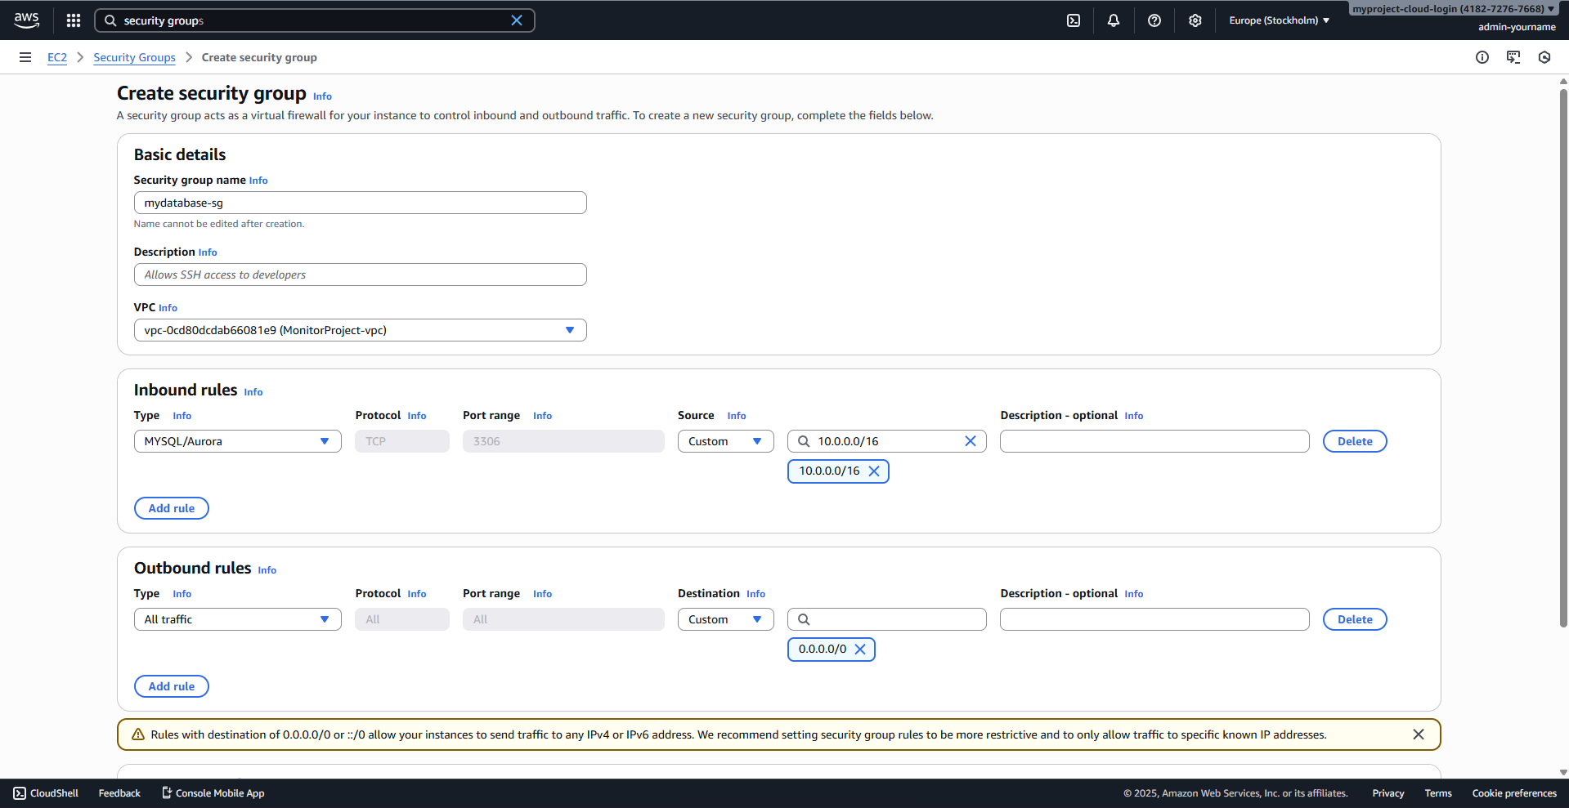

**Step 5.3: Verification** We verified the creation of the security group, confirming the rule was correctly applied to allow internal database traffic.

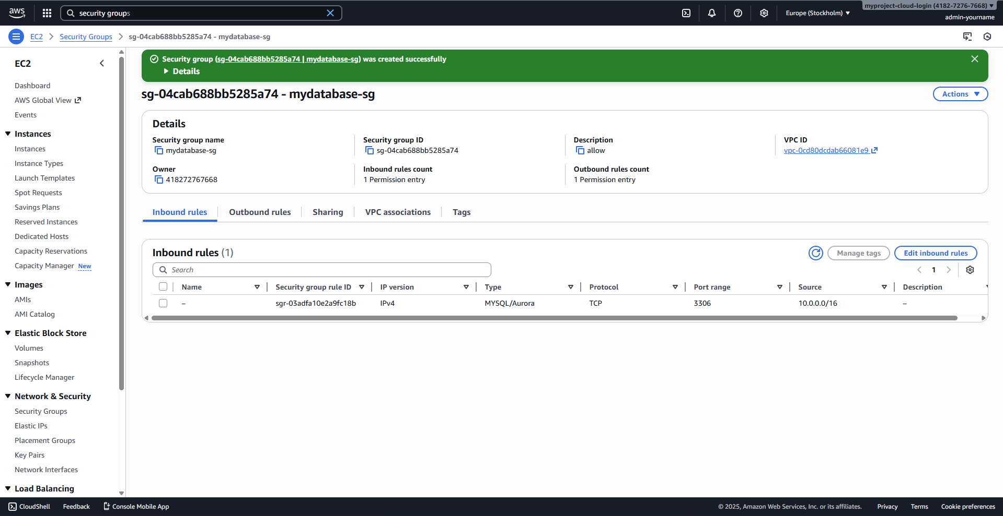

### Phase 6: Database Provisioning (RDS)

With our network security prepared, we proceeded to create the managed database instance.

**Step 6.1: Accessing RDS** We navigated to the RDS console and initiated the database creation wizard.

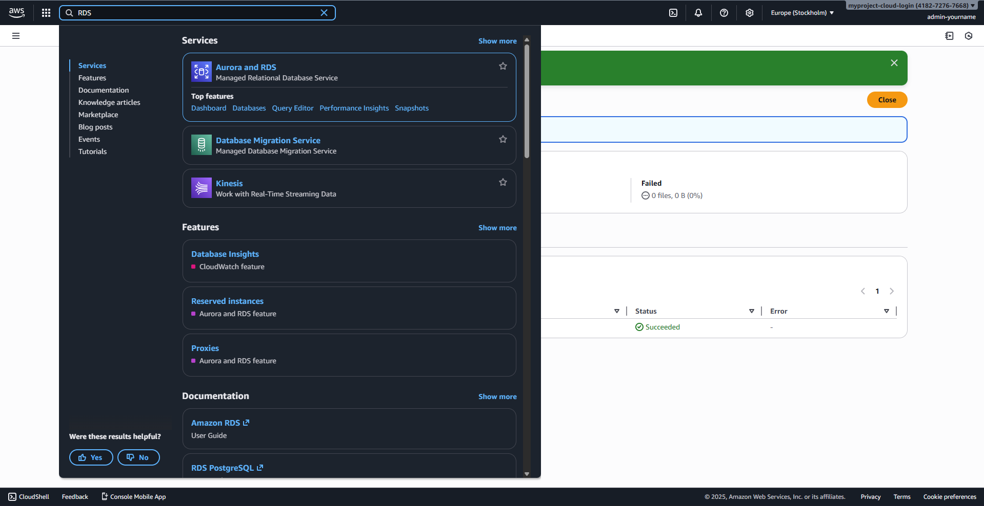

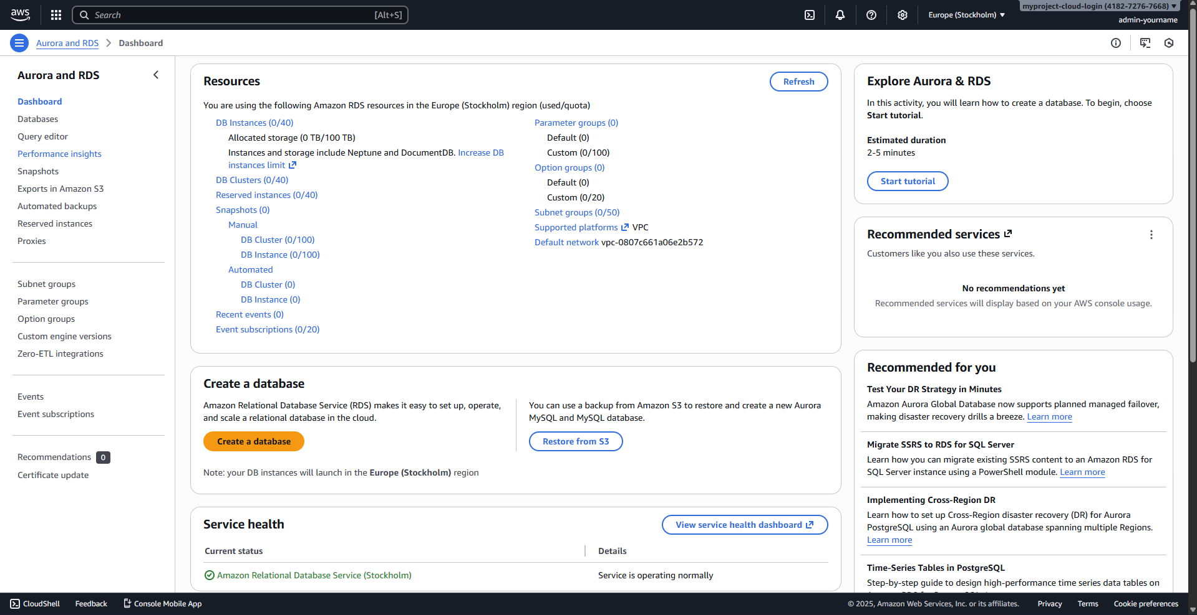

**Step 6.2: Engine Selection** We selected **MySQL** as our database engine and opted for the **Free Tier** template to minimize costs while developing the dashboard.

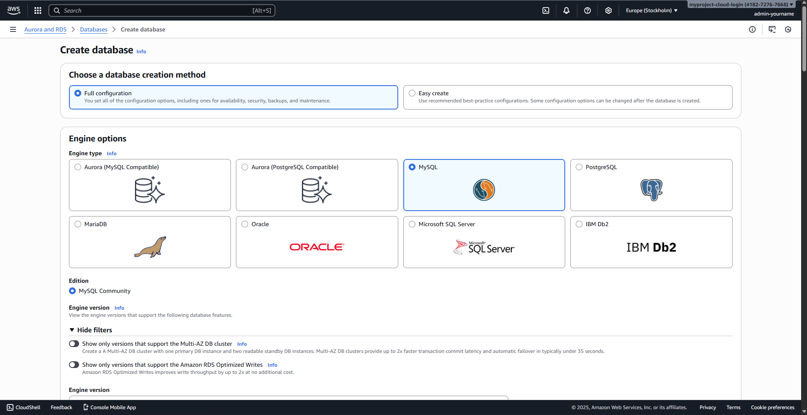

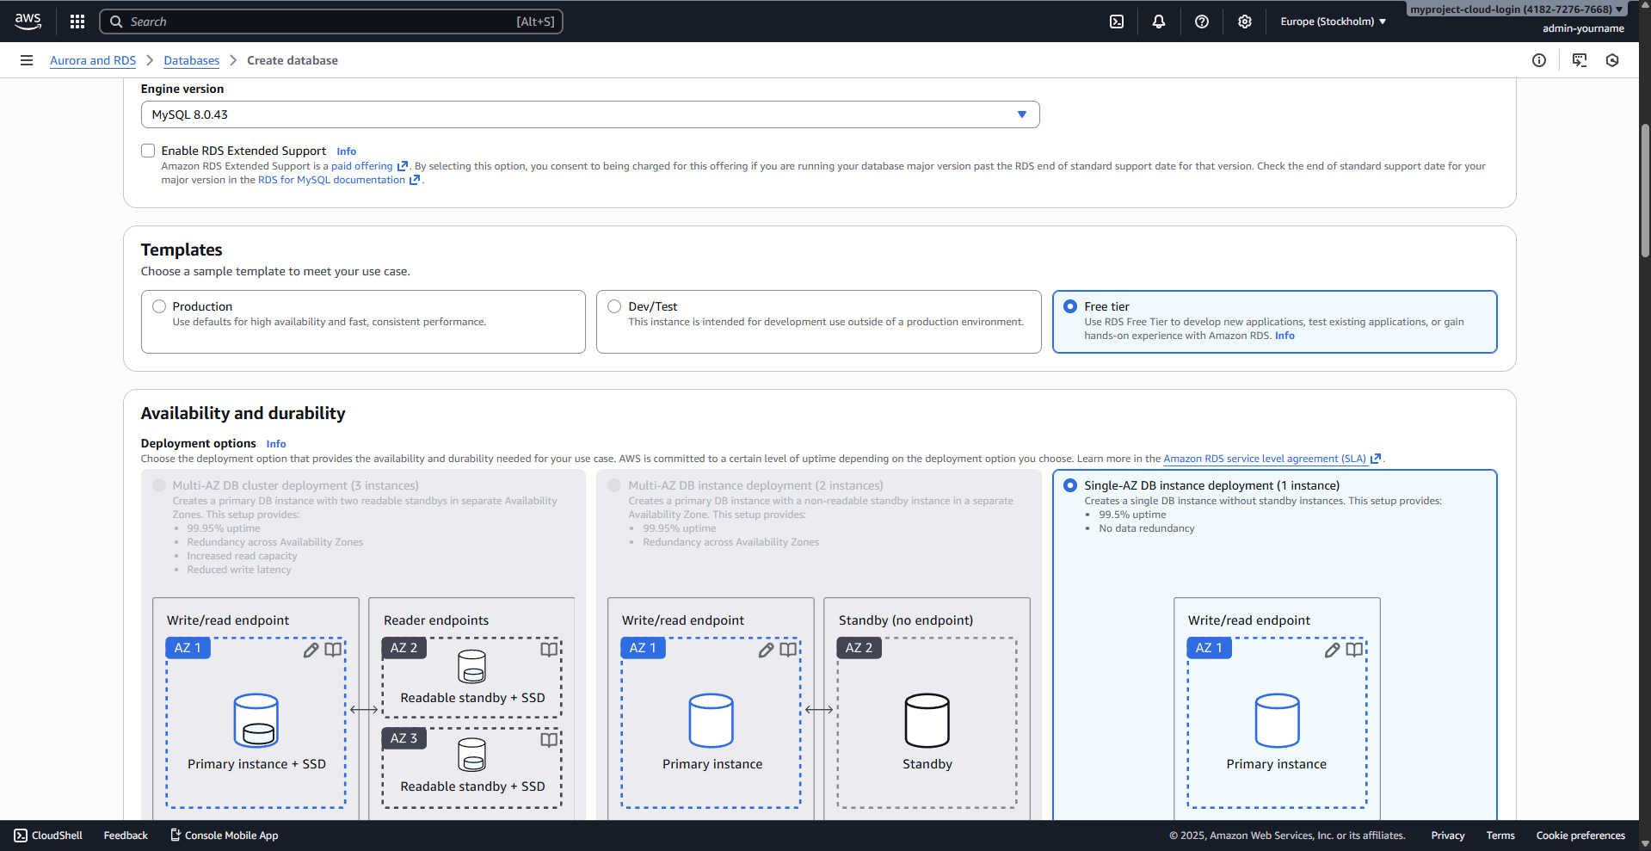

**Step 6.3: Instance Settings** We named the database instance mydatabase and configured the master credentials (username admin).

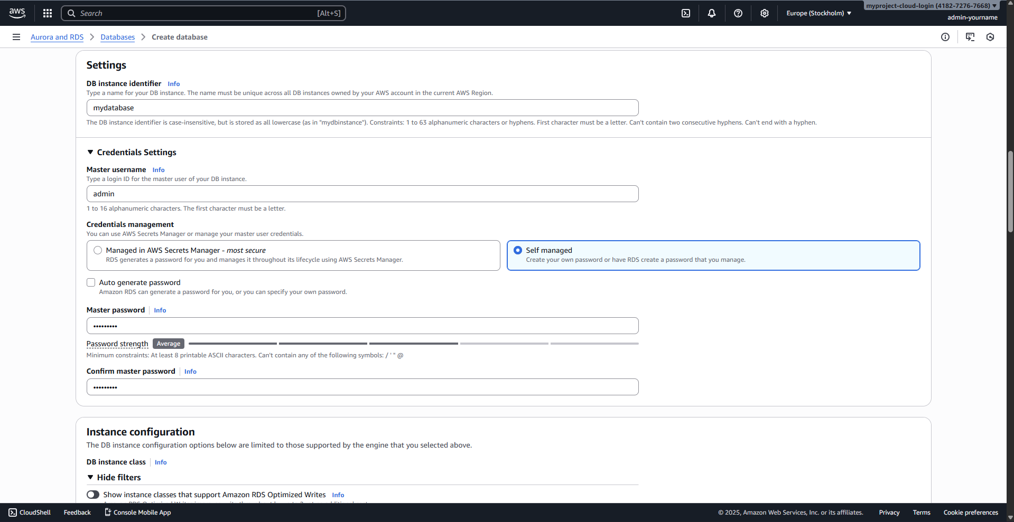

**Step 6.4: Compute & Storage** We selected the burstable db.t3.micro instance class and allocated 20 GiB of General Purpose SSD (gp2) storage.

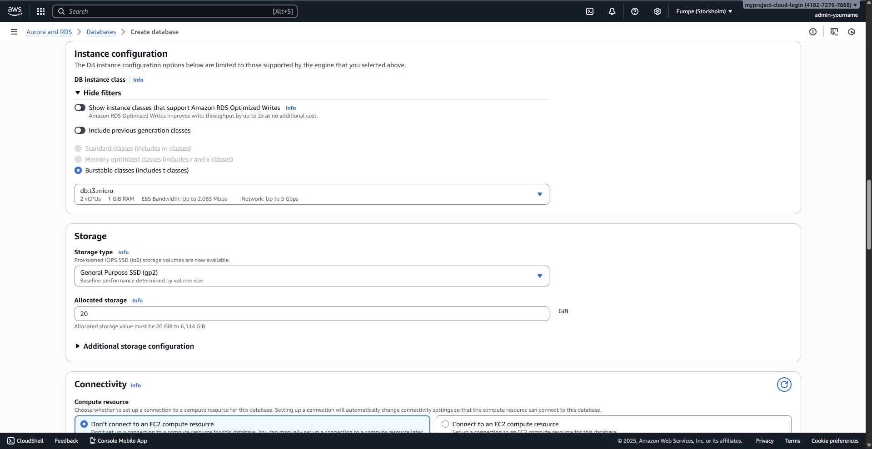

**Step 6.5: Connectivity Configuration** We placed the database in our custom MonitorProject-vpc and attached it to the mydatabase-sg security group we defined earlier. We explicitly disabled public access to ensure security.

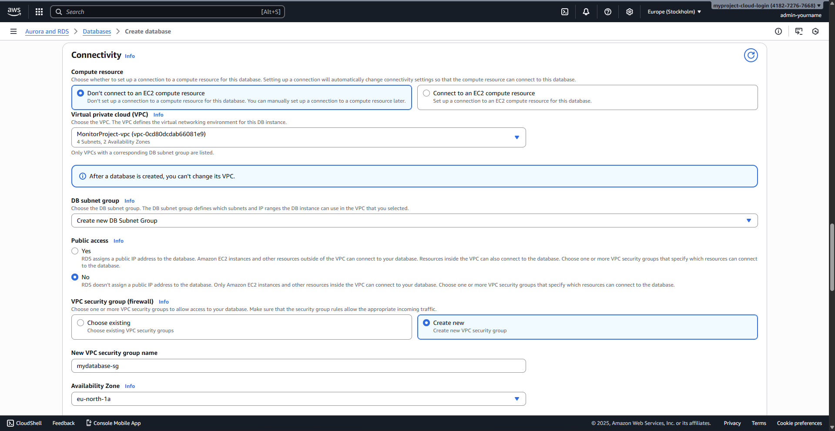

**Step 6.6: Authentication & Monitoring** We enabled Password authentication and reviewed the monitoring settings.

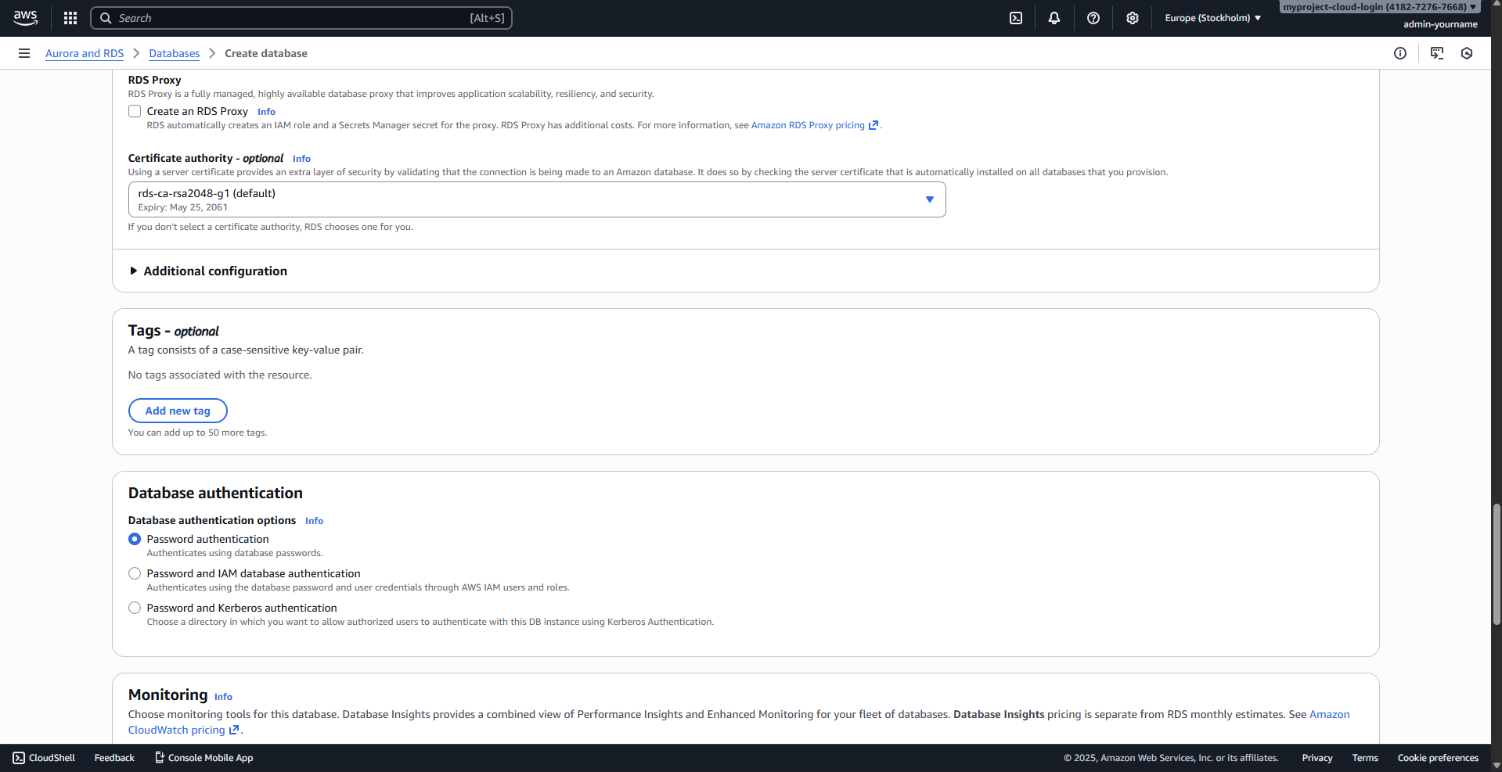

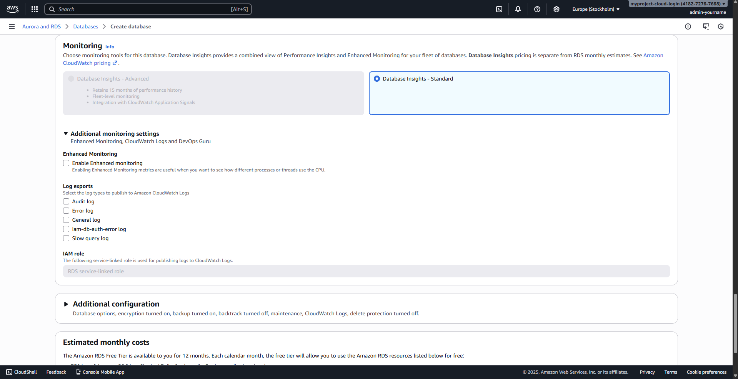

**Step 6.7: Creation Success** We launched the database instance. AWS confirmed the creation was successful and began the provisioning process.

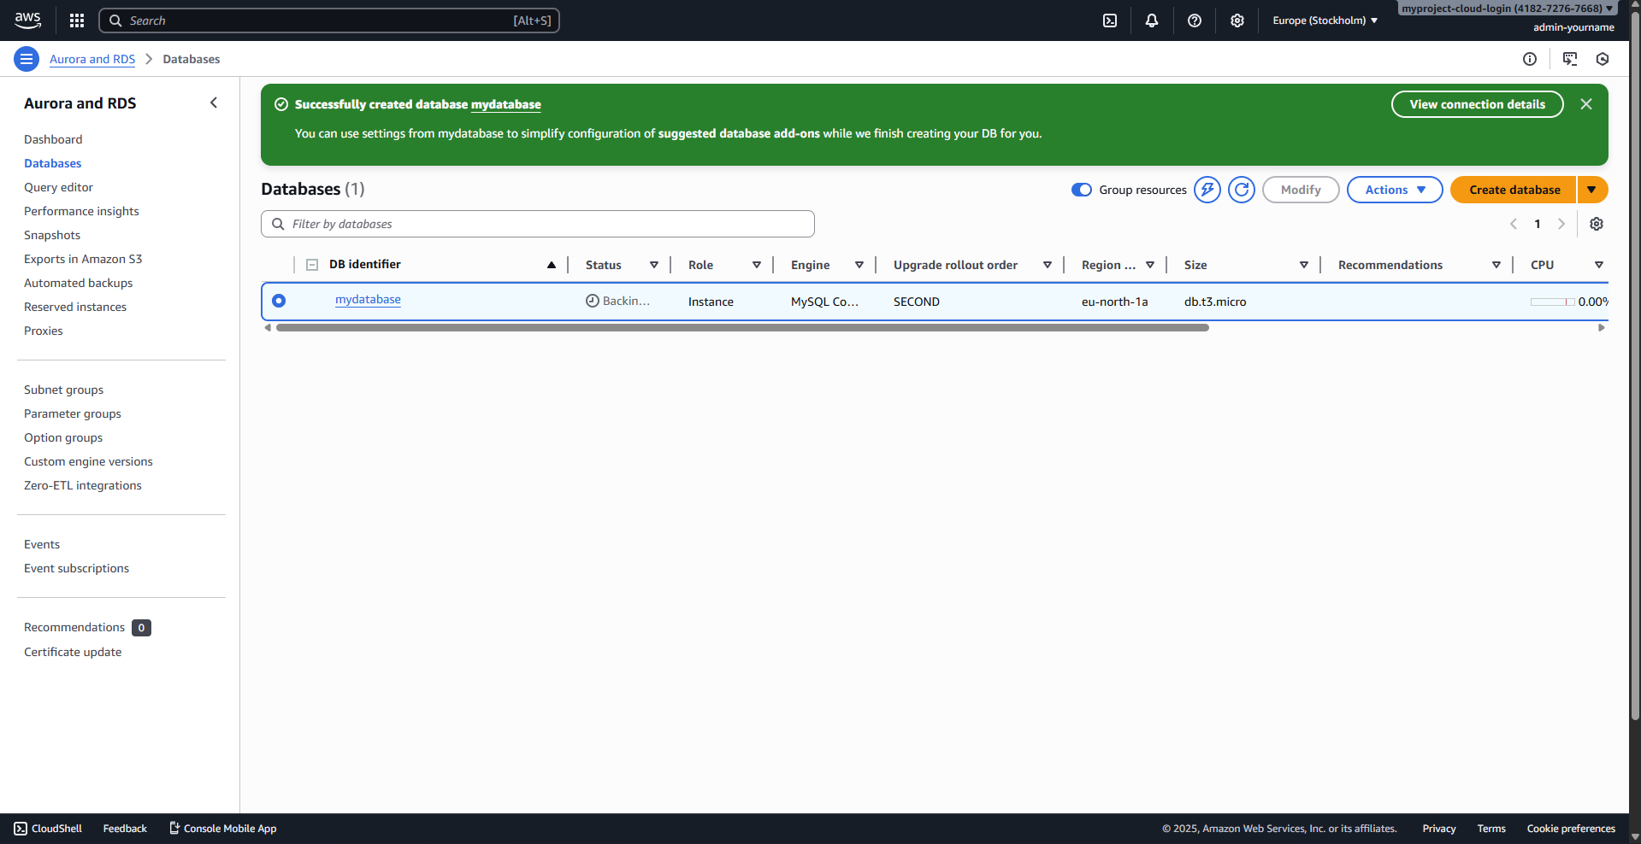

### Phase 7: Monitoring & Dashboards

With all infrastructure components (EC2, S3, RDS) running, we moved to the final phase: setting up the centralized monitoring dashboard.

**Step 7.1: Accessing CloudWatch** We navigated to the CloudWatch service, which acts as the central repository for metrics and alarms.

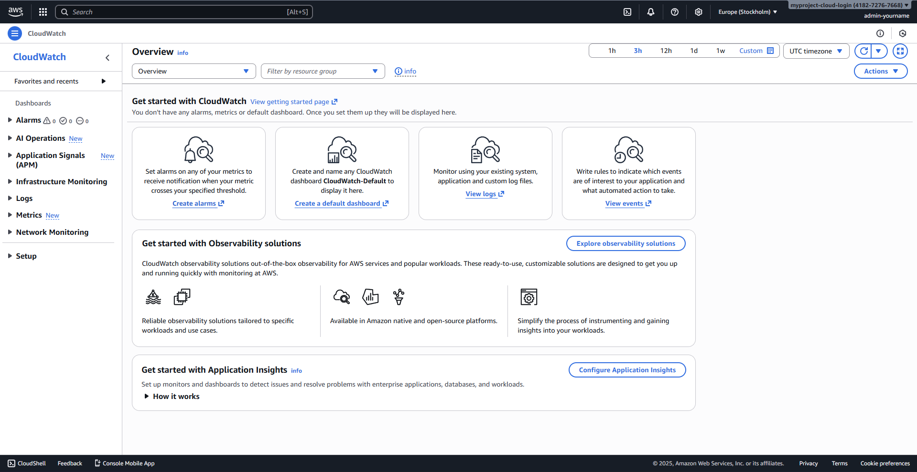

**Step 7.2: Creating the Dashboard** We initiated the creation of a new custom dashboard and named it Infrastructure-Health-Main.

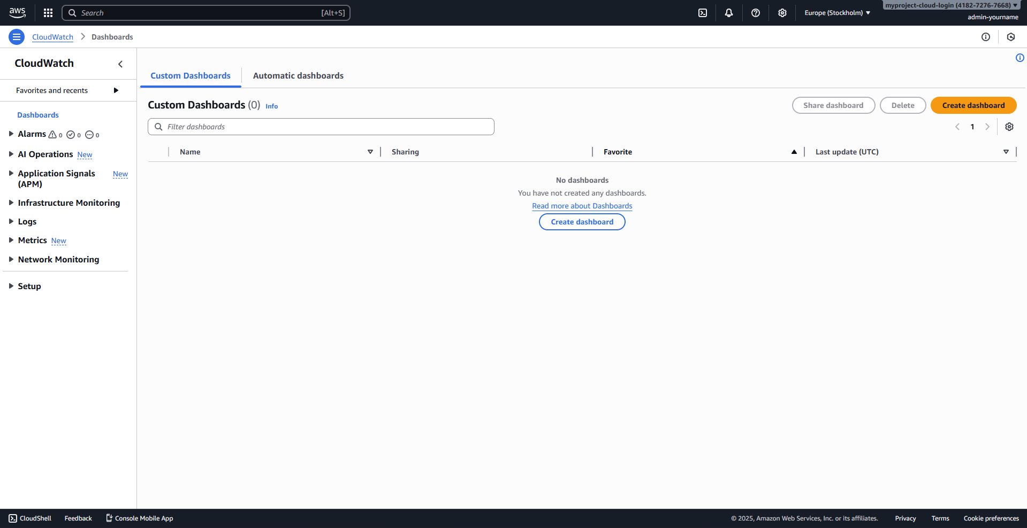

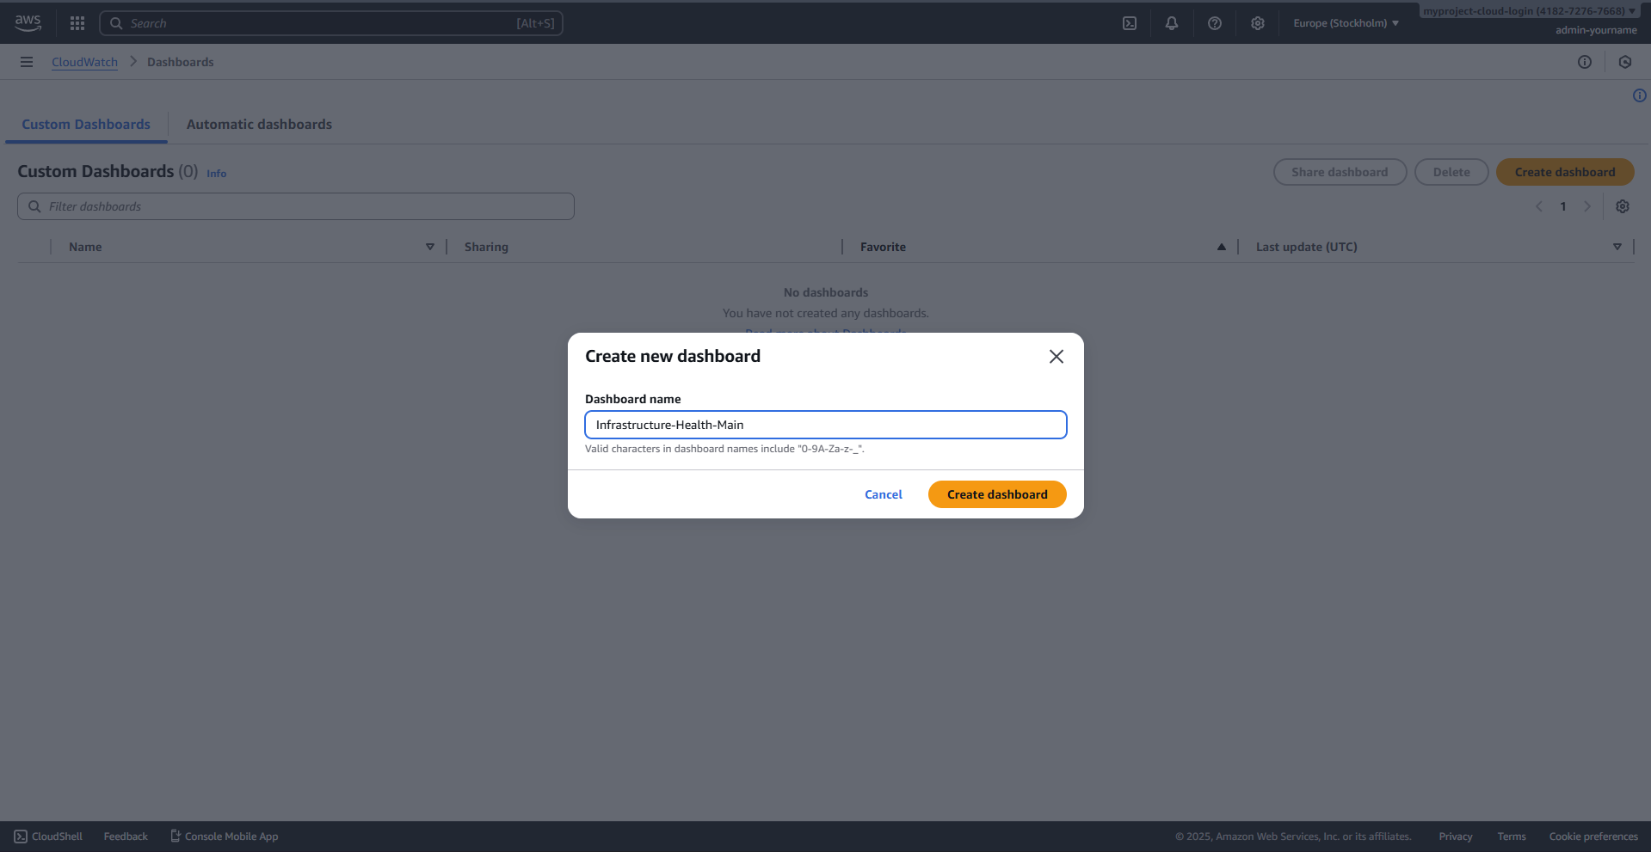

**Step 7.3: Adding EC2 Widget** We added a "Line" widget to monitor the web server's CPU utilization. We selected **EC2 > Per-Instance Metrics** and chose the CPUUtilization metric for our instance. 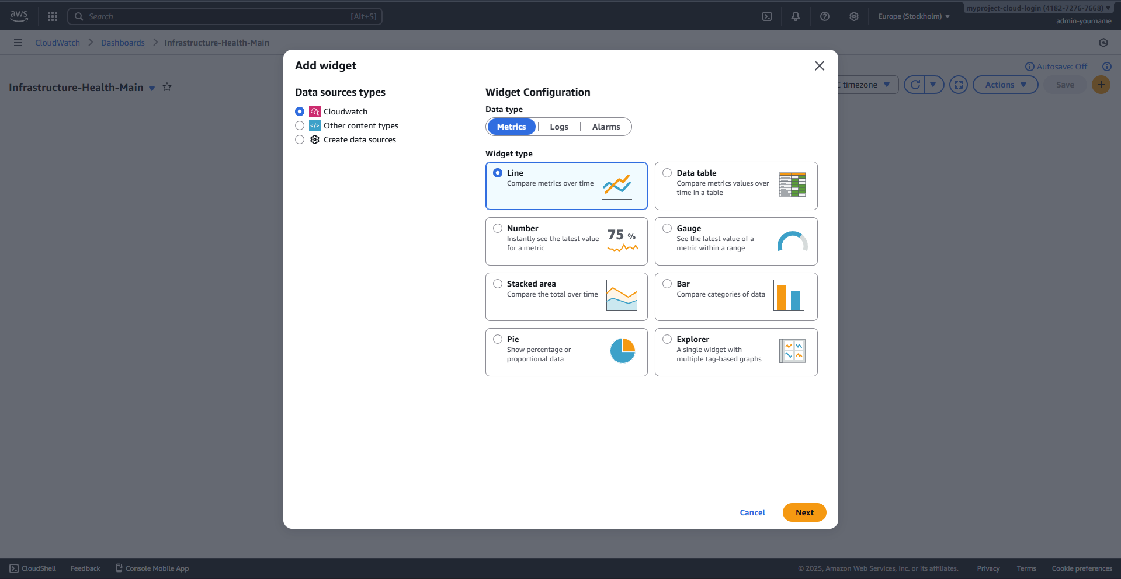

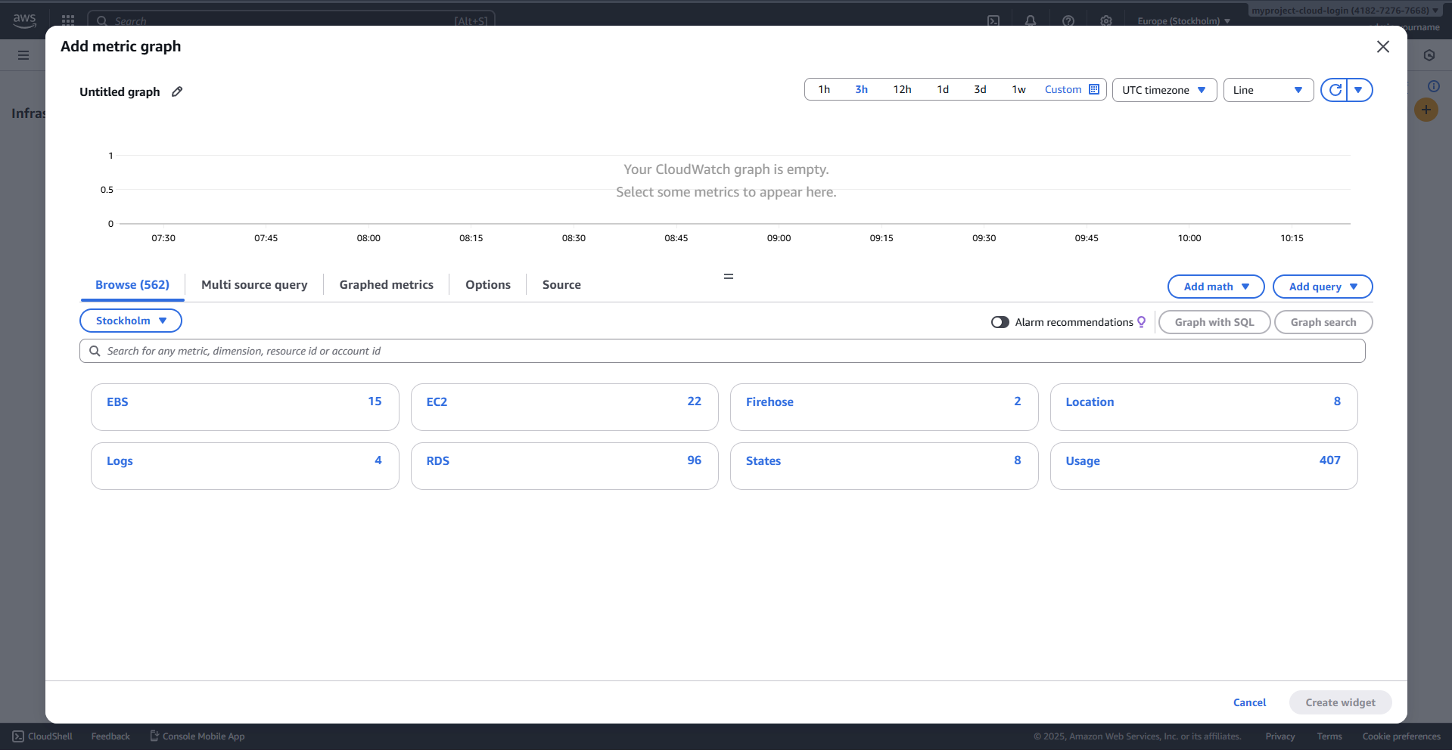

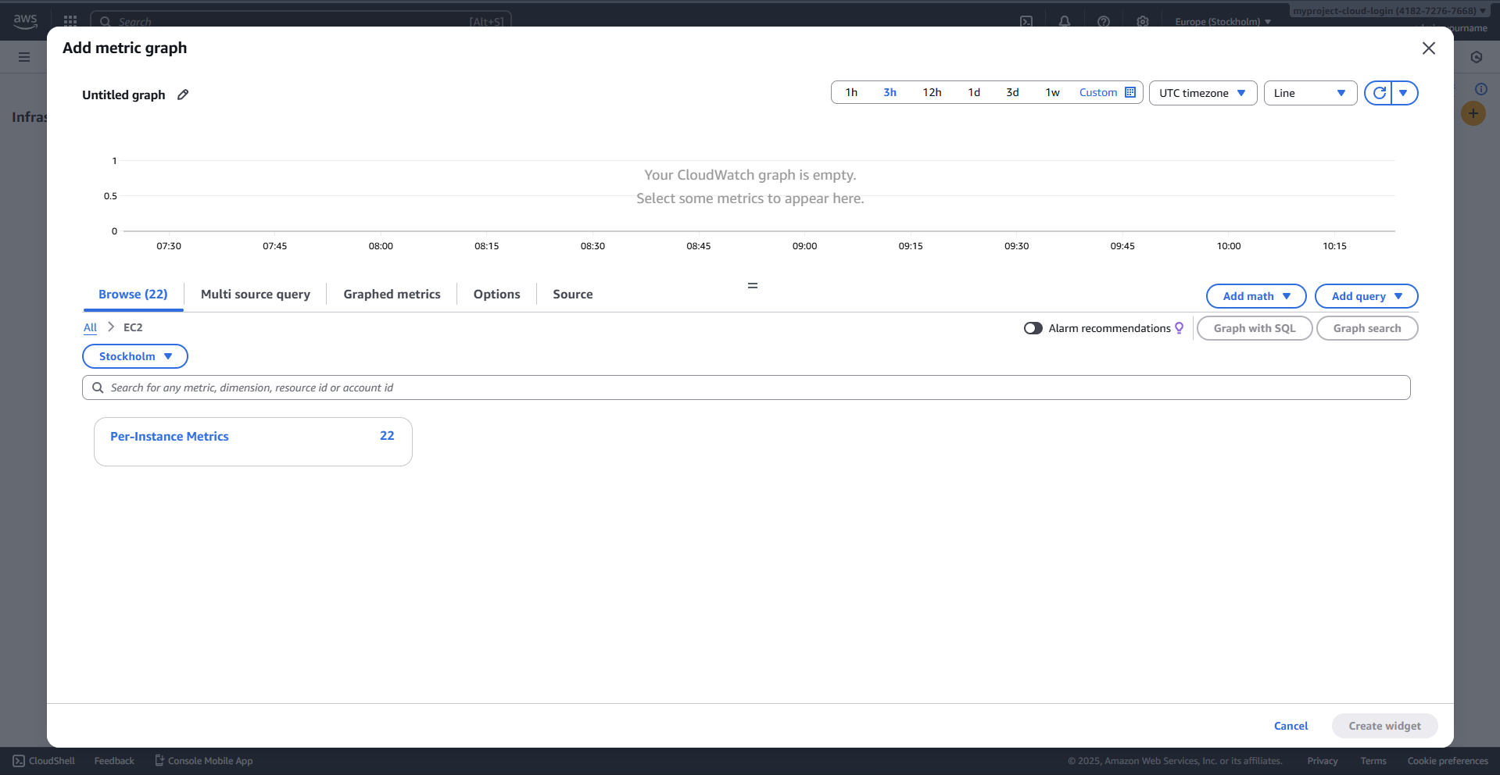

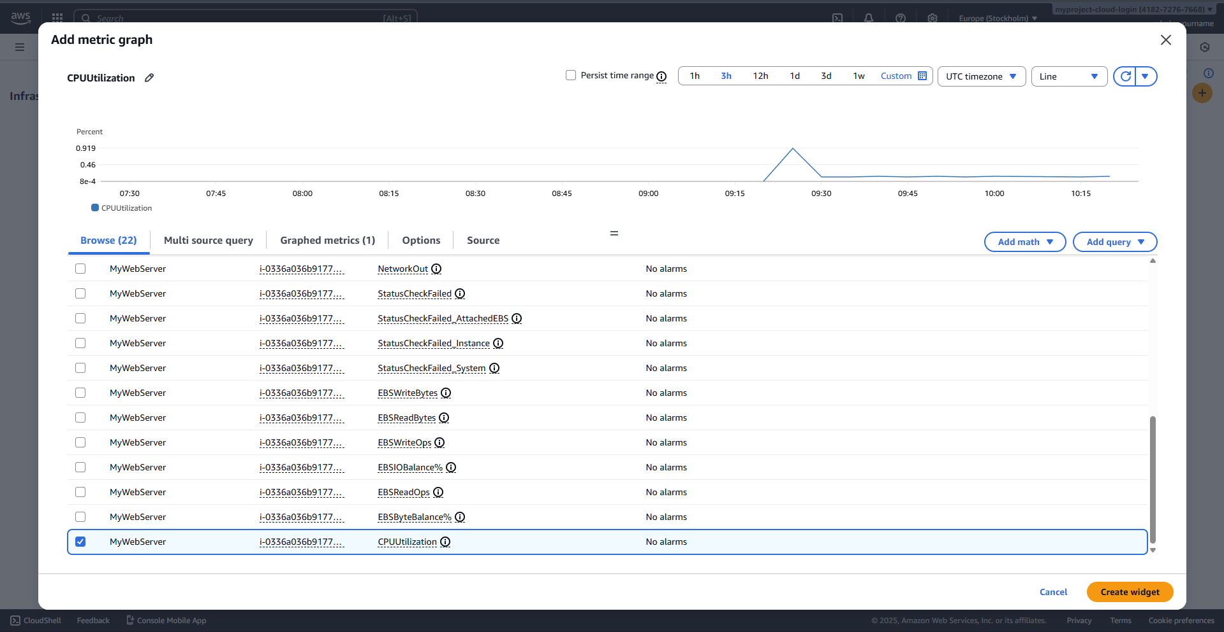

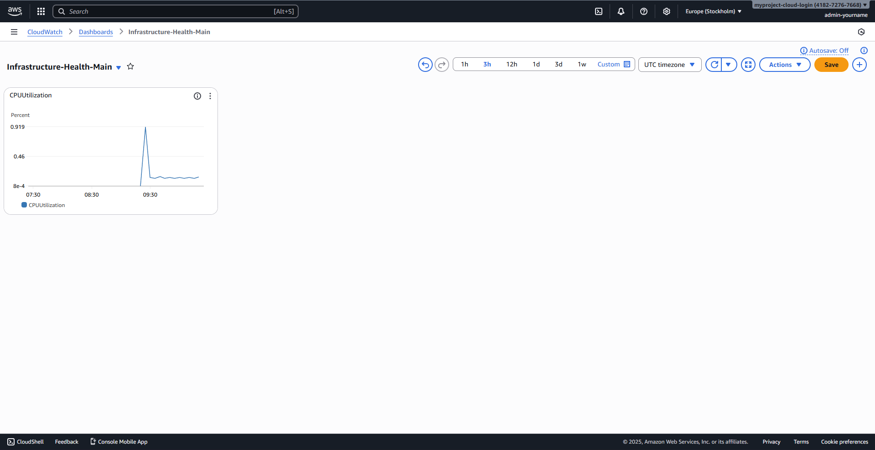

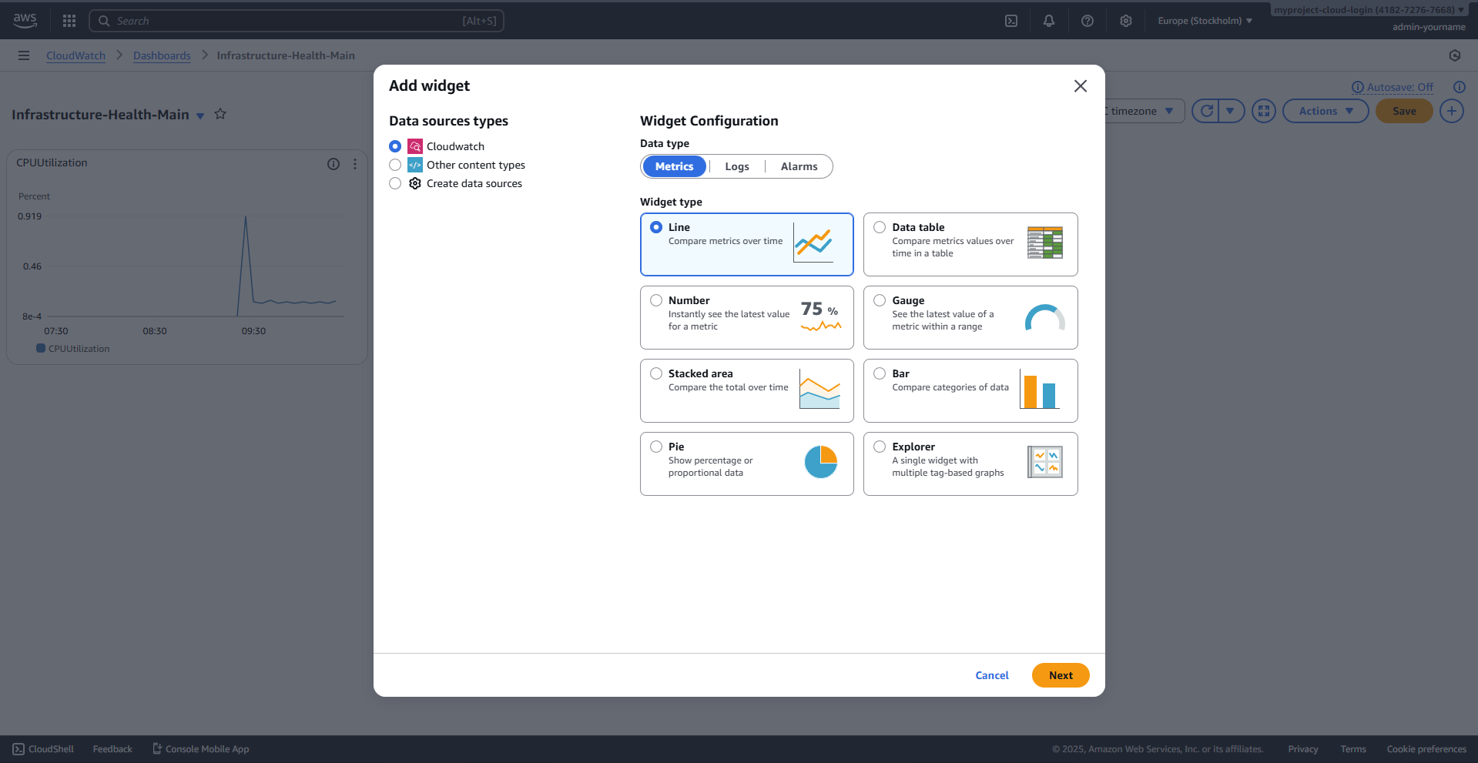

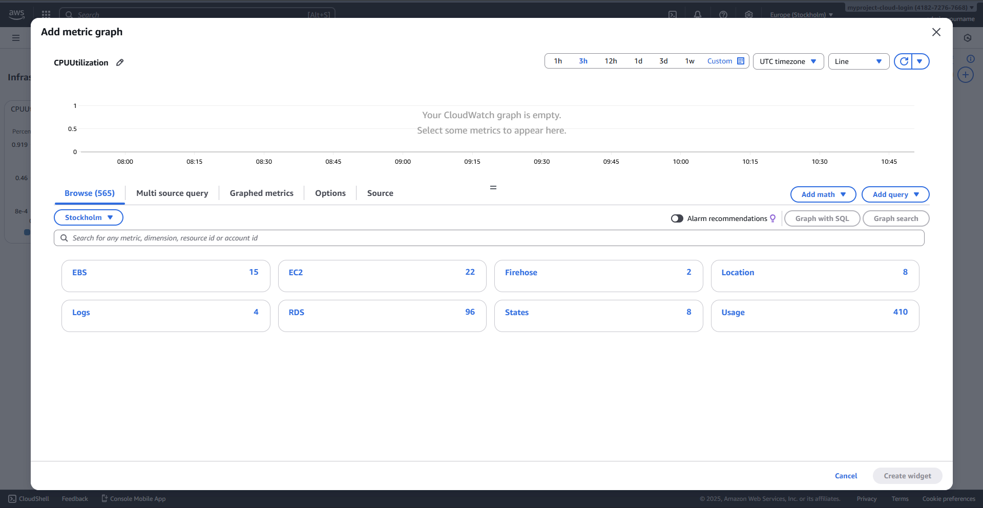

**Step 7.4: Adding RDS Widget** We added a second widget to monitor the database's free storage. We browsed to **RDS > DBInstanceIdentifier** metrics and selected FreeStorageSpace for mydatabase.

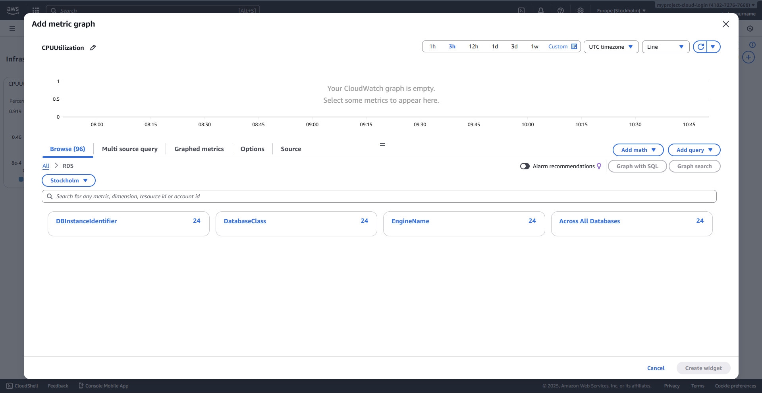

**Step 7.5: Final Dashboard View** We successfully created a single pane of glass showing both our Compute (EC2) and Database (RDS) health metrics side-by-side.

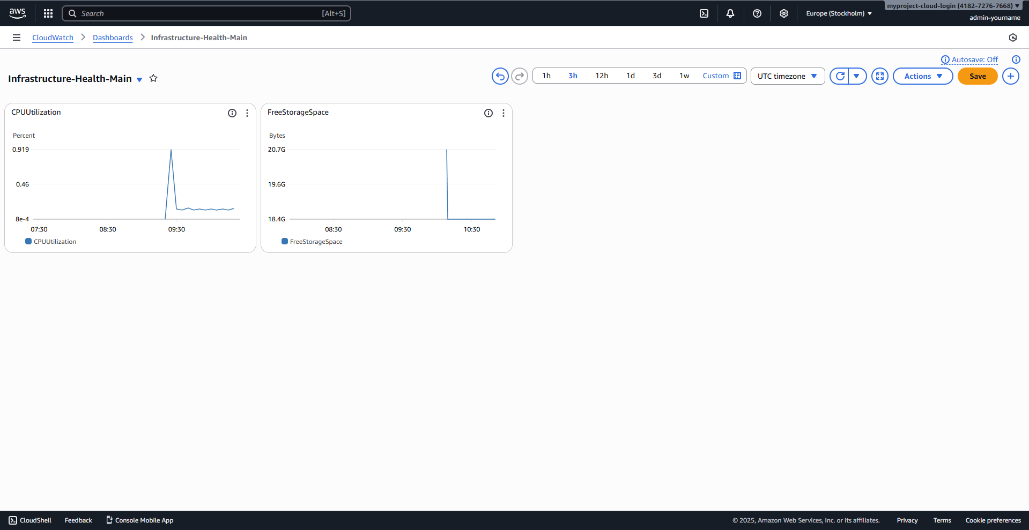

### Phase 8: Alerting System (SNS)

To ensure we are notified of issues immediately, we set up an SNS topic for email alerts.

**Step 8.1: Accessing SNS** We navigated to the Simple Notification Service (SNS) console.

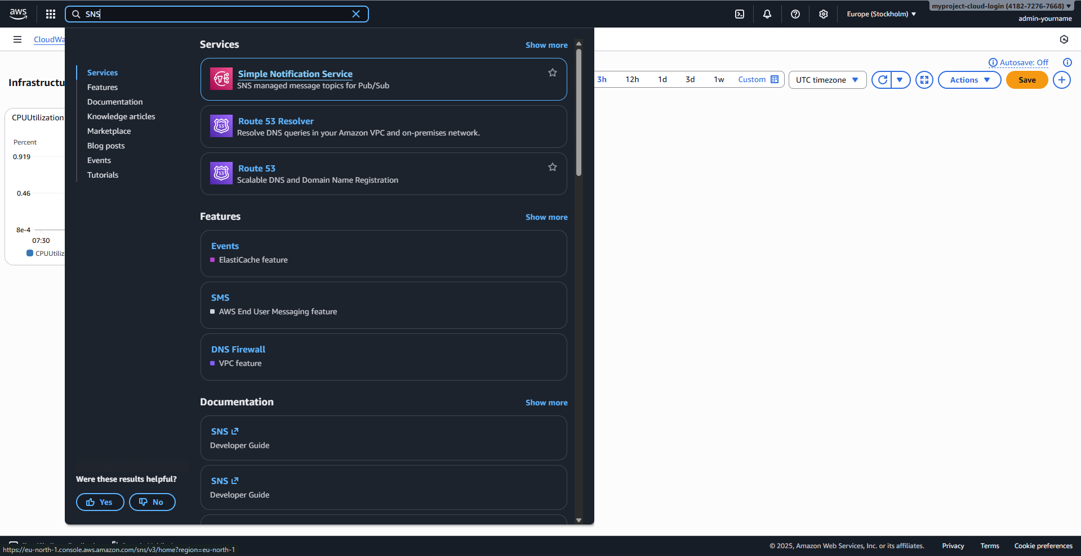

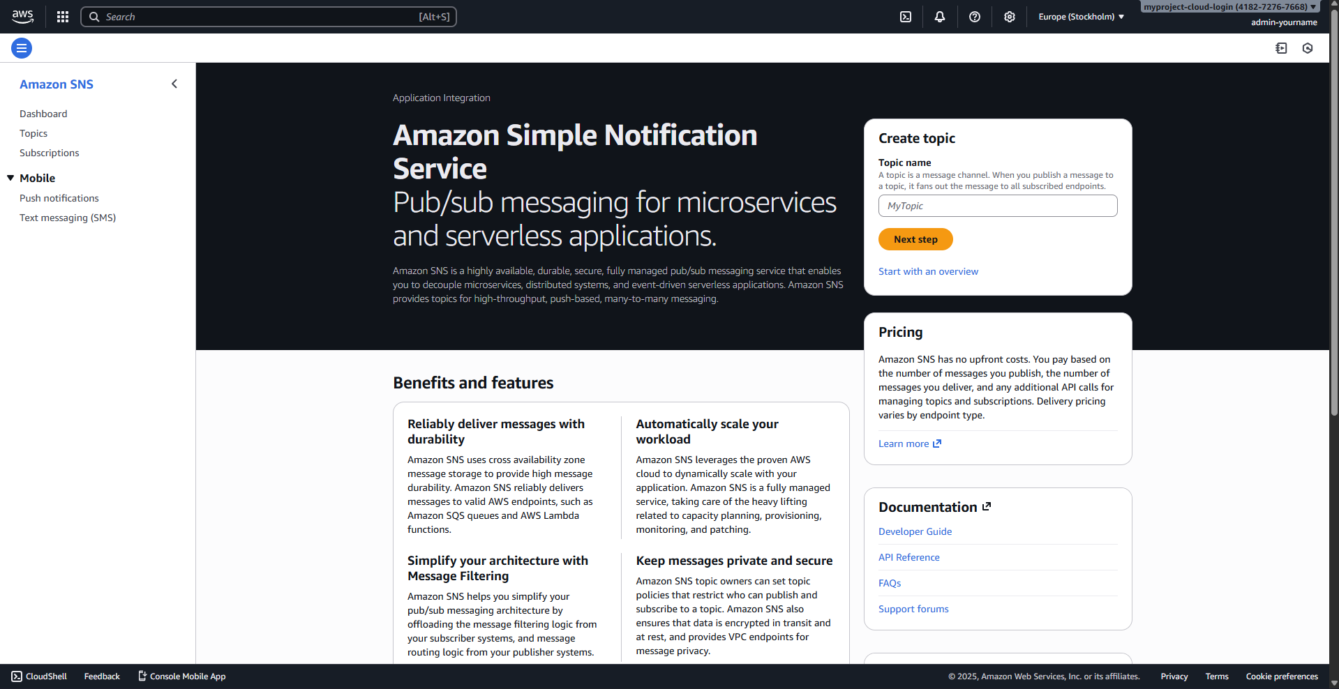

**Step 8.2: Creating a Topic** We created a new Standard topic named AdminAlertsTopic to serve as the communication channel for our alarms.

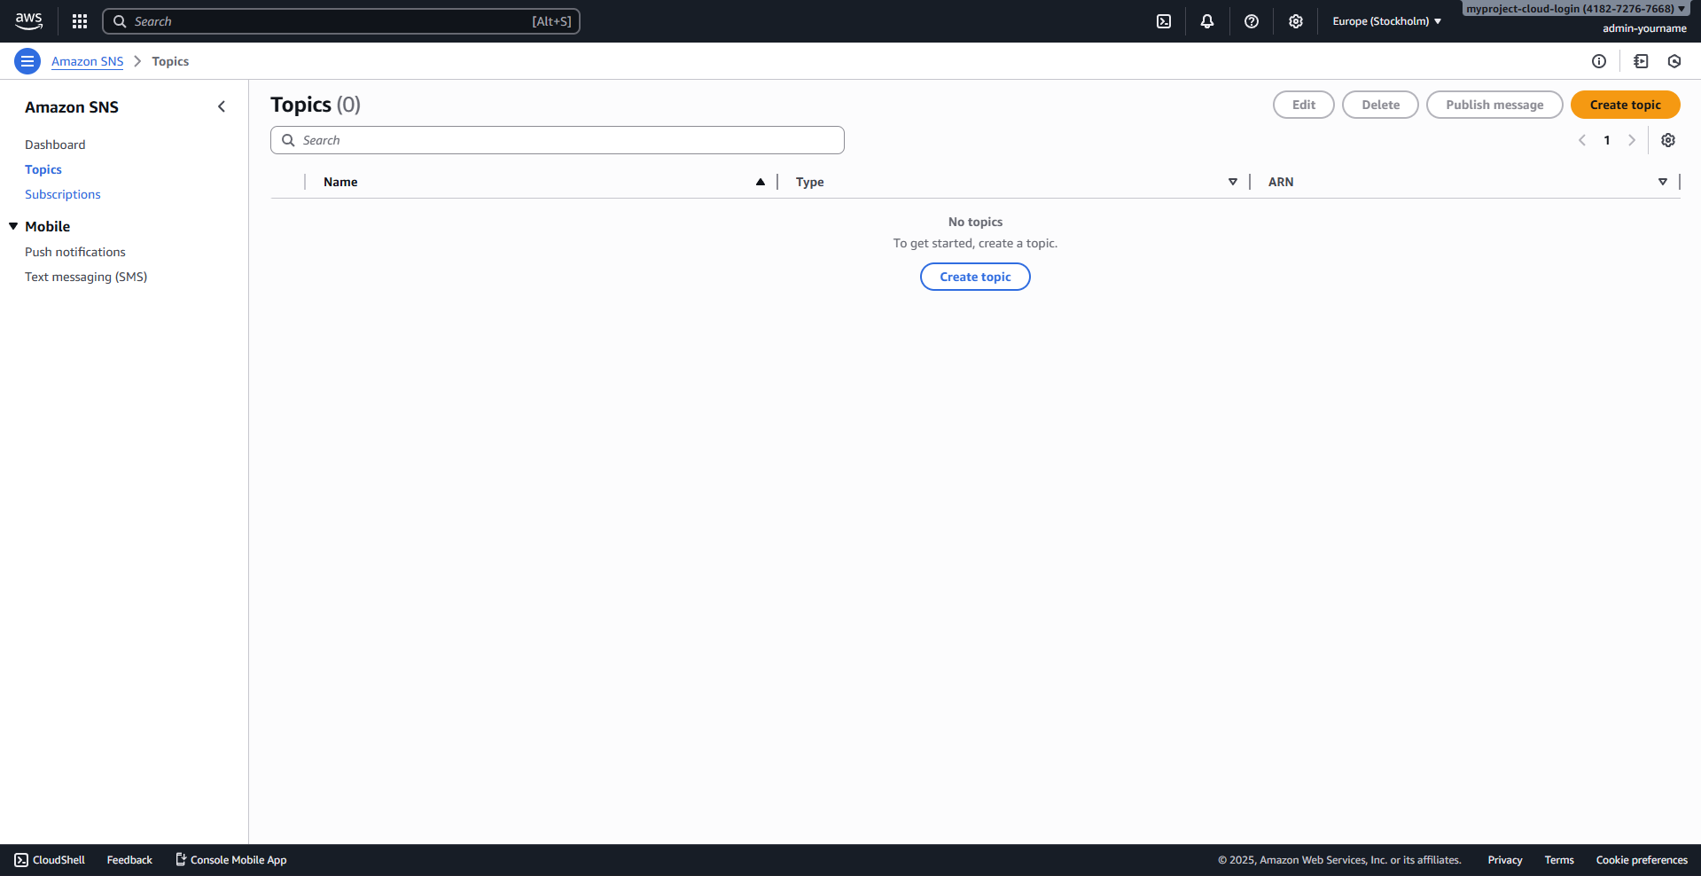

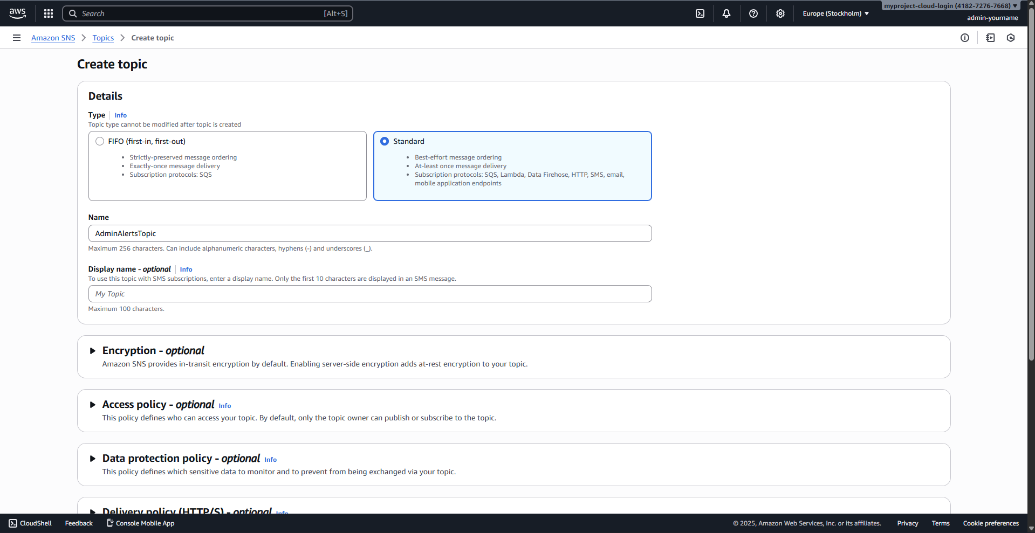

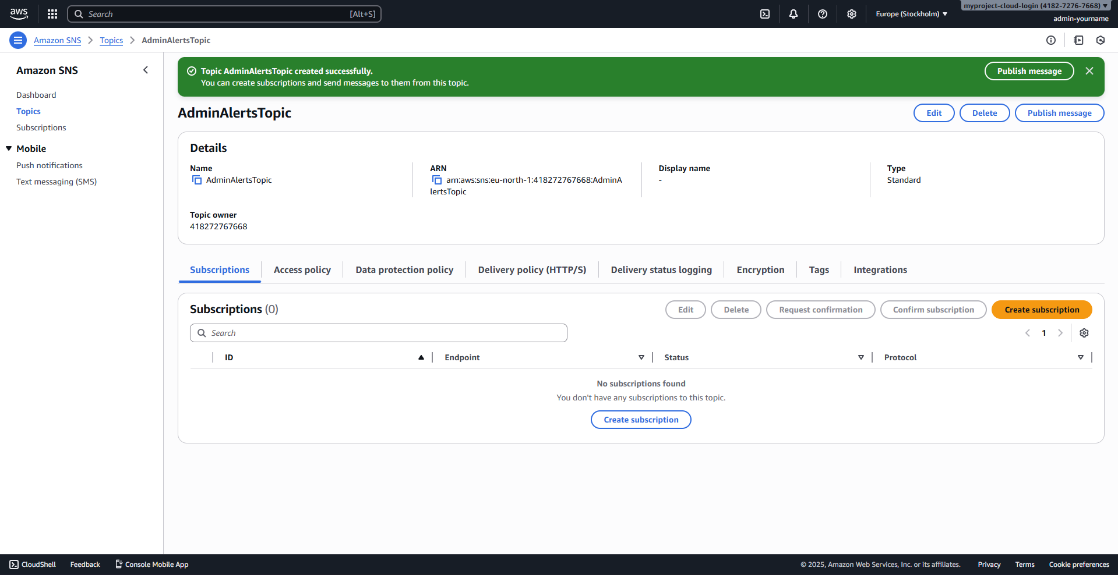

**Step 8.3: Subscribing to Alerts** We created a subscription for this topic, selecting "Email" as the protocol and entering our administrative email address. This ensures that any alarm triggering this topic will send an email directly to us.

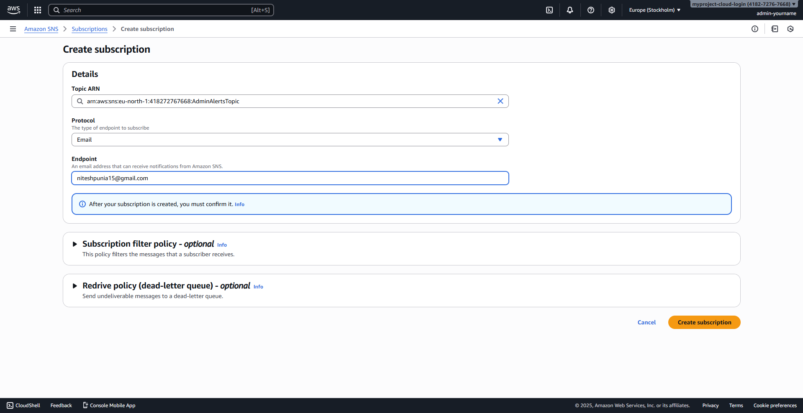

### Phase 9: Automated Alarms (CloudWatch)

With the notification channel ready, we configured CloudWatch to monitor our EC2 metrics and trigger an alarm if thresholds are breached.

**Step 9.1: Selecting the Metric** We navigated to CloudWatch Metrics, selected the EC2 CPUUtilization metric for our instance, and clicked the "bell" icon to create an alarm.

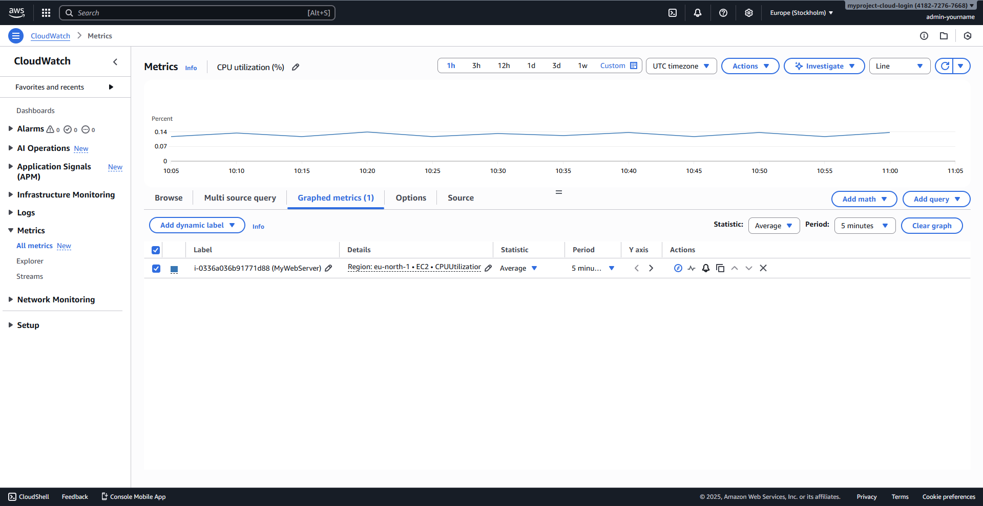

**Step 9.2: Defining Thresholds** We defined a Static threshold. If CPU utilization is **Greater/Equal to 80%**, the alarm condition will be met.

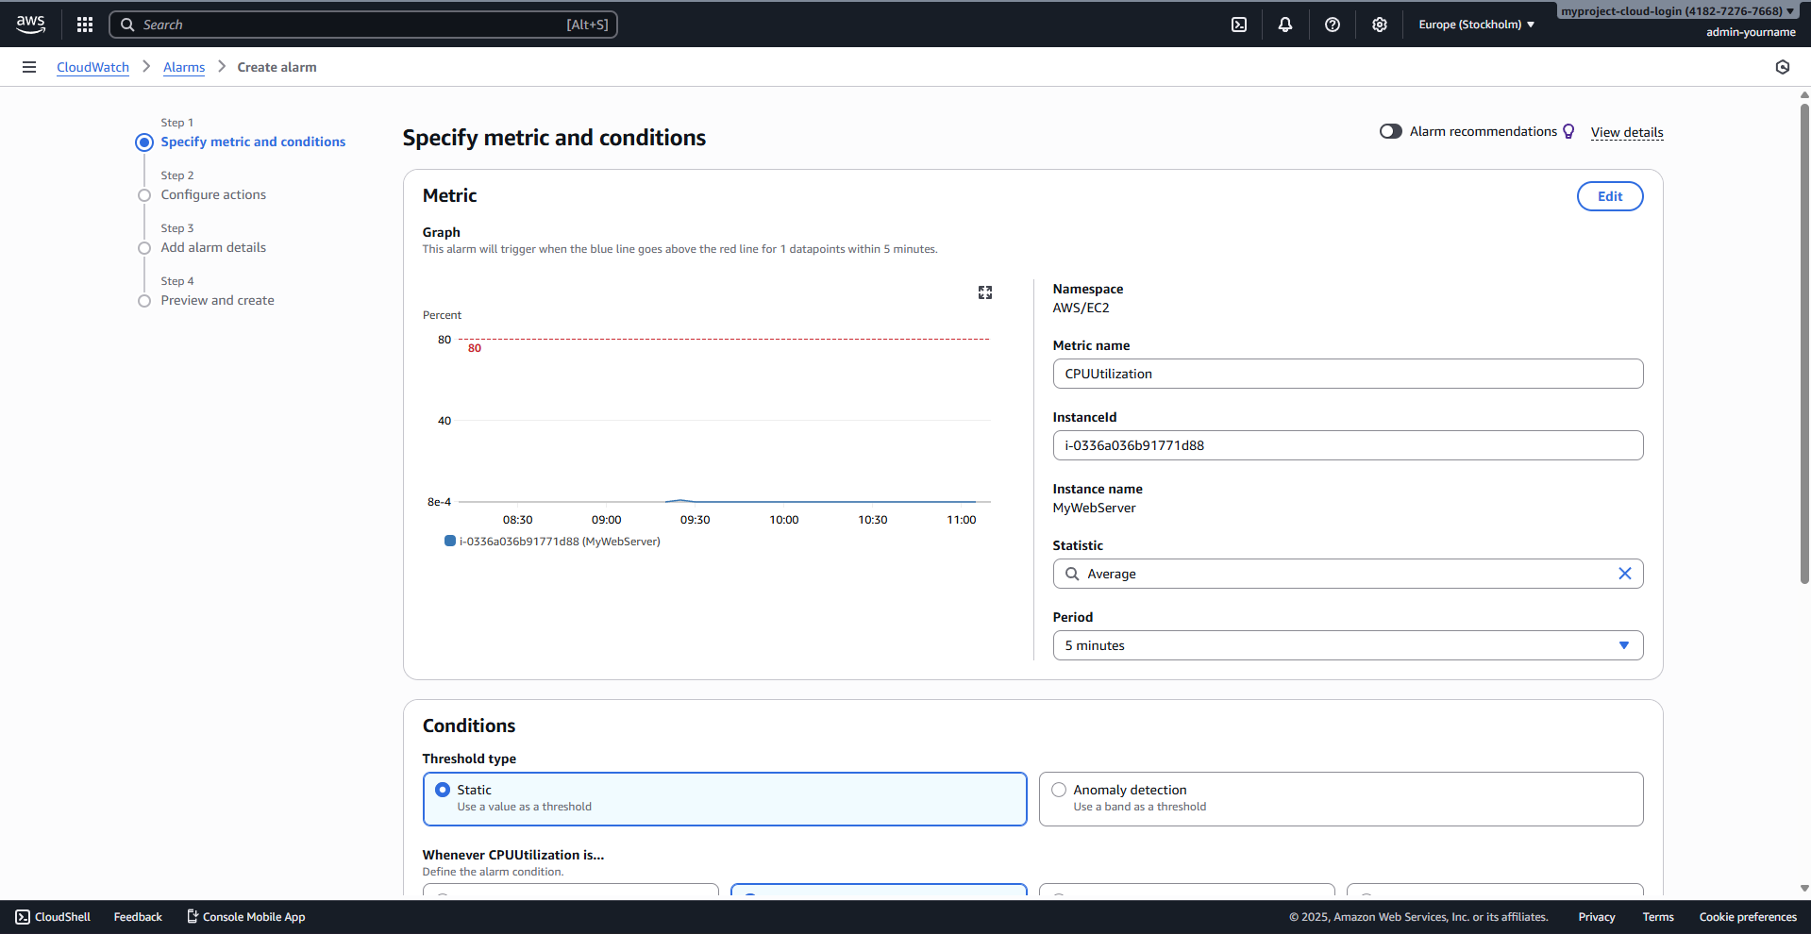

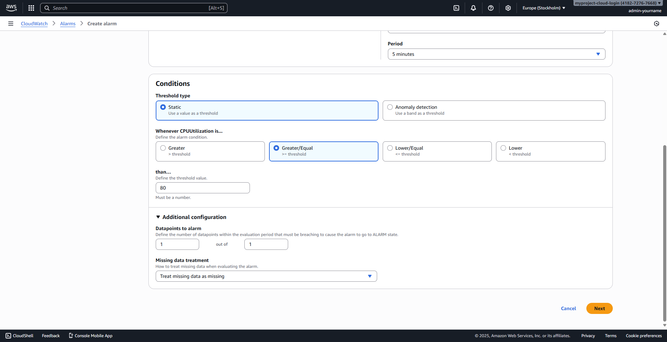

**Step 9.3: Configuring Actions** We configured the alarm action to send a notification to our previously created SNS topic AdminAlertsTopic whenever the state triggers "In alarm".

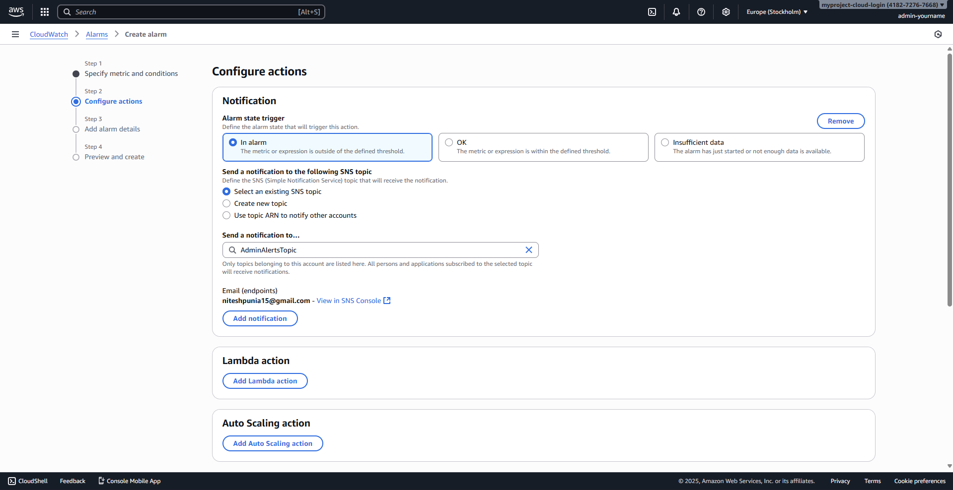

**Step 9.4: Alarm Details** We named the alarm HighCPU-WebServer and added a description to help support teams identify the issue quickly.

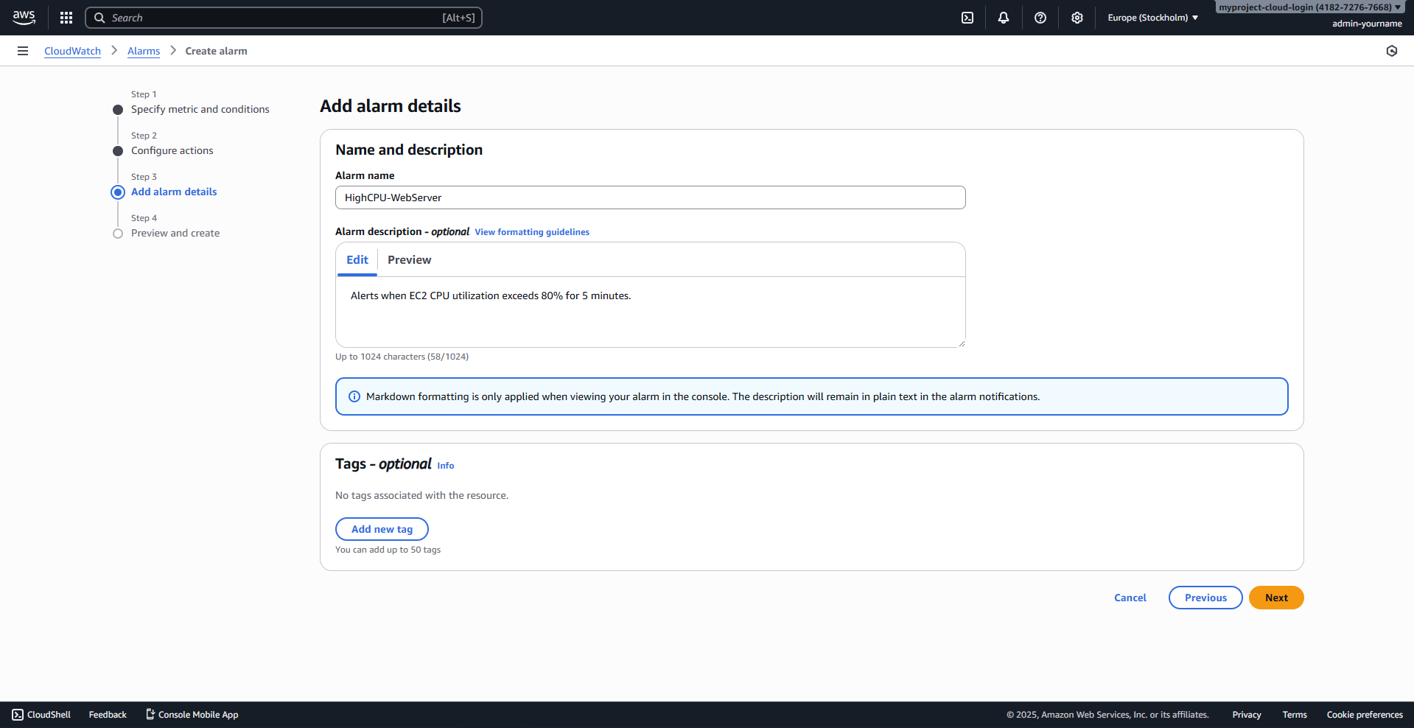

**Step 9.5: Review and Create** We reviewed all settings on the preview page, ensuring the metric, threshold, and action were correct before creating the alarm.

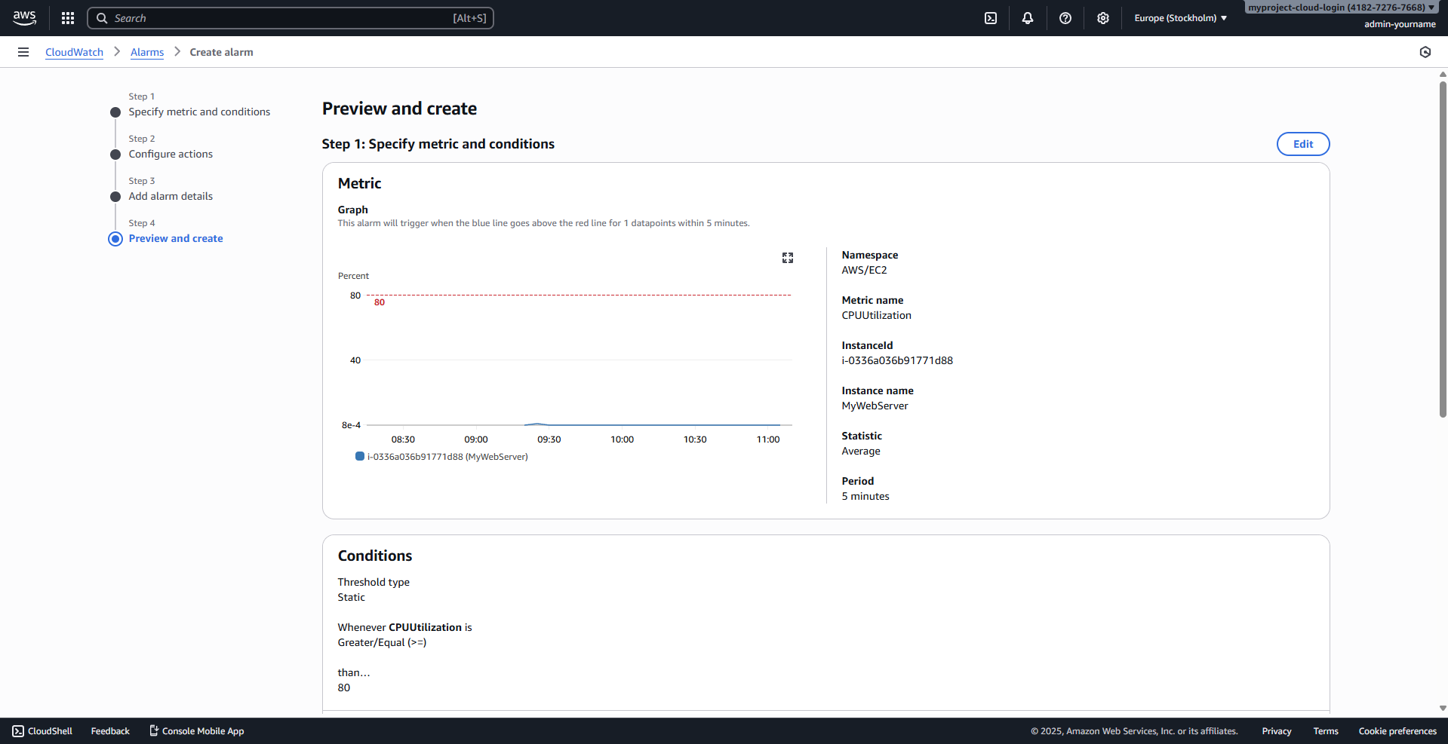

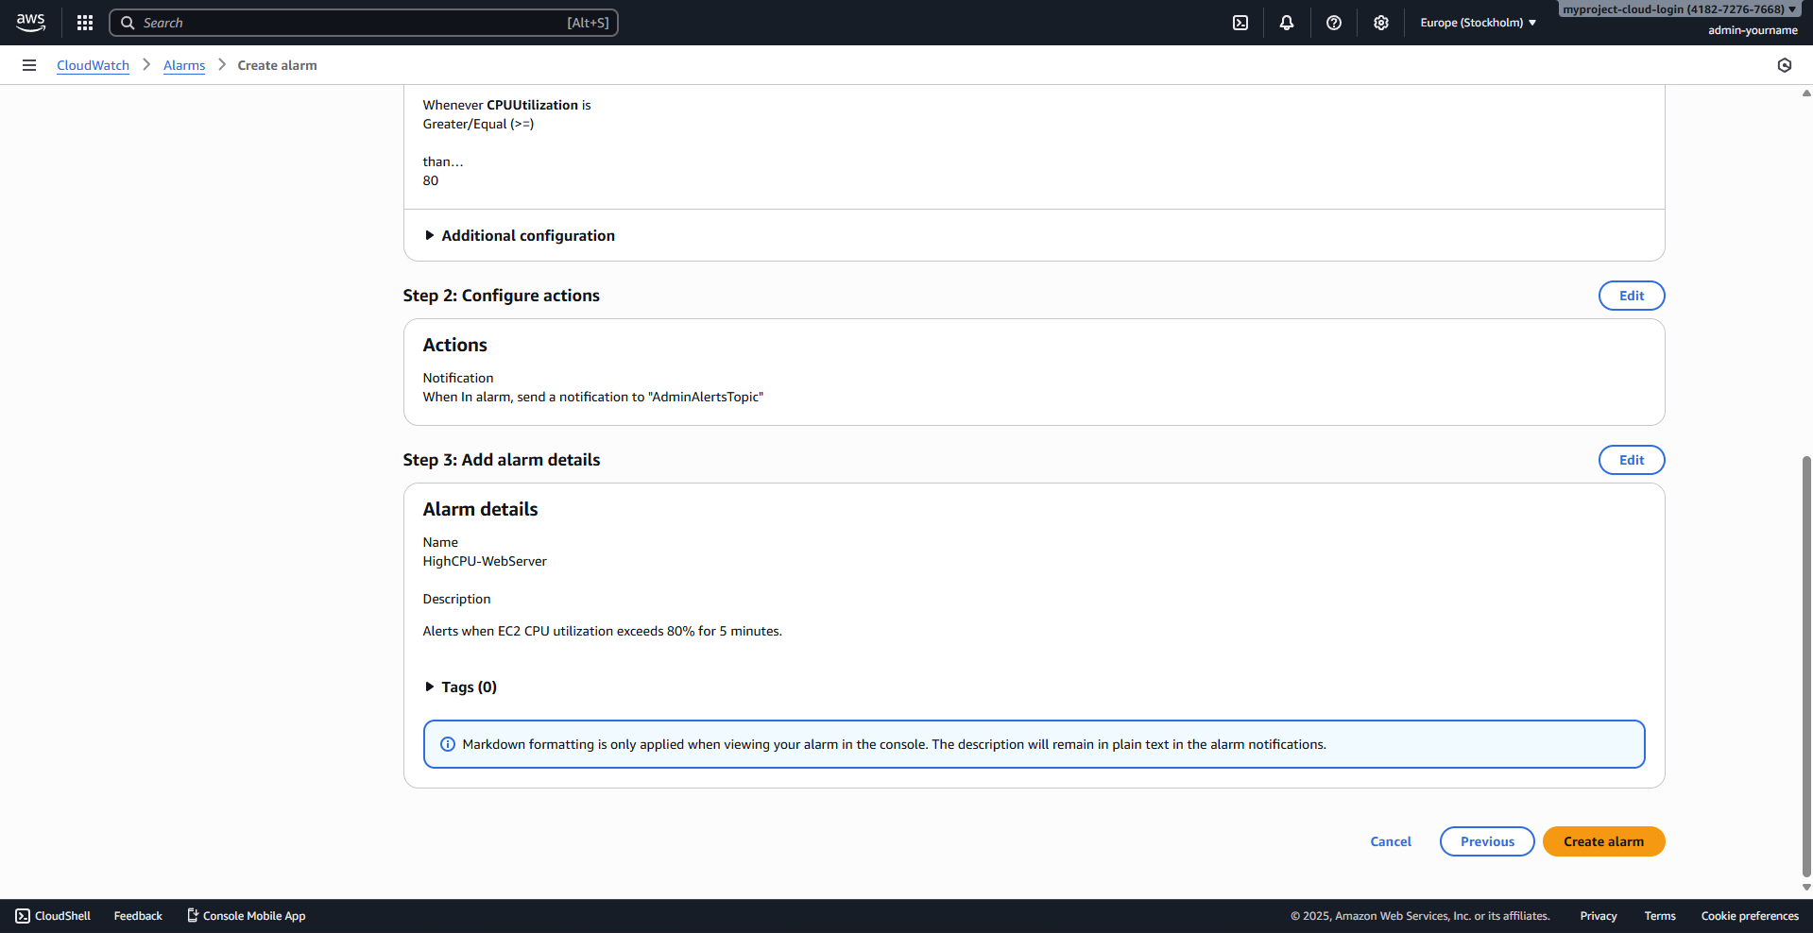

**Step 9.6: Verification** The alarm was successfully created. It initially showed "Insufficient data" while waiting for the first few data points to arrive.

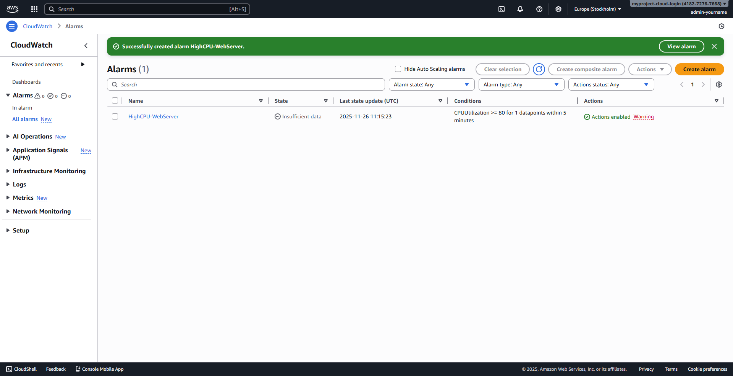

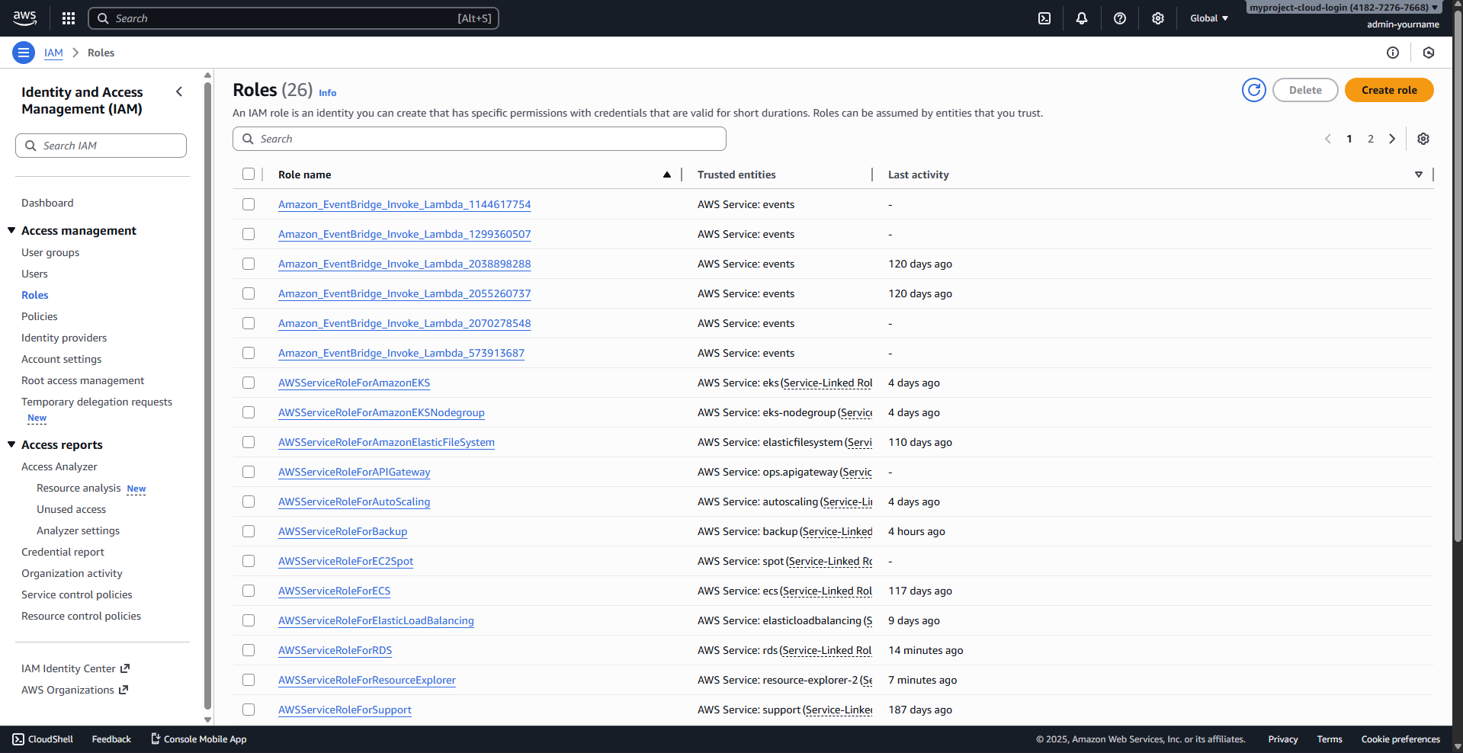

**Step 9.7: EC2 Integration Check** We verified on the EC2 Console that the instance is correctly reporting data and is linked to the monitoring system.

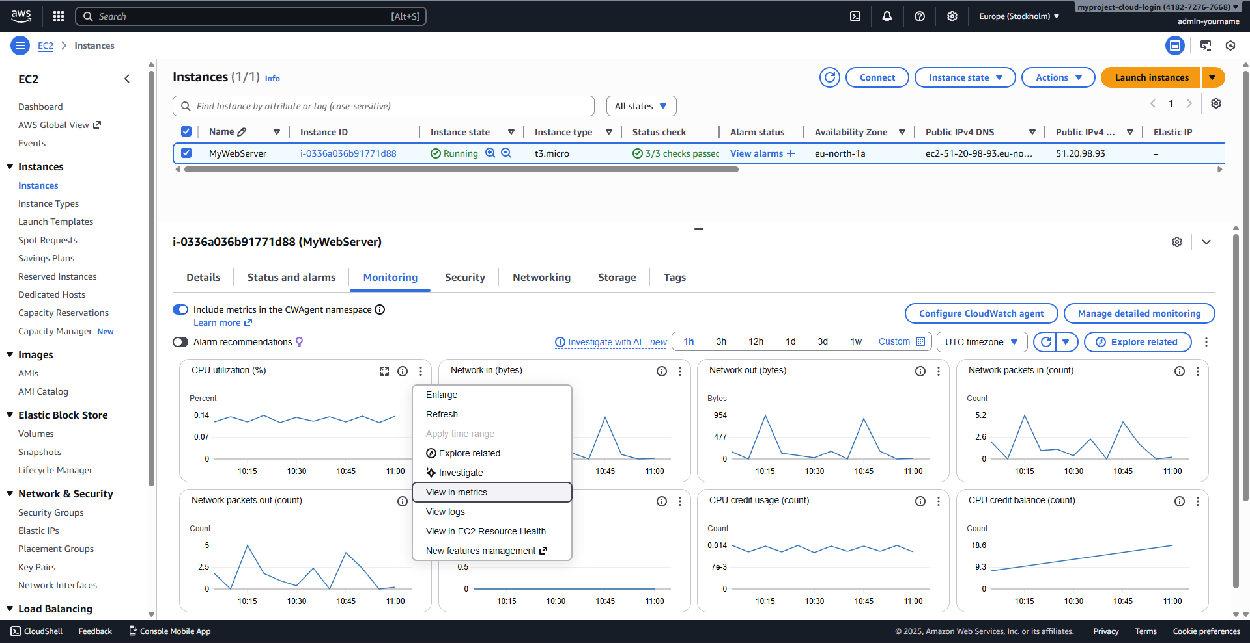

### Phase 10: Automation (Lambda)

To enable advanced automated checks (like network reachability testing), we began by setting up the necessary permissions and serverless functions.

**Step 10.1: IAM Role for Lambda** We navigated to the IAM console to create a new Role. We selected **AWS Service** and **Lambda** as the trusted entity, allowing our future automation script to access AWS resources securely.

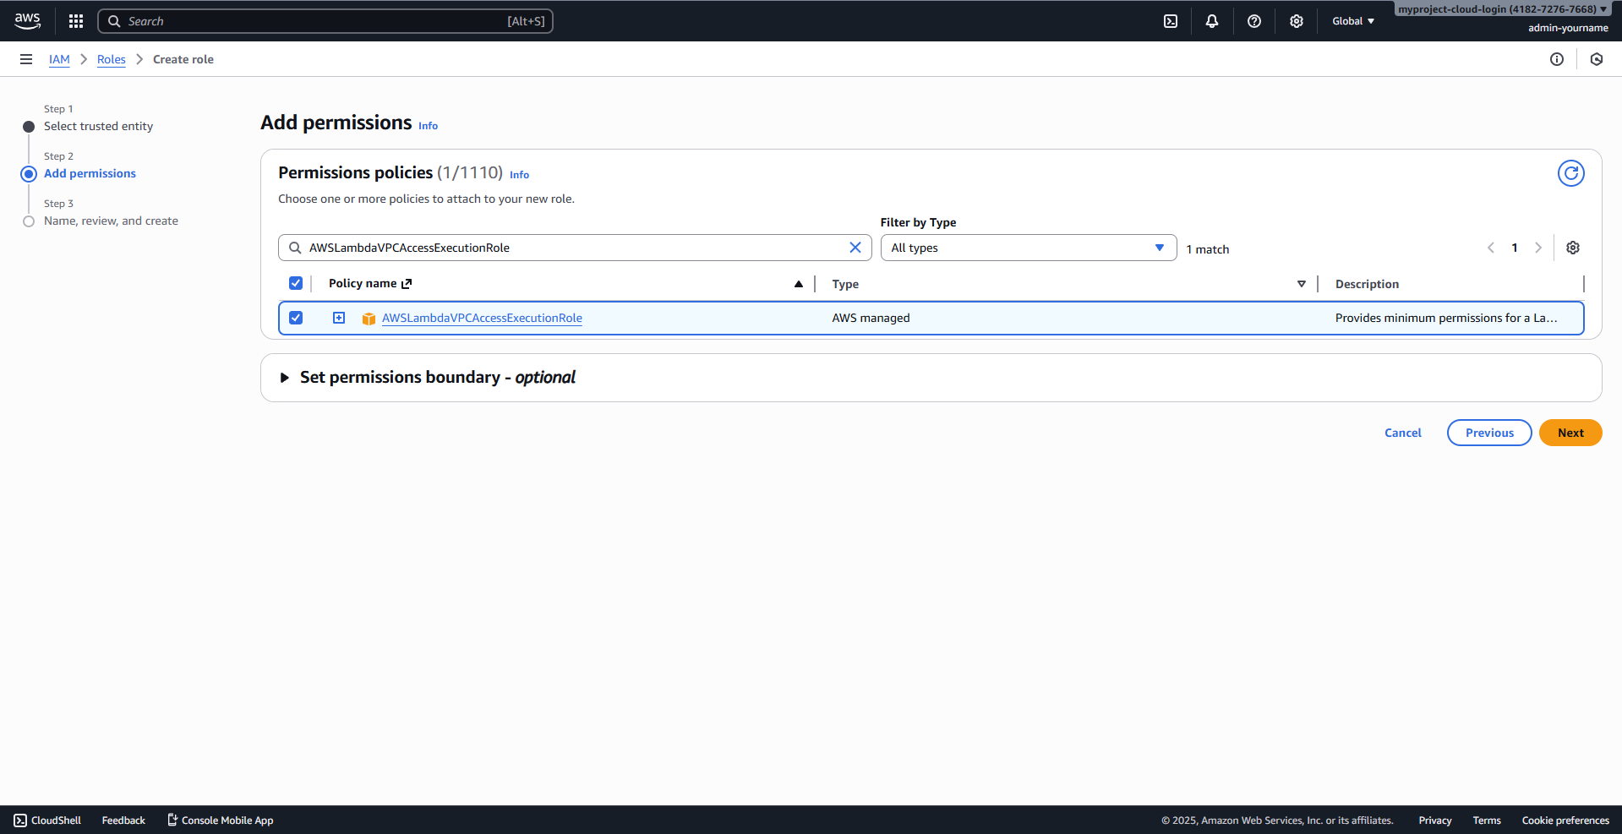

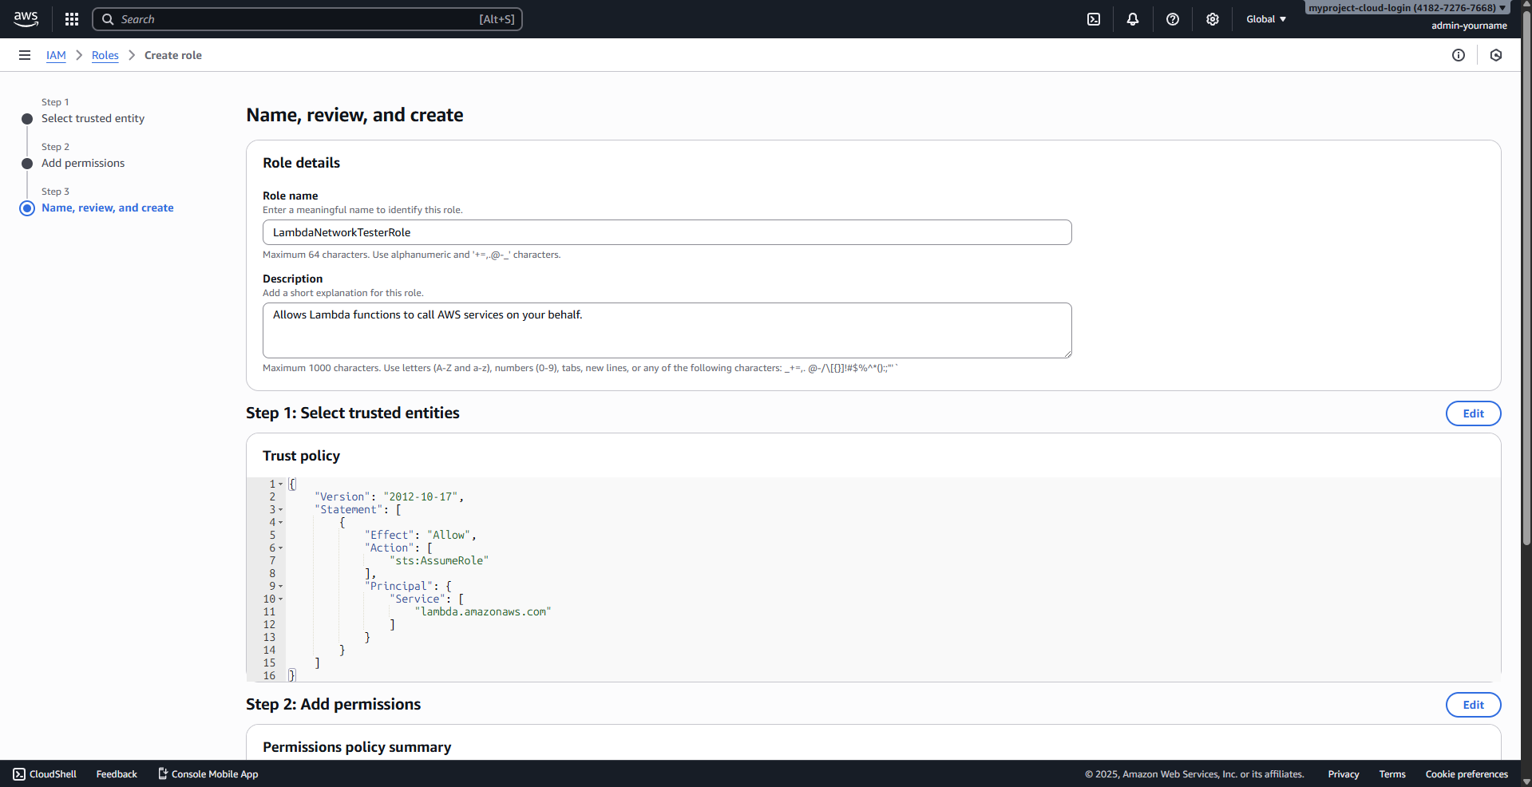

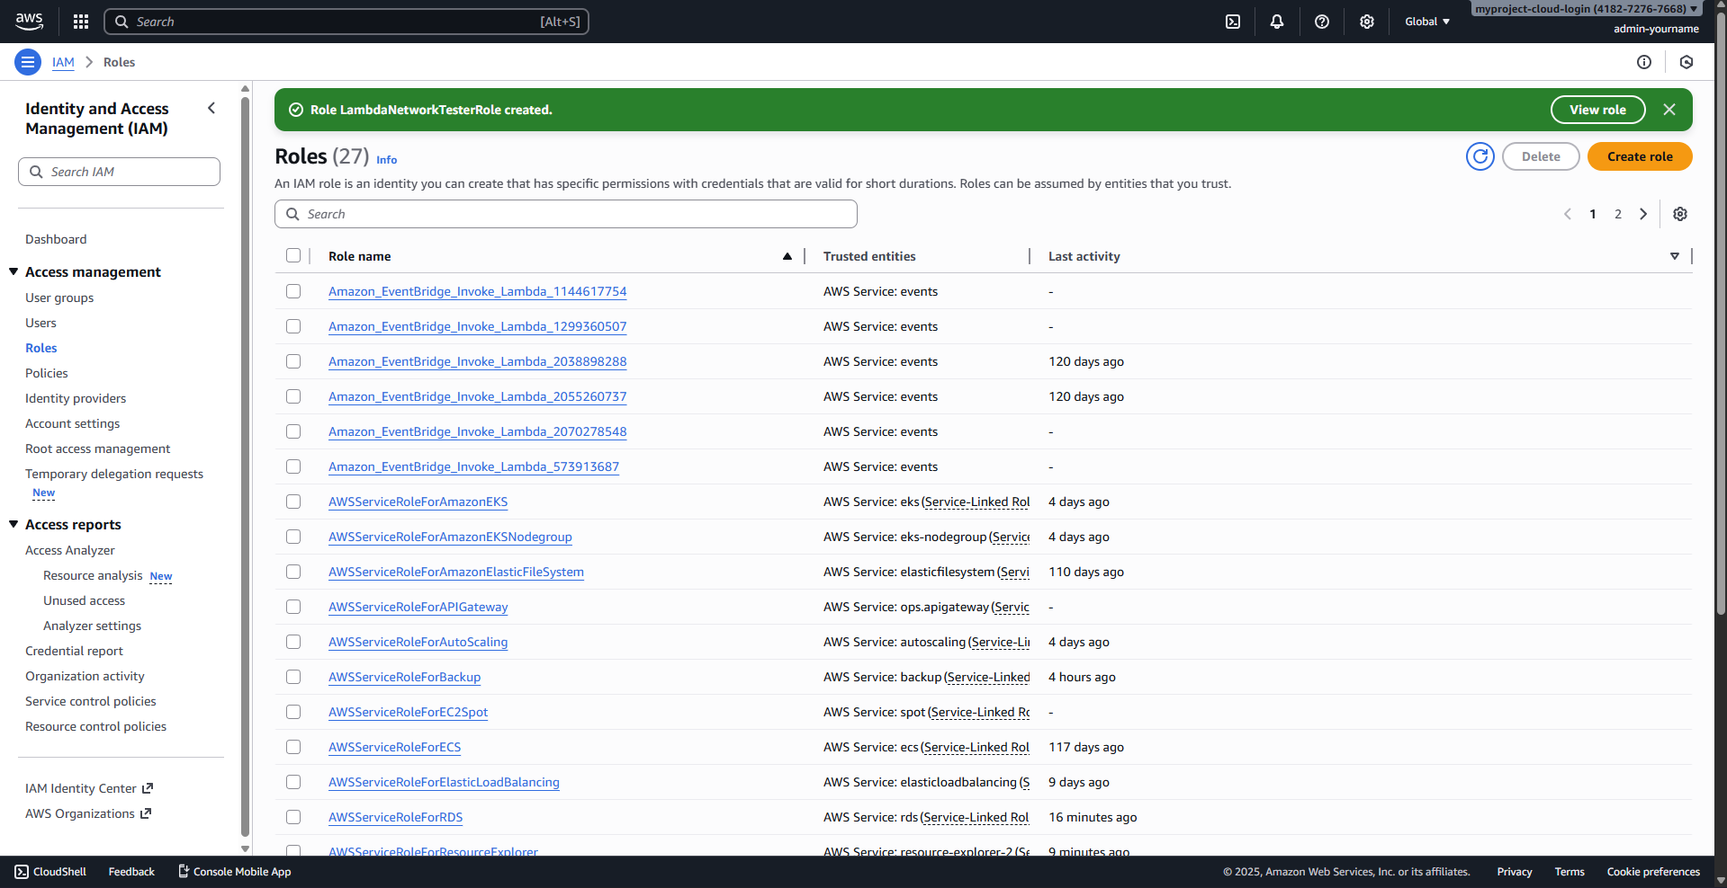

**Step 10.2: Creating the Lambda Function** We navigated to the Lambda console to author the automation script.

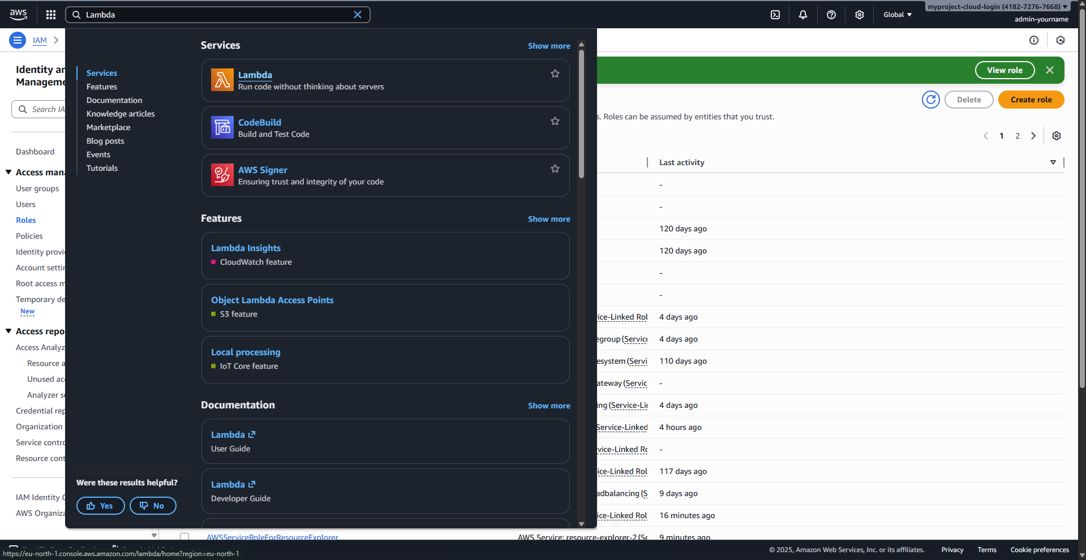

**Step 10.3: Function Configuration** We selected "Author from scratch" and named the function NetworkTester. We chose **Python 3.11** as the runtime environment.

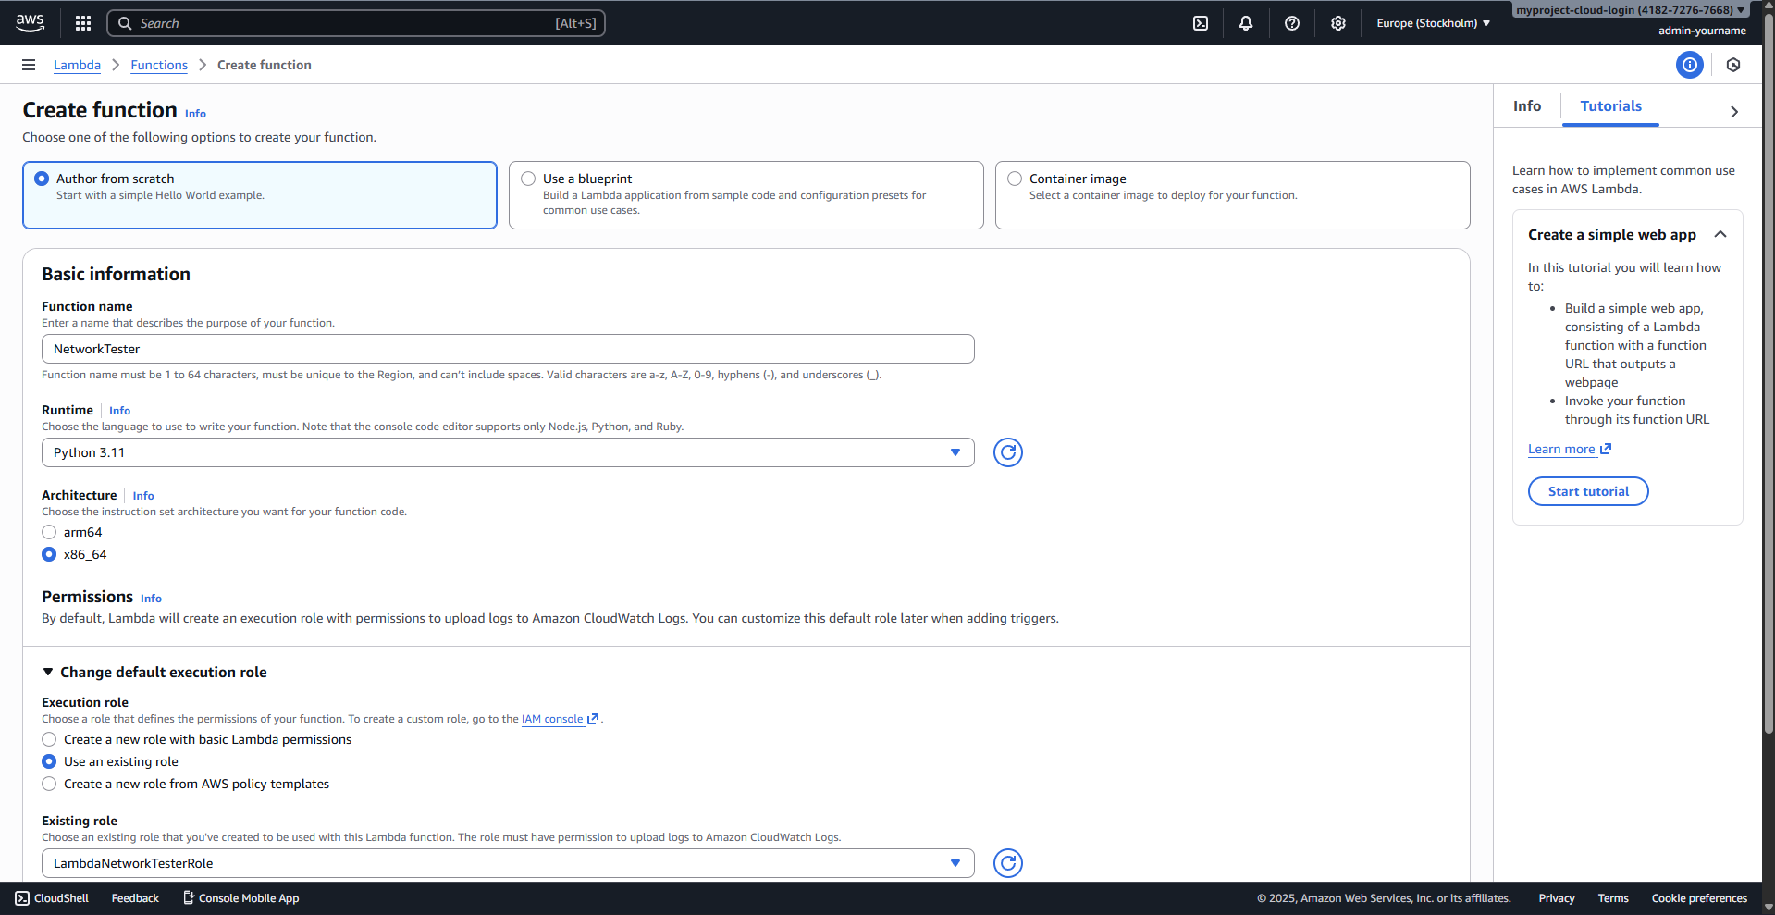

**Step 10.4: Assigning Permissions** Crucially, we attached the existing role we created earlier (LambdaNetworkTesterRole) to ensure the function has the correct permissions to log to CloudWatch and access network interfaces.

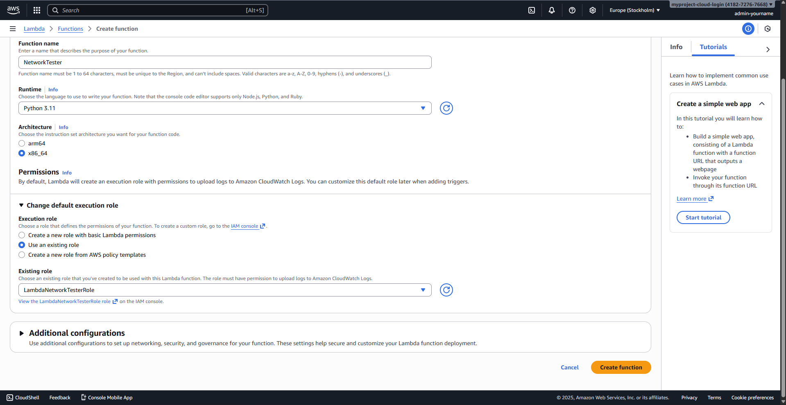

**Step 10.5: Network Configuration (VPC)** We configured the function to run inside our MonitorProject-vpc and attached it to the private subnets. This allows the function to securely test internal resources. We also assigned the default security group.

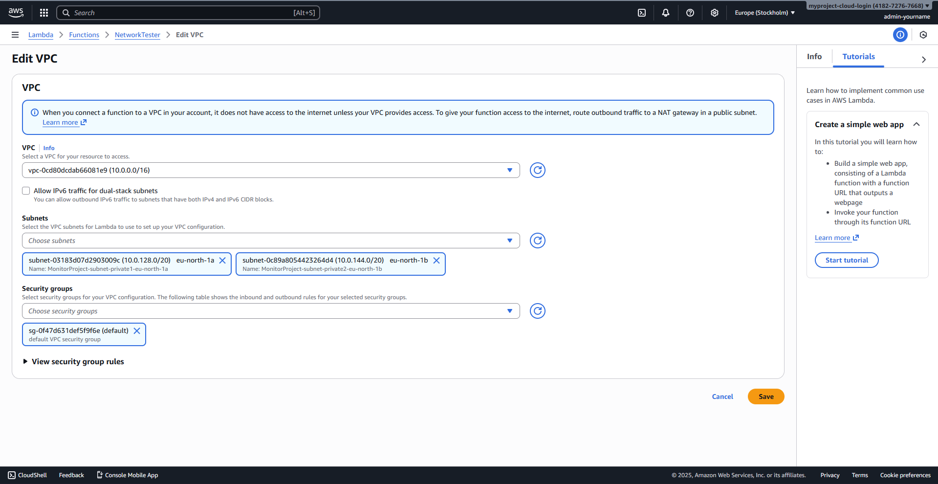

**Step 10.6: Deployment Success** We finalized the creation. The function was successfully deployed and is now ready for the Python code implementation.

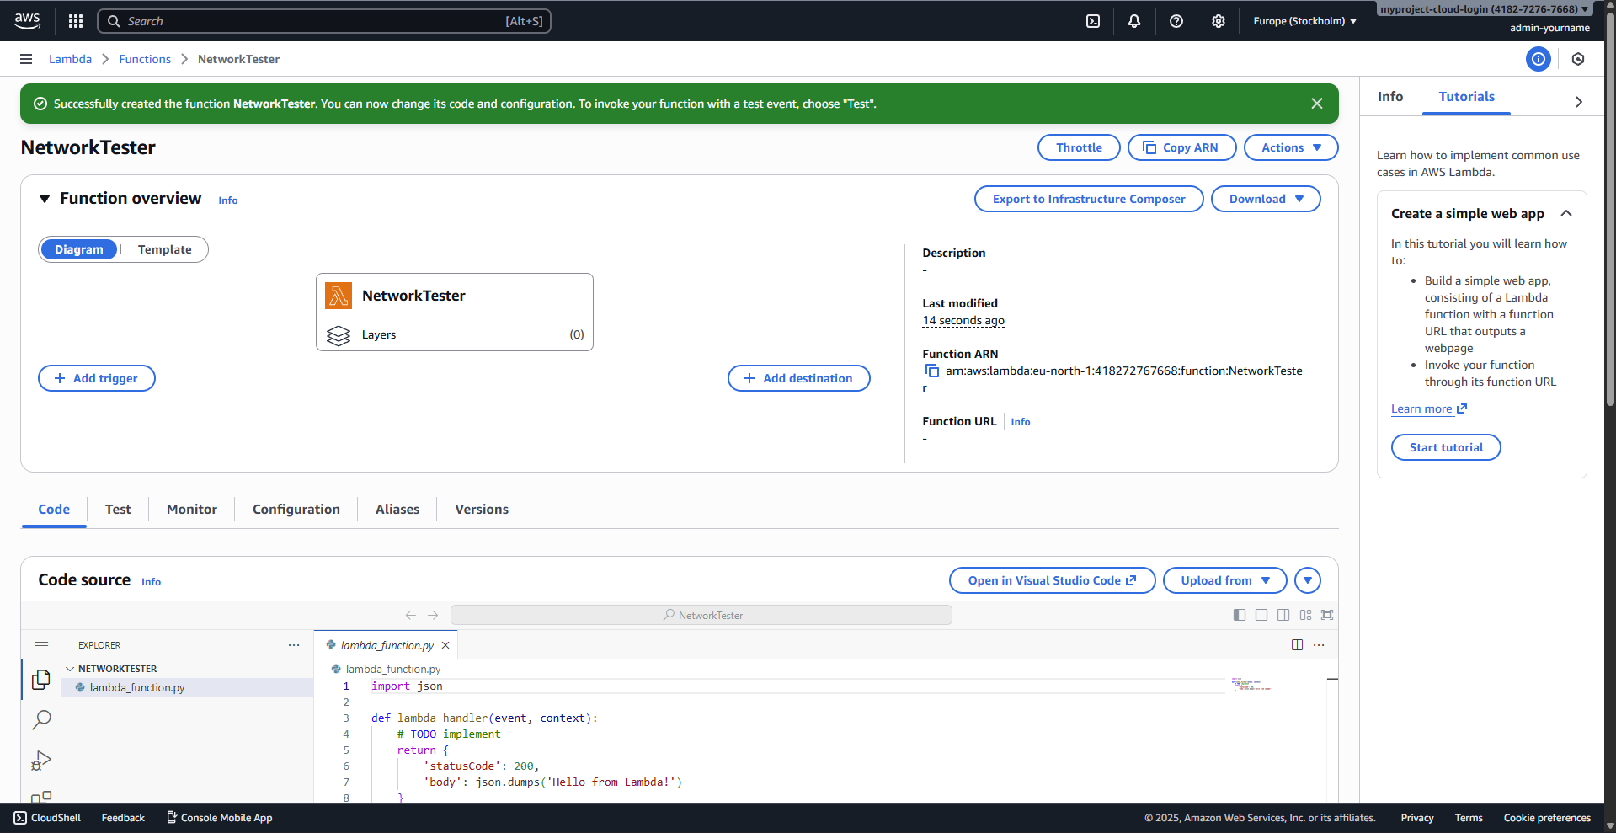

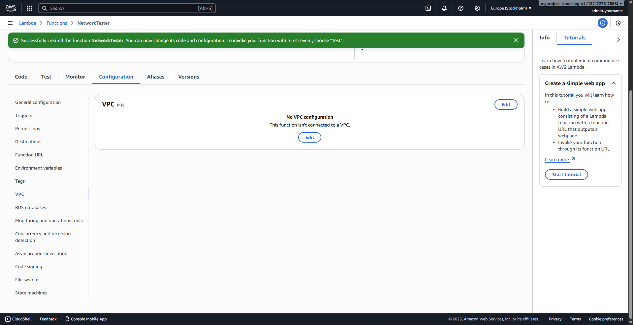

### Phase 11: Advanced Networking (NAT Gateway)

Since our Lambda function is located in a private subnet, it has no direct access to the internet. To allow the function to ping external websites (like https://www.google.com/search?q=google.com) for reachability testing, we implemented a NAT Gateway.

**Step 11.1: Allocating an Elastic IP** We allocated a new Elastic IP address to provide a static public IP for our NAT Gateway.

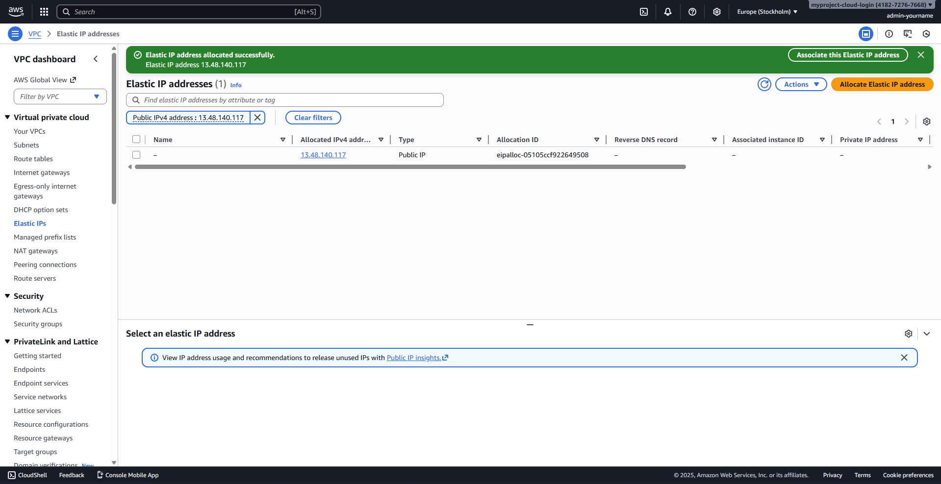

**Step 11.2: Creating the NAT Gateway** We navigated to the VPC console and created a NAT Gateway. We placed it in the **Public Subnet** and associated it with the Elastic IP we just created.

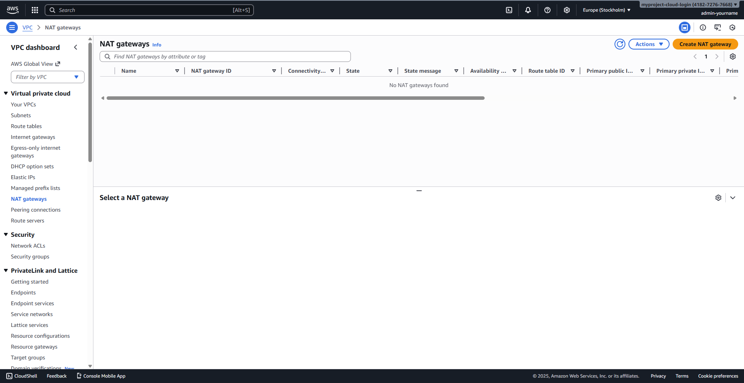

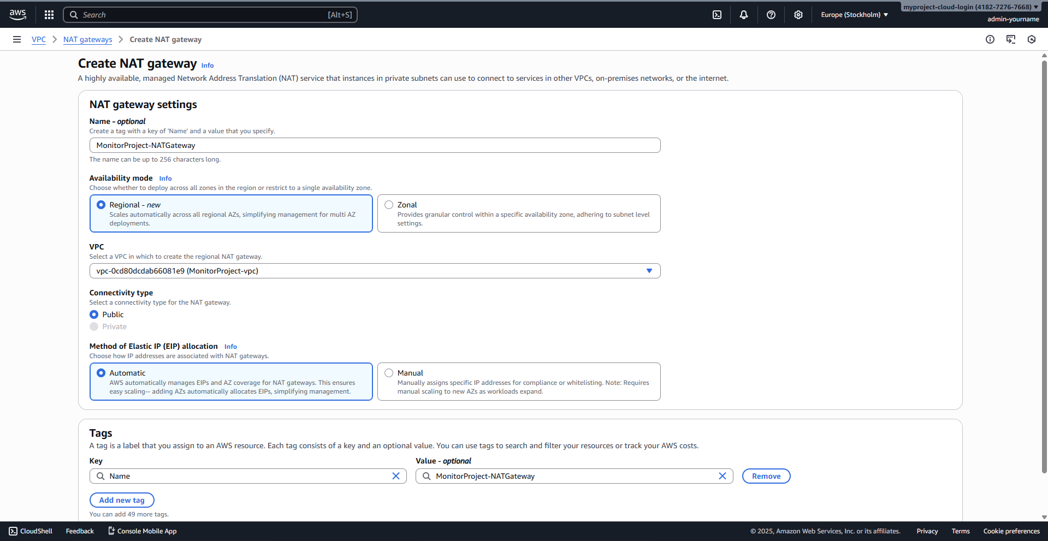

**Step 11.3: Verification** We confirmed that the NAT Gateway state changed to "Available".

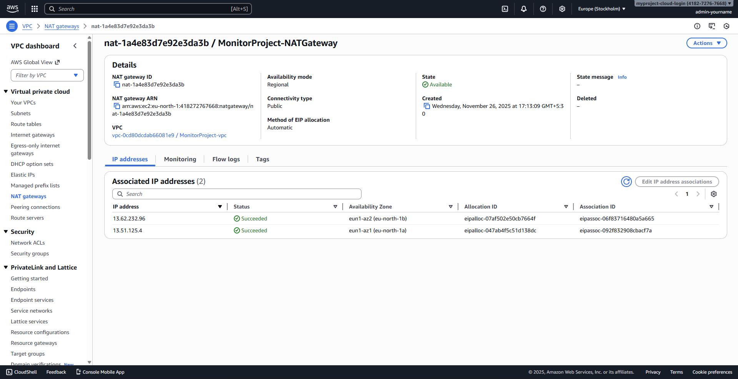

**Step 11.4: Routing Configuration (Troubleshooting)** Initially, our Lambda function failed with a "Task timed out" error because it could not reach the internet.

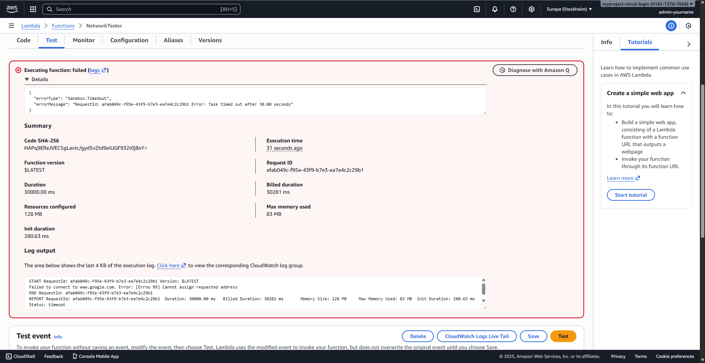

To fix this, we updated the route tables associated with our **Private Subnets**. We routed all internet-bound traffic (0.0.0.0/0) through the new **NAT Gateway** (instead of the Internet Gateway, which is only for public subnets).

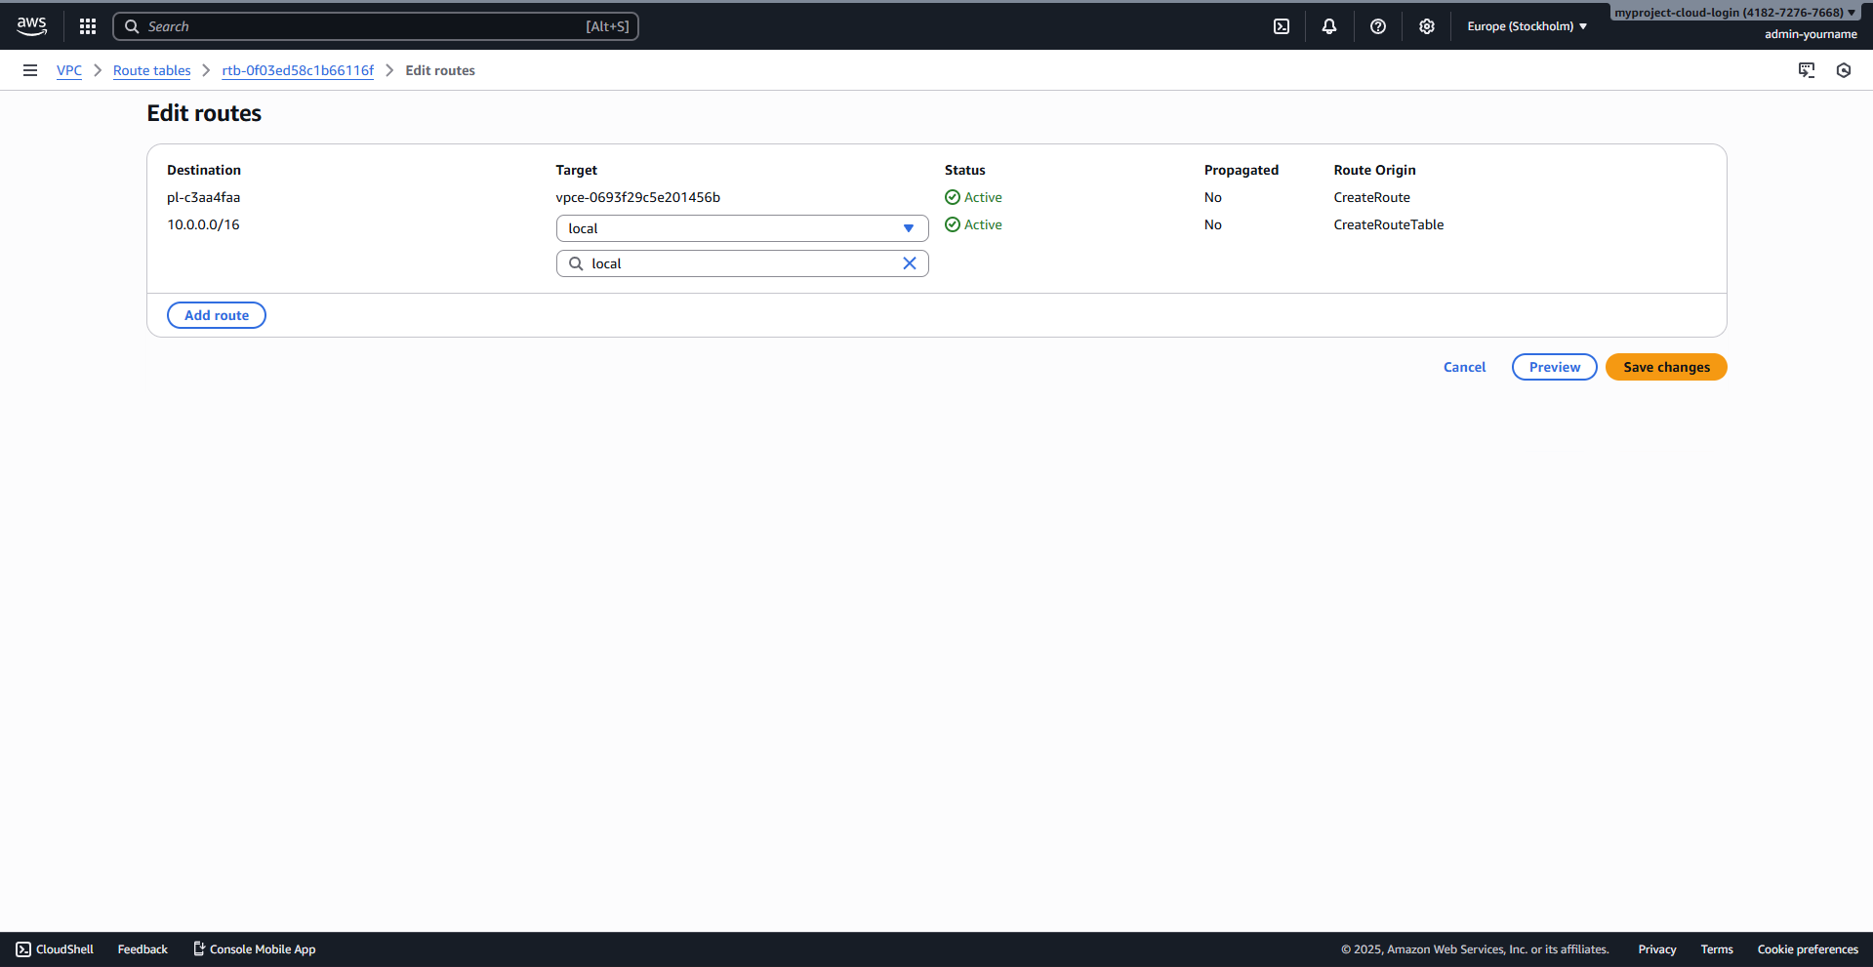

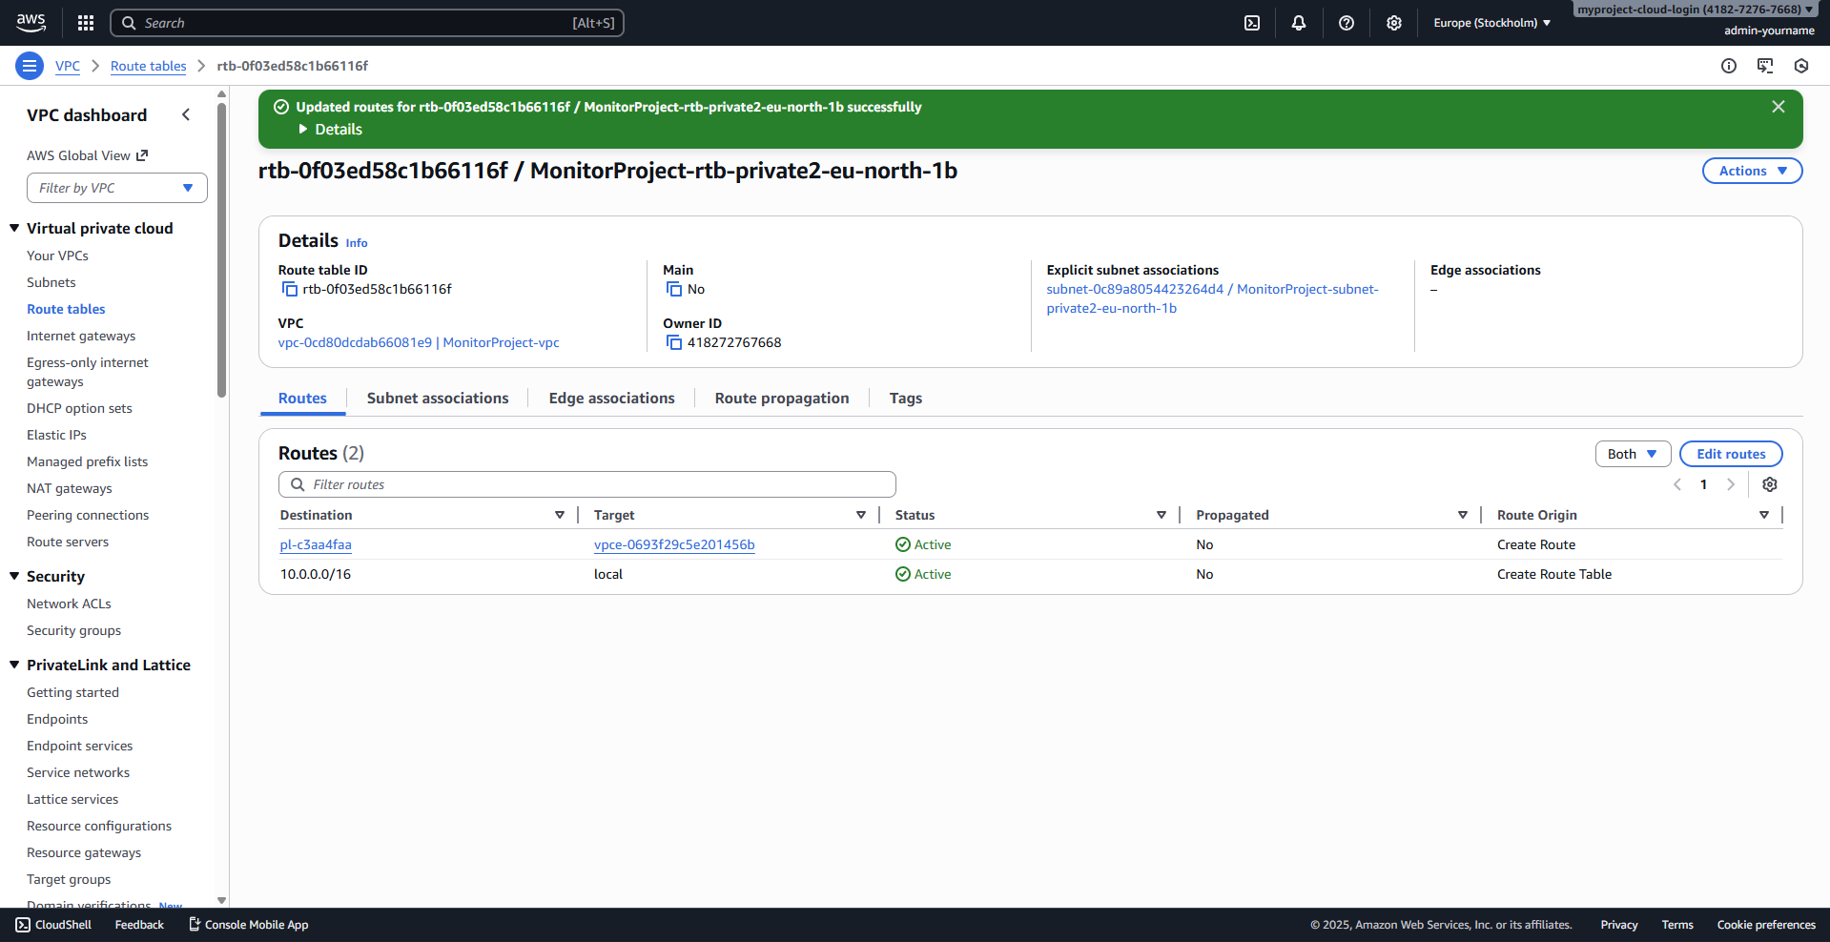

### Phase 12: Lambda Implementation & Testing

With the network path established, we implemented the logic for the health check.

**Step 12.1: Configuring Function Settings** We verified the VPC configuration for the Lambda function to ensure it was correctly associated with the private subnets.

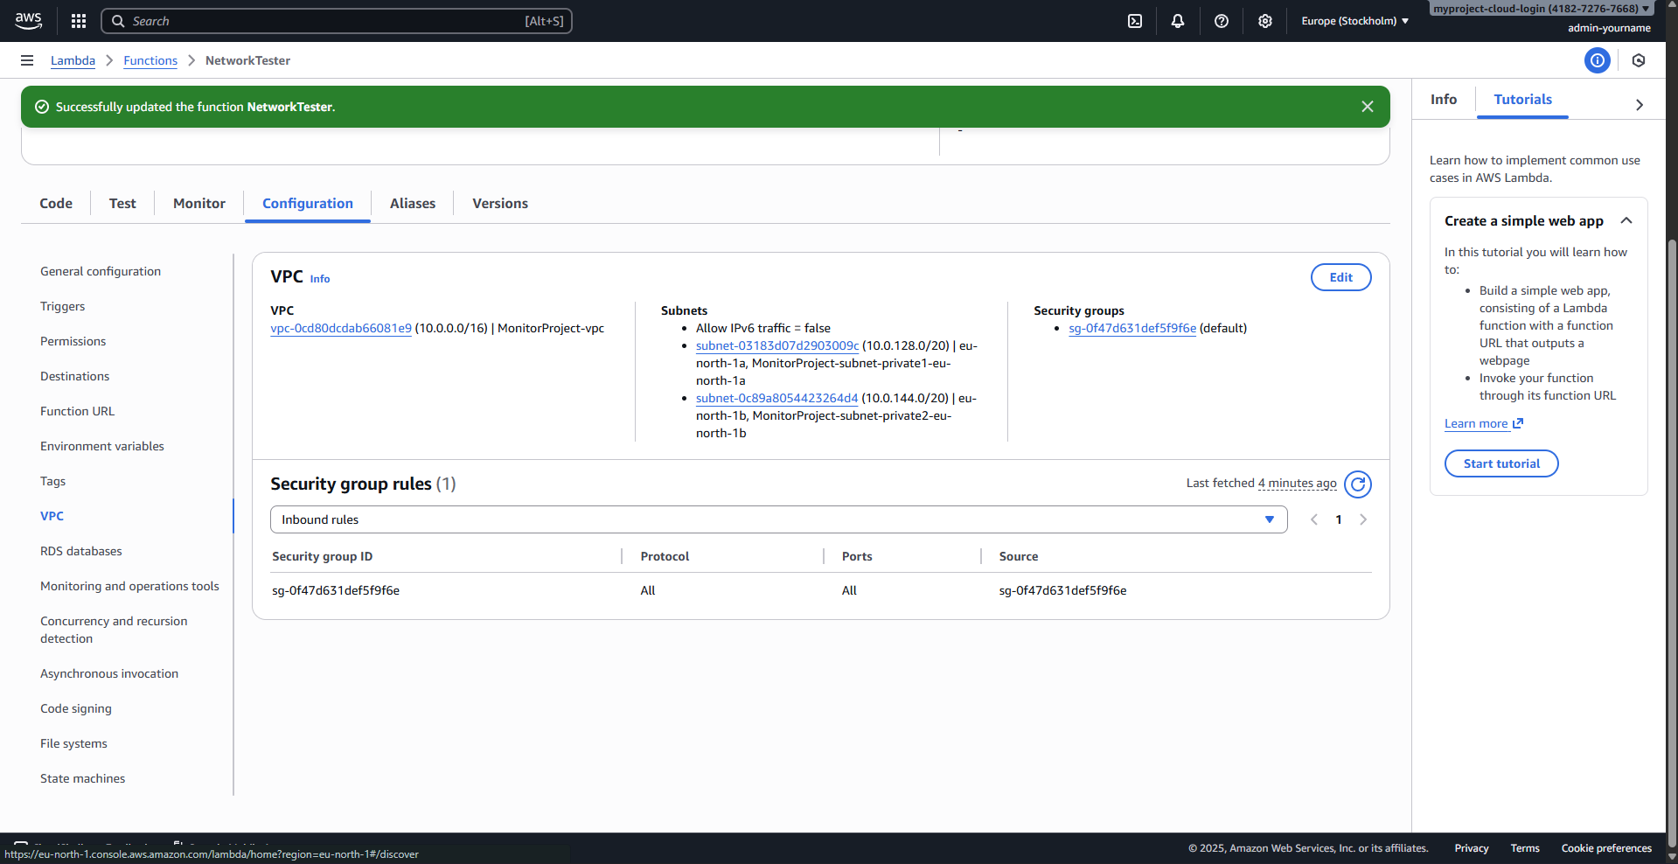

We also adjusted the basic settings, setting the timeout to 3 seconds to ensure rapid failure detection without incurring high costs.

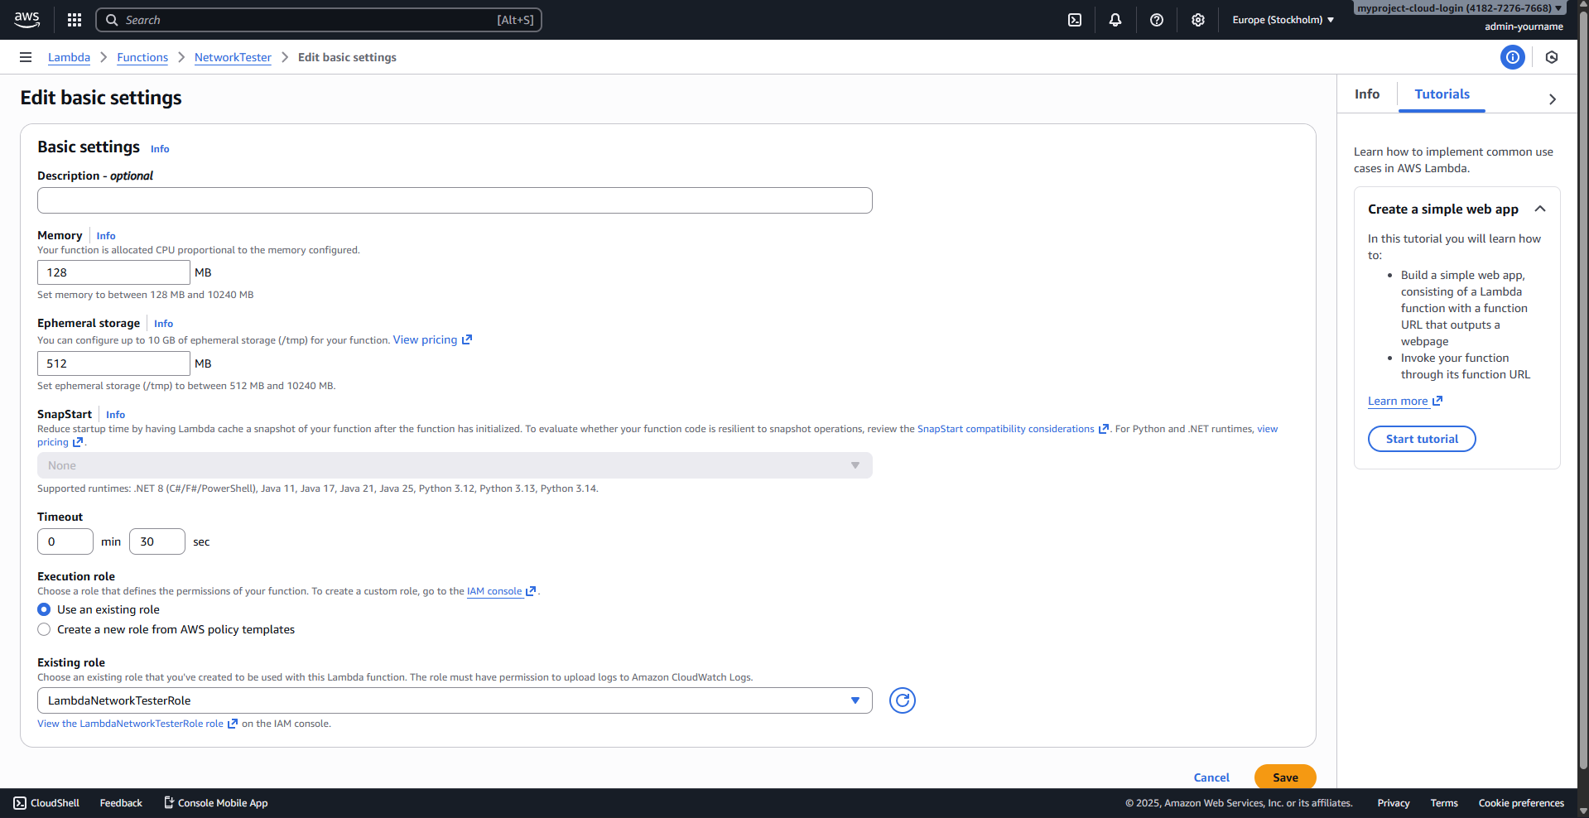

**Step 12.2: Writing the Automation Script** We wrote a Python script using the socket library to attempt a connection to www.google.com on port 80. If the connection fails, the script uses the boto3 library to publish an urgent alert to our AdminAlertsTopic.

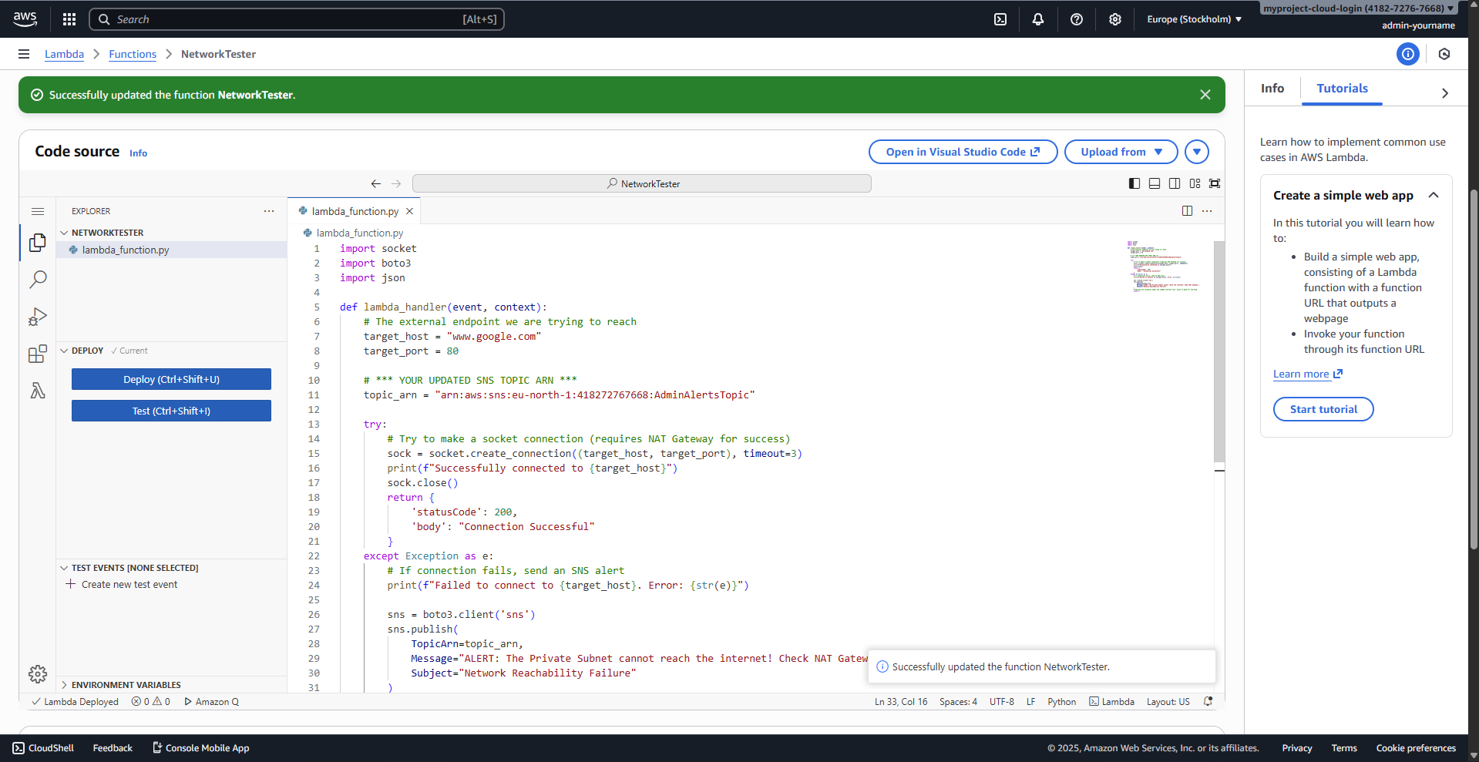

**Step 12.3: Scheduling the Automation** To make this check automated, we added an EventBridge trigger to run the function every hour.

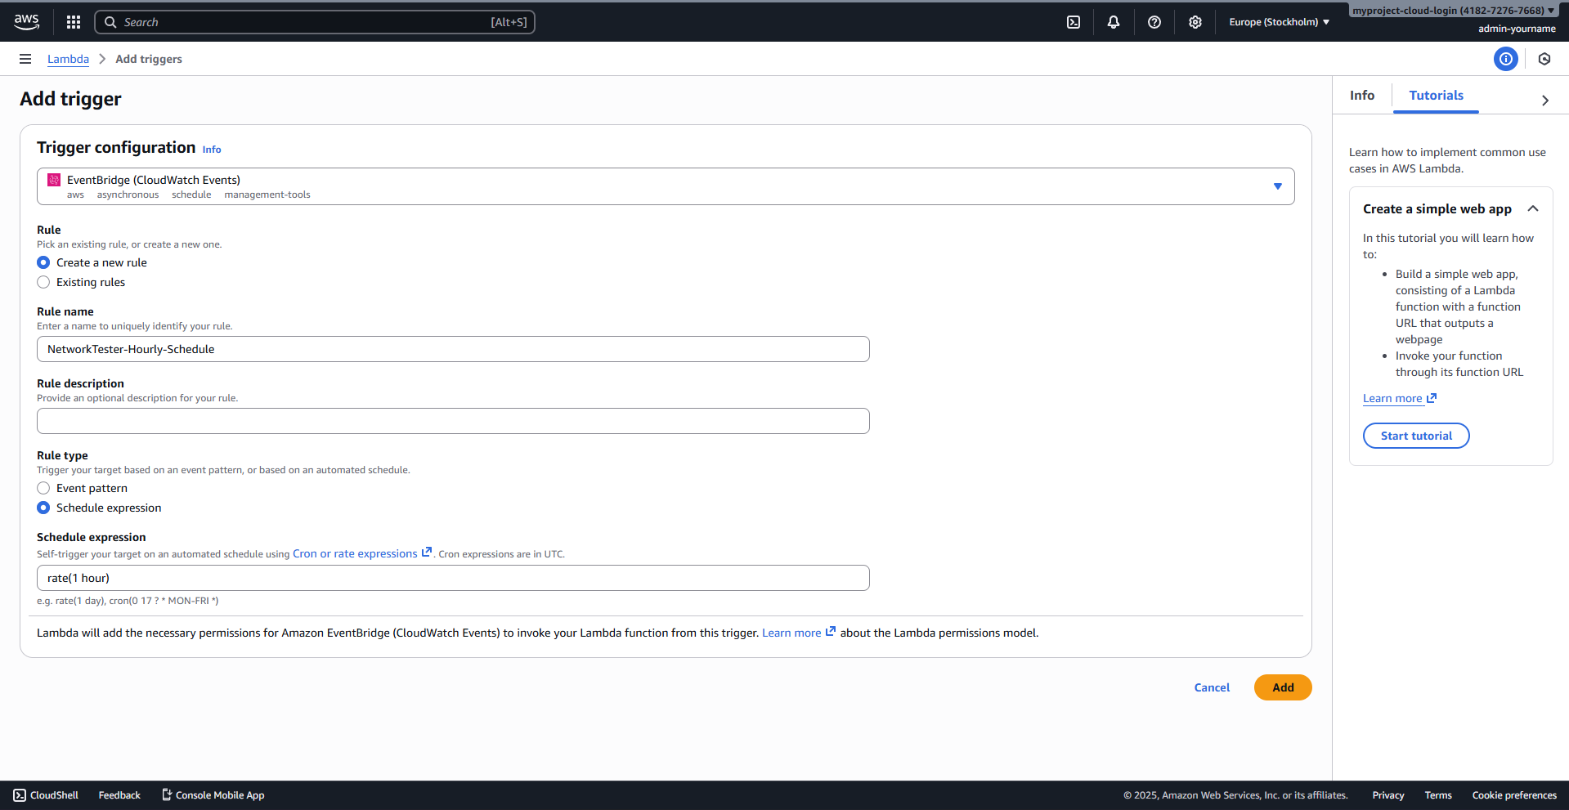

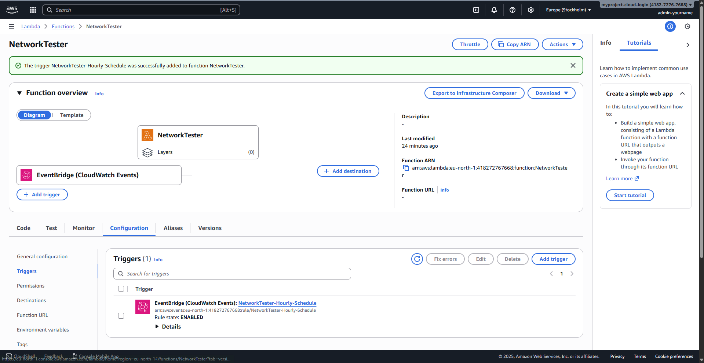

**Step 12.4: Testing the Function** We created a test event named DummyTestEvent to manually trigger the function and verify that the connectivity logic works as expected.

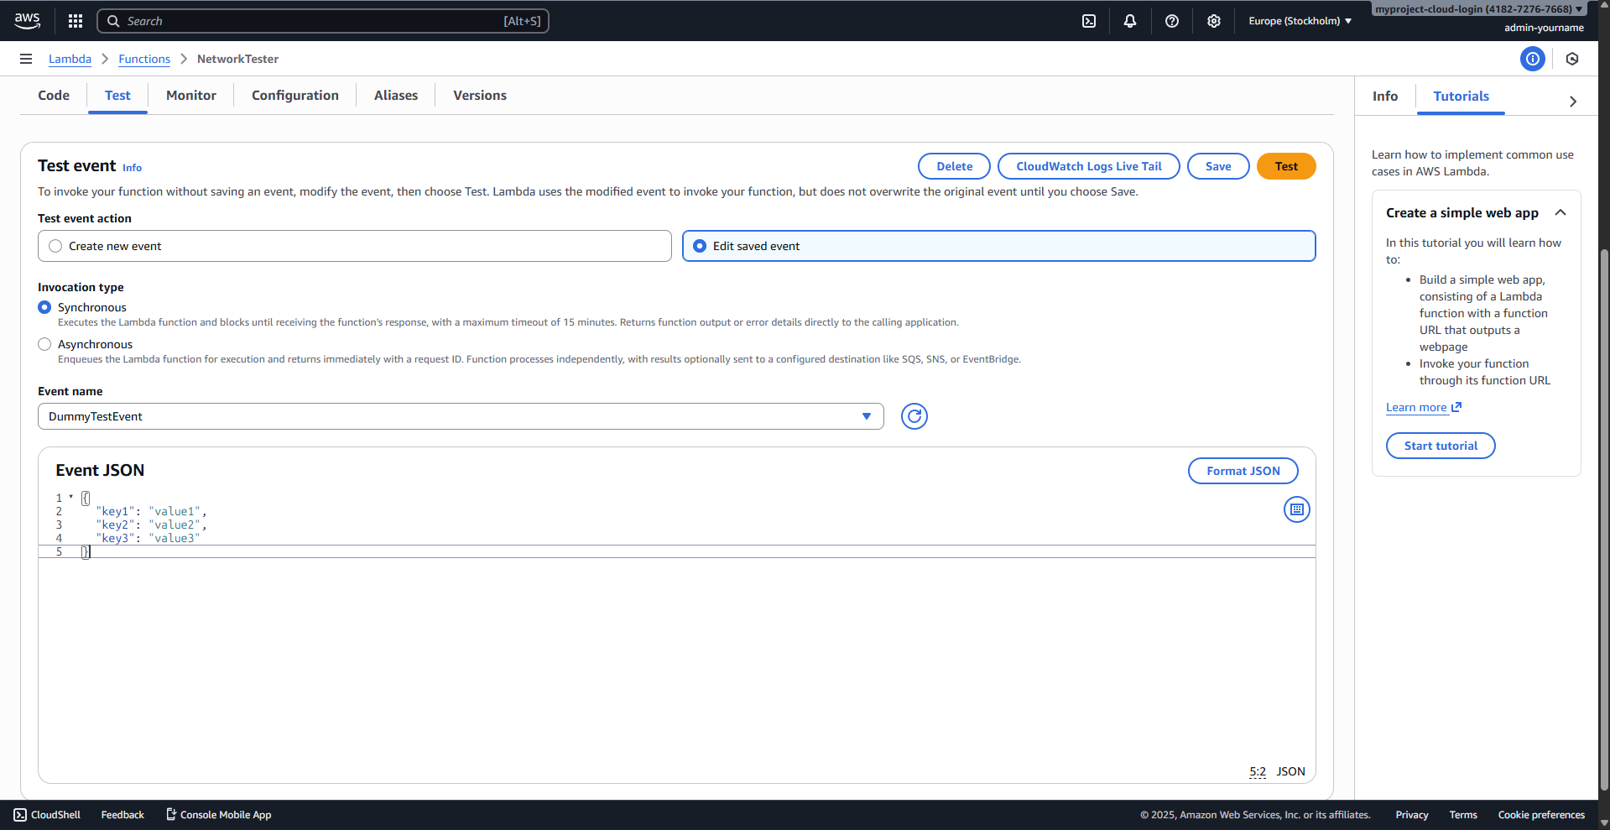

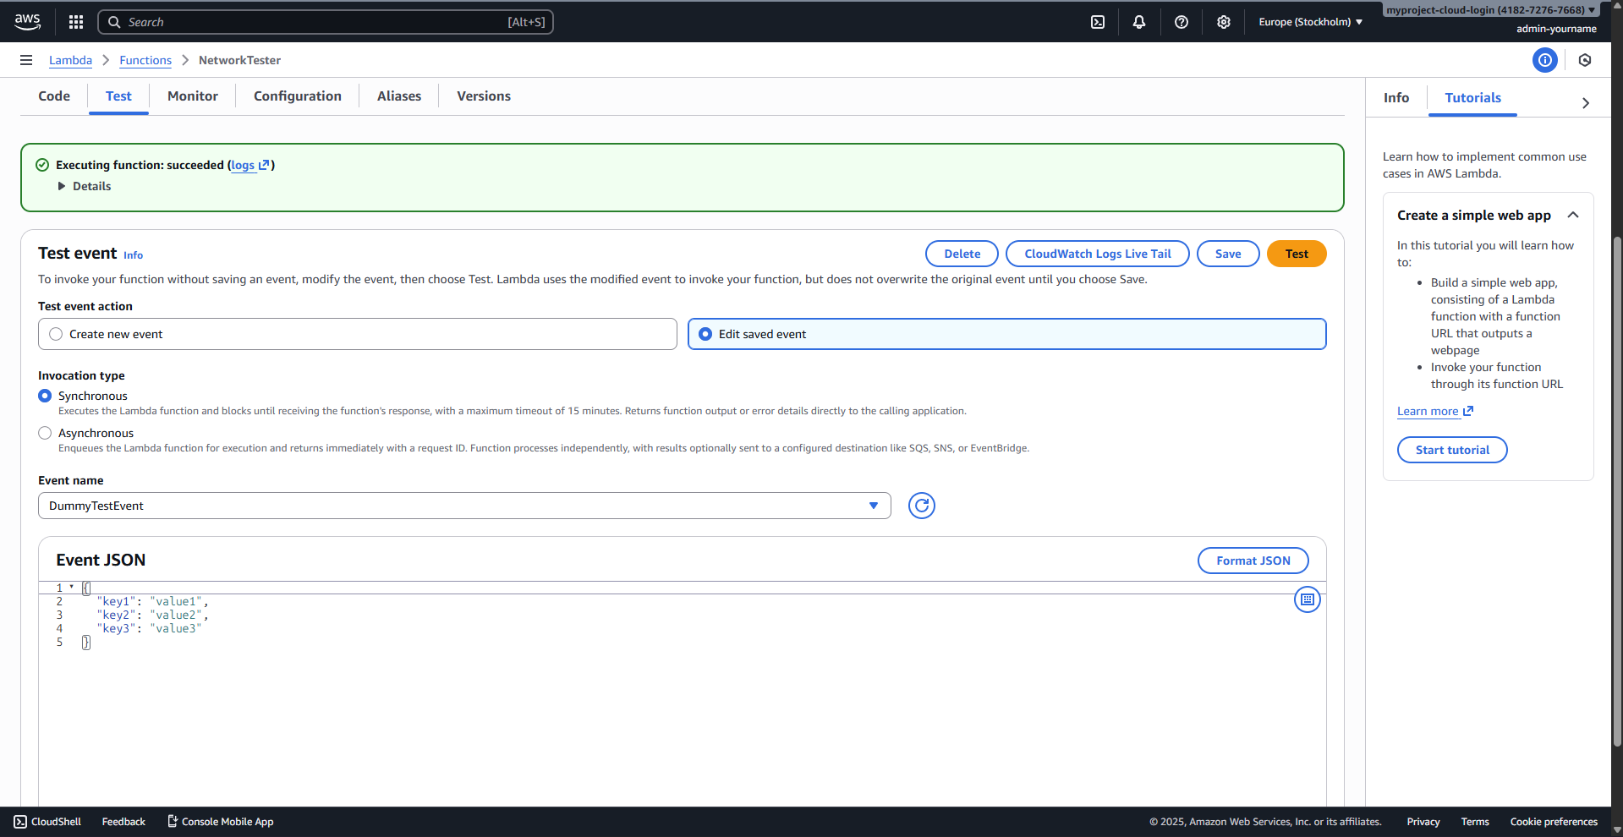

**Step 12.5: Alert Verification** Finally, we confirmed that the entire alert pipeline works by receiving the subscription confirmation email from SNS.

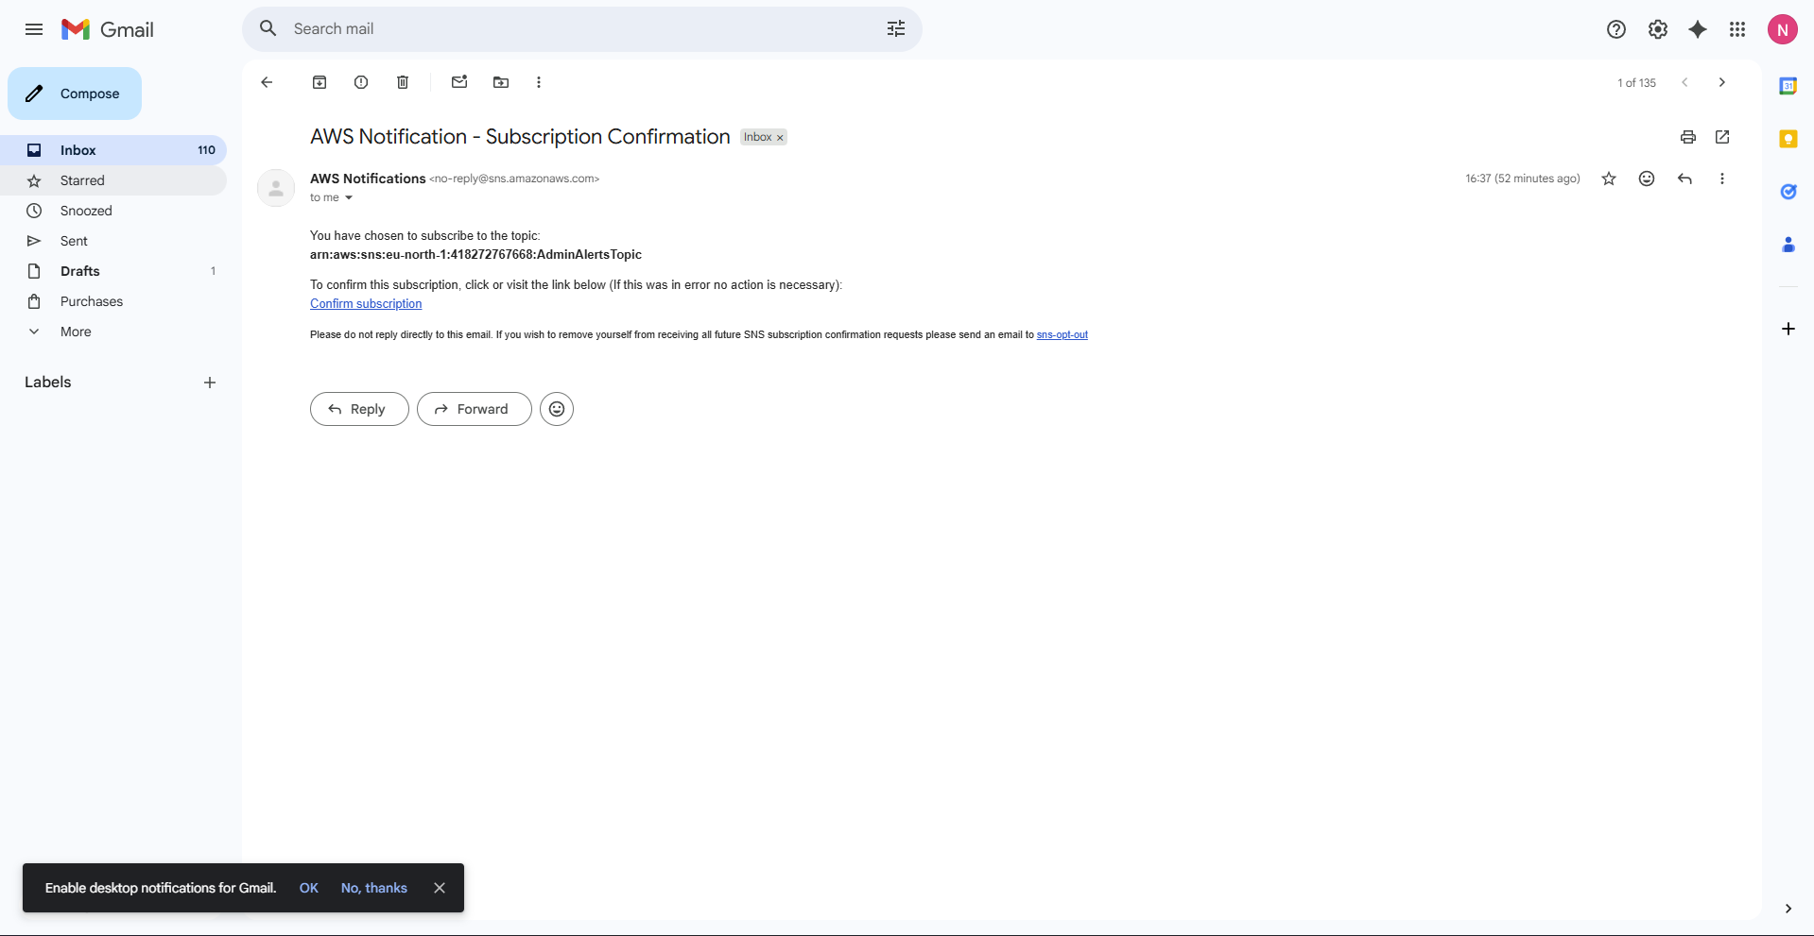

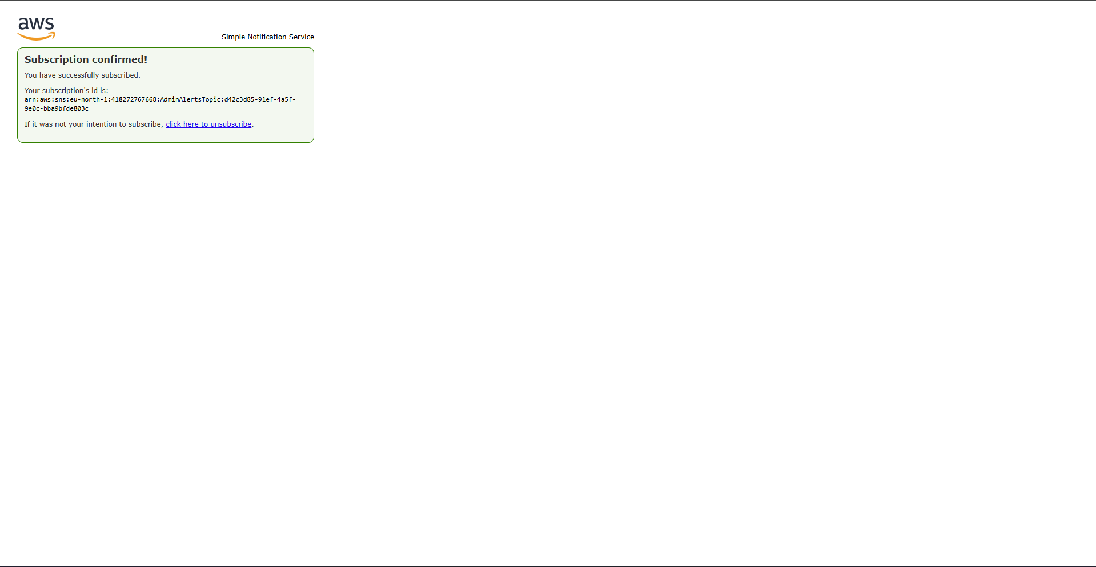

### Phase 13: System Stress Test (End-to-End Validation)

To guarantee our monitoring system works under real-world pressure, we performed a stress test on the EC2 instance.

**Step 13.1: Connecting to the Server** We connected to our MyWebServer instance securely via SSH. 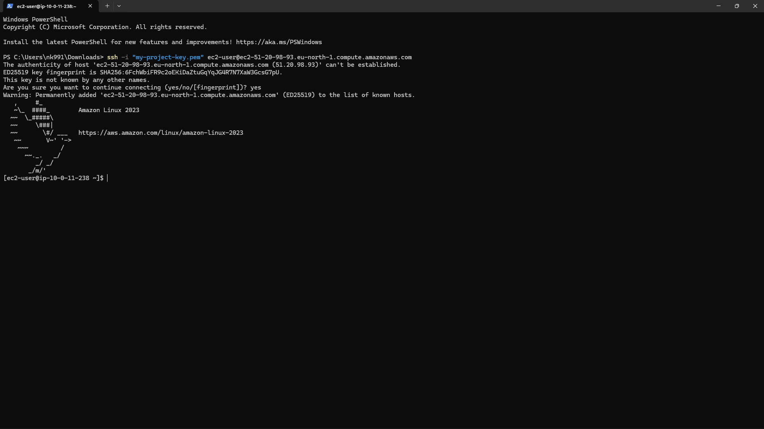

**Step 13.2: Installing Stress Tools** We updated the system repositories and installed the stress utility to simulate high system load. *(Place Screenshot 113 here: sudo yum install -y stress command execution)*

**Step 13.3: Executing the Stress Test** We ran the command stress --cpu 1 --timeout 300s to max out the CPU for 5 minutes, ensuring it would breach our 80% alarm threshold.

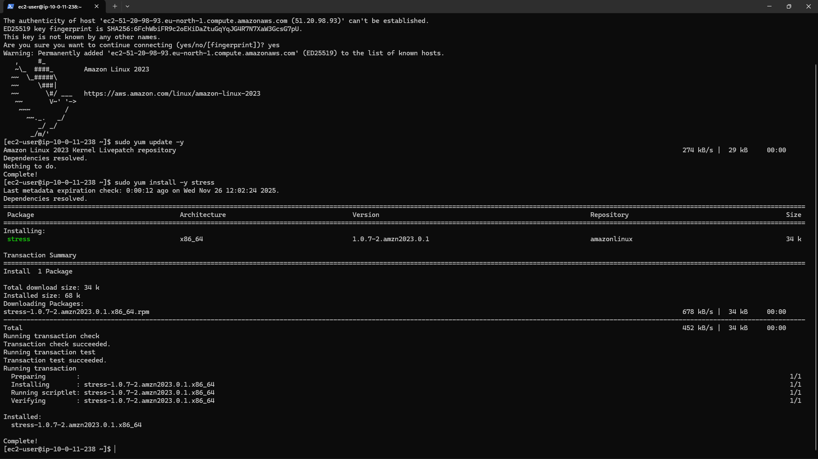

**Step 13.4: Verifying the Alarm** We monitored the CloudWatch dashboard and confirmed that the CPU utilization spiked to 100%, triggering the alarm state.

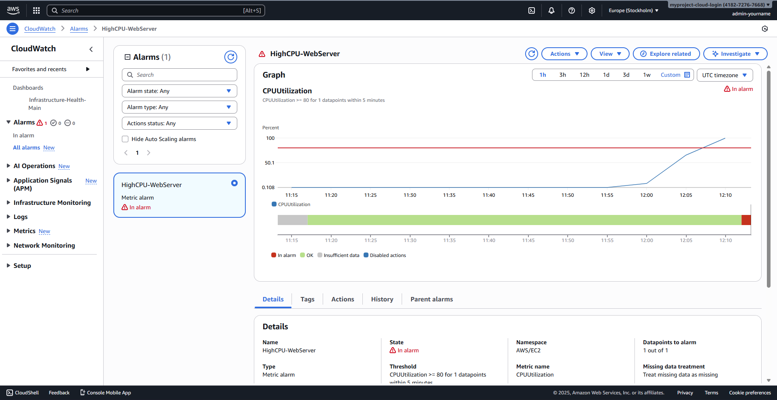

**Step 13.5: Receiving the Alert** Within moments of the alarm triggering, we received an automated email notification, confirming the end-to-end success of our monitoring infrastructure.

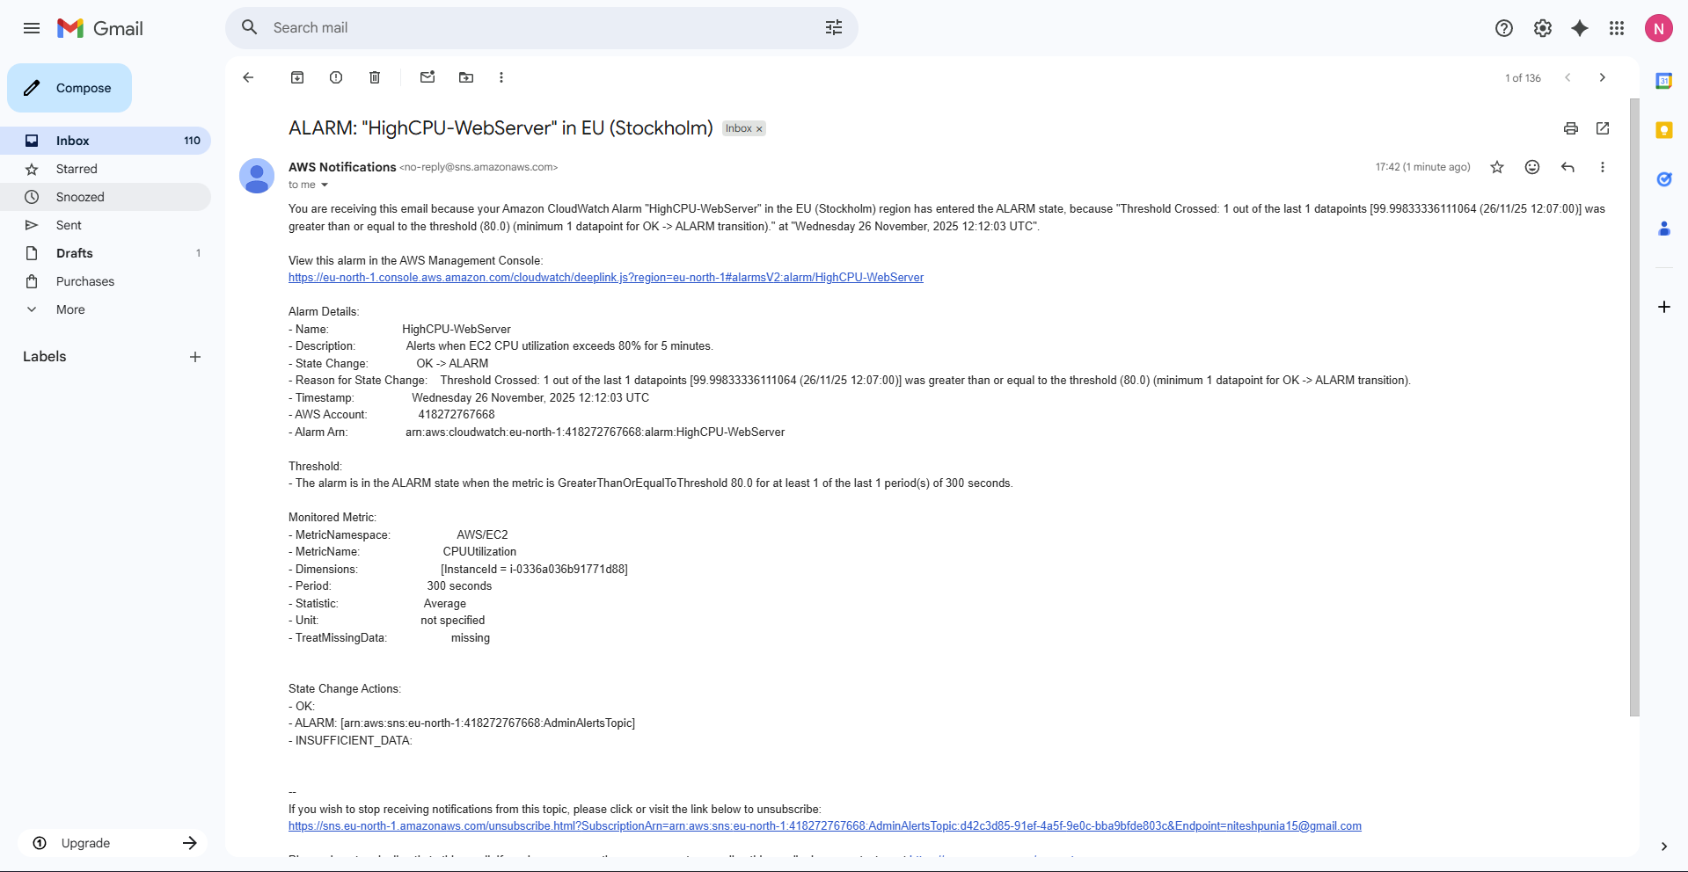

## 4. Conclusion

This project successfully established a robust monitoring framework for AWS infrastructure. By starting with a secure IAM foundation and layering on CloudWatch, SNS alerting, and Lambda-based automation, we have ensured that the support team has comprehensive visibility into the health of EC2, S3, RDS, and network resources.

**Key Achievements:**

* Eliminated reliance on root account usage.
* Implemented automated CPU and Storage monitoring.
* Created a "single pane of glass" dashboard for infrastructure health.
* Established an email alerting pipeline for critical incidents.
* Deployed serverless automation to actively test network reachability.